**MINISTRY OF EDUCATION AND TRAINING**

**FPT UNIVERSITY**

Capstone Project Document

**The mobile surveillance using Handheld Device’s Camera**

|  |  |
| --- | --- |
| **Group 4** | |
| **Group Members** | Đặng Minh Khiêm – Team Leader – SE60773  Phạm Đình Năng – Team Member - SE60693  Lý Khánh Duy Bảo – Team Member - SE60853  Nguyễn Minh Toàn – Team Member - SE60748  Nguyễn Kiều Thoa – Team Member - SE60812 |
| **Supervisor** | Mr. Phạm Công Thiện |
| **Ext Supervisor** | N/A |
| **Capstone Project code** | FU0014 |

- Ho Chi Minh City, 01/2014 -

***ACKNOWLEDGEMENTS***

After more than three months of intensive researching, working, and having fun, we have finally reached the fundamental objectives of the project *Mobile Surveillance*. We would like to take this opportunity to thank all the persons who have contributed in the different aspects of this project.

First and foremost we offer my sincerest gratitude to my supervisor, Mr. Phạm Công Thiện, who always full of surprising yet innovative ideas, whose advice and assistance in keeping our progress on schedule. Although the working time we had spent together is not too much but always efficient One simply could not wish for a better big brother.

We wish to thank Mr.Lâm Hữu Khánh Phương, who takes time to review our document no matter how busy he was, also sharing ideas and our pressure.

And to Mr Kiều Trọng Khánh, without his strong advised when we been lost, we may have no idea to be on the way.

A great thank to “Dream of innovation” - FPT University, where we prepared to innovate future launch.

At last but not least, we would like to express our deepest gratitude to our parents and our lecturers for always being there for us. We appreciate that they did a lot to gear us up for all the things we might encounter in our lives. We would not be who we are today if it weren’t for them.

*Đặng Minh Khiêm*

*Phạm Đình Năng*

*Nguyễn Minh Toàn*

*Lý Khánh Duy Bảo*

*Nguyễn Kiều Thoa*

***ABSTRACT***

Mobile devices are becoming more and more useful in every people lives nowadays. Million mobile applications on different platforms have been developed in several fields. Mobile sensors including image sensor and GPS sensor help to create several interesting Tracking applications. Many valuable mobile applications have been developed base on combining WIFI, 3G, and Cloud Technologies. Mobile tracking is the application recording or capturing information from mobile devices when travelling on a long distance. However, most of the applications of this type are using video record, which will take much bandwidth, and have several disadvantages using Vietnam Telecommunication Network. Therefore, we propose the application of **The Mobile Surveillance Using Handheld’s Device Camera**, aiming to solve the above problems. Several difficulties have been encountered, but we have used many advanced technologies in this capstone project to help project development and management more feasible. Moreover, software process model in real industry has been applied from beginning to end in this project, helping the project meet deadline and requirements.

最近、モバイルデバイスは段々に人間の生活に便利になっています。億のモバイルアプリケーションが様々な分野とプラットフォームにおいて使われました。モバイルセンサーは、イメージセンサとGPSセンサを含めて、いろいろな面白いトラッキングアプリケーションを作成することが役に立ちます。おくのすばらしいモバイルアプリケーションがWIFIと3Gとクラウド技術を組み合わせることに基づいて開発されました。モバイルトラッキングアプリケーションは長旅の情報を記録するアプリケーションです。しかし、ほとんどのそのタイプのアプリケーションは録画を使って、多くの帯域幅を消費して、ベトナムのテレコミュニケーションのネットワークを利用すると、問題が表れる。ですから、この問題を解決するために、私たちは　「**The Mobile Surveillance Using Handheld’s Device Camera**」を提案します。困難が多いですが、アドバンスドテクノロジズを利用して、プロゼクトの開発プロセスと管理のことを実現可能にします。さらに、仕様と締め切りに間に合わせて、このプロジェクトには、終始の実際の業界のソフトウェアプロセスモデルを利用しました。

# Table of Contents

Report No. 1 Introduction 10

1.1. Project Information 10

1.2. Overview 10

1.3. Benefits of expected system 10

1.4. Role and Responsibility 10

1.5. Content of this document 10

Report No.2 Software Project Management Plan (SPMP) 12

2.1. Problem Definition 12

2.1.1. Name of this Capstone Project 12

2.1.2. Problem Abstract 12

2.1.3. Project Overview 12

2.1.3.1. The Current System 12

2.1.3.2. The Proposed System 13

2.1.3.3. Boundaries of the System 14

2.1.3.4. Development Environment 15

2.2. Project organization 15

2.2.1. Software Process Model 15

2.2.2. Roles and Responsibilities 16

2.2.3. Tools 17

2.3. Project management plan 17

2.3.1. Tasks 17

2.3.1.1. Task 1: Initiating 17

2.3.1.2. Task 2: Planning 17

2.3.1.3. Task 3: Specifying requirements 18

2.3.1.4. Task 4: Designing database 18

2.3.1.5. Task 5: Creating Software Design Description 18

2.3.1.6. Task 6: Implementing 18

2.3.1.7. Task 7: Performing Testing 19

2.3.1.8. Task 8: Writing User’s Manual 19

2.3.1.9. Task 9: Deploying the Website 19

2.3.1.10. Task 10: Finalizing and Closing 20

2.3.2. Task sheet 20

2.4. Coding Convention 28

Report No.3 Software System Design (SRS) 30

3.1. User Requirement Specification 30

3.1.1. Guest Requirements 30

3.1.2. User Requirements 30

3.2. System Requirement Specification 30

3.2.1. External Interface Requirements 30

3.2.1.1. User Interfaces 30

3.2.1.2. Hardware Interfaces 30

3.2.1.3. Software Interfaces 31

3.2.2. Main flow overviews 31

3.2.3. Functional Requirement 31

3.2.3.1. Overall Web Application System Use Case Diagram 31

3.2.3.2. Overall Mobile Application Use Case Diagram 32

3.2.3.3. Web Application System 33

3.2.3.3.1. Login 33

3.2.3.3.2. Register 33

3.2.3.3.3. Recover Password 34

3.2.3.3.4. Change Password 35

3.2.3.3.5. Change Private Information 35

3.2.3.3.6. Search Trajectories 36

3.2.3.3.7. Update Trajectory 37

3.2.3.3.8. Delete Trajectory 38

3.2.3.3.9. View Trajectory 38

3.2.3.3.10. Remove Location 39

3.2.3.3.11. Remove Image 40

3.2.3.3.12. View Friends 41

3.2.3.3.13. Search Friends 41

3.2.3.3.14. Unfriend 42

3.2.3.3.15. View Friend’s Trajectory 43

3.2.3.3.16. Search All Users 43

3.2.3.3.17. Send Friend Request 44

3.2.3.3.18. Manage Request Inbox 45

3.2.3.4. Mobile Application System 46

3.2.3.4.1. Login 46

3.2.3.4.2. Register 47

3.2.3.4.3. View Trajectory 48

3.2.3.4.4. Track On Map 49

3.2.3.4.5. Create Trajectory 50

3.2.3.4.6. Delete Trajectory 51

3.2.3.4.7. Update Trajectory 52

3.2.3.4.8. Search Trajectory 53

3.2.3.4.9. Take picture 54

3.2.3.4.10. Upload Images 56

3.2.3.4.11. View Uploaded Images 57

3.2.3.4.12. View Friends 57

3.2.4. Non-Functional Requirement 58

3.2.4.1. Reliability 58

3.2.4.2. Availability 58

3.2.4.3. Security 58

3.2.4.4. Maintainability 59

3.2.4.5. Portability 59

3.2.4.6. Performance 59

3.3. Entity Relationship Diagram 59

Report No.4 Software Design Description (SDD) 60

4.1. Design Overview 60

4.2. System Architectural Design 60

4.2.1. Choice of System Architecture 60

4.3. Component Diagram 62

4.4. Detailed Description of Components 63

4.4.1. Entity Component 63

4.4.1.1. Class Diagram 63

4.4.1.2. Role Class 64

4.4.1.3. Account Class 64

4.4.1.4. Friendship Class 65

4.4.1.5. Trajectory Class 65

4.4.1.6. Location Class 66

4.4.1.7. CapturedImage Class 66

4.4.2. Entity Context Component 66

4.4.2.1. Class Diagram 66

4.4.2.2. IAccounts Interface 67

4.4.2.3. ITrajectories Interface 68

4.4.2.4. IFriendships Interface 69

4.4.2.5. IRoles Interface 71

4.4.2.6. ILocations Interface 71

4.4.2.7. ICapturedImages Interface 73

4.4.2.8. MobileSurveillanceContext Class 74

4.4.3. WebAPI Component 75

4.4.3.1. Class Diagram 75

4.4.3.2. IAccountAPI Interface 75

4.4.3.3. ITrajectoryAPI Interface 76

4.4.3.4. ILocationAPI Interface 77

4.4.3.5. IImageAPI Interface 78

4.4.4. Network Service Component 79

4.4.4.1. Class Diagram 79

4.4.4.2. INetworkDataTransfer Interface 79

4.4.4.3. IHttpRequest Interface 80

4.4.4.4. INetworkService Interface 81

4.4.4.5. IUploadCallback Interface 82

4.4.4.6. IUploadCallback Interface 82

4.4.5. Camera Location Service Component 83

4.4.5.1. Class Diagram 83

4.4.5.2. ICameraManager 83

4.4.5.3. IImageProcessor 84

4.4.5.4. IGPSLocationManager 85

4.4.5.5. GPSLocation 85

4.4.6. Data Access Component 85

4.4.6.1. Class Diagram 85

4.4.6.2. ImageLocationDTO 86

4.4.6.3. TrajectoryDTO 87

4.4.6.4. UserDTO 87

4.4.6.5. LocationDTO 87

4.4.6.6. IDatabaseHelper 88

4.4.7. Mobile Interface Component 90

4.4.7.1. Class Diagram 90

4.4.7.2. ITakePictureView 90

4.4.7.3. TakePictureView 92

4.4.7.4. ITrajectoryView 93

4.4.7.5. TrajectoryView 96

4.4.7.6. IUploadManagerView 96

4.4.7.7. UploadManagerView 97

4.4.7.8. IFriendView 98

4.4.7.9. FriendView 99

4.4.7.10. IUploadedPictureView 99

4.4.7.11. IFriendTrajectoryView 100

4.4.7.12. FriendTrajectoryView 101

4.4.7.13. IMaptrackerView 101

4.4.7.14. MapTrackerView 103

4.4.7.15. IGridView 103

4.4.7.16. GridView 104

4.4.7.17. IFullScreenView 104

4.4.8. Business Logic Component 104

4.4.8.1. Class Diagram 104

4.4.8.2. IImageLocationBusiness 105

4.4.8.3. ITrajectoryBusiness 107

4.4.8.4. IUserBusiness 110

4.5. Sequence Diagrams 111

4.5.1. [WebApplication] Search Trajectory 111

4.5.2. [WebApplication] Update Trajectory 111

4.5.3. [WebApplication] Delete Trajectory 112

4.5.4. [WebApplication] Remove Location 112

4.5.5. [WebApplication] Remove Image 113

4.5.6. [WebApplication] Search All User 113

4.5.7. [WebApplication] Send Friend Request 114

4.5.8. [WebApplication] View Trajectory 116

4.5.9. [MobileApplication] Create Trajectory 118

4.5.10. [MobileApplication] Edit Trajectory 118

4.5.11. [MobileApplication] Search Trajectory 119

4.5.12. [MobileApplication] Upload Images 120

4.5.13. [MobileApplication] Track On Map 123

4.6. User Interface Design 124

4.6.1. Mobile Application 124

4.6.1.1. Login 124

4.6.1.2. Home page – Trajectories 124

4.6.1.3. Add Trajectory 125

4.6.1.4. Take Picture 126

4.6.1.4.1. Manual Take Picture 126

4.6.1.4.2. Auto Take Picture 126

4.6.1.5. Upload Manager 127

4.6.1.6. Friends 127

4.6.1.7. Setting 128

4.6.2. Web Application 129

4.6.2.1. Login 129

4.6.2.2. Forgot Password 130

4.6.2.3. Register 130

4.6.2.4. Trajectories 131

4.6.2.5. View Trajectory 133

4.6.2.6. View Friend List 134

4.6.2.7. Search Trajectory 135

4.6.2.8. Search Friend 136

4.7. Database Design 137

4.7.1. Logical database design 137

4.7.1.1. Role Relation 138

4.7.1.2. Account Relation 138

4.7.1.3. Friendship Relation 139

4.7.1.4. Trajectory Relation 139

4.7.1.5. Location Relation 140

4.7.1.6. CapturedImage Relation 140

4.7.2. Physical database design 141

番５のレポート。システムの展開とテスト (SIT) 142

5.1. はじめに 142

5.1.1. システムの概要 142

5.1.2. テストアプローチ 142

5.2. テストの計画 143

5.2.1. 機能要件 143

5.2.1.1. 携帯のアプリケーシオン 143

5.2.1.2. ウェブアプリケーション 143

5.2.2. 非機能要件 144

5.3. テストケース 145

5.3.1. 携帯のアプリケーシオン 145

5.3.1.1. ログイン- 145

5.3.1.2. TRAJECTORYの作成する 146

5.3.1.3. 写真を撮る 147

5.3.1.4. 写真セッティング 147

5.3.1.5. 写真のアップロード 148

5.3.2. ウェブアプリケーション 150

5.3.2.1. ログイン 150

5.3.2.2. レジスター 150

5.3.2.3. TRAJECTORYの ビュー 153

5.3.2.4. TRAJECTORYの削除 154

5.3.2.5. TRAJECTORYのエディト 155

5.3.2.6. FRIENDの探索 156

5.3.2.7. FRIENDのプロフィールのビュー 157

5.3.2.8. リクエストの受信トレイ 157

5.3.2.9. FRIENDの削除 158

5.4. チェックリスト 160

5.4.1 検証のチェックリスト 160

5.4.2 提出のチェックリスト 160

番６のレポート。ソフトウェアのユウザの案内 163

6.1. インストレーションガイド 163

6.1.1. 必要条件 163

6.1.2. インストール手順 163

6.1.2.1. アンドロイドのインストール 163

6.1.2.2. インストールウェブサーバ 164

6.2. ユーザの手引書 169

6.2.1. 携帯のアプリケーシオン 169

6.2.1.1. ログイン 169

6.2.1.2. TRAJECTORYの作成 170

6.2.1.3. TRAJECTORYのビュー 171

6.2.1.4. 手動で写真の撮る 172

6.2.1.5. 自動で写真の撮る 172

6.2.1.6. 写真のアップロード 173

6.2.2. ウェブアプリケーション 174

6.2.2.1. ログイン 174

6.2.2.2. レジスター 174

6.2.2.3. パスワードを取得する 176

6.2.2.4. TRAJECTORY をビュー 177

6.2.2.5. ロケーションの管理 178

6.2.2.6. FRIEND のビュー 179

Appendix 180

Reference 180

# Table of Figures

Figure 1: System operation 14

Figure 2: The waterfall software lifecycle model 16

Diagram 1: Use Case diagram: Web Application System 32

Diagram 2: Use Case diagram: Mobile Application System 32

Diagram 3: Entity Relationship Diagram 59

Diagram 4: Architecture Design: MVC 61

Diagram 5: Architecture Design: Web Service 61

Diagram 6: Architecture Design: Three layers 62

Diagram 7: Component Diagram 62

Diagram 8: Class Diagram: Entity 64

Diagram 9: Class Diagram: Entity Context 67

Diagram 10: Class Diagram: WebAPI 75

Diagram 11: Class Diagram: Network Service 79

Diagram 12: Class Diagram: Camera Location Service 83

Diagram 13: Class Diagram: Data Access 86

Diagram 14: Class Diagram: Mobile Interface 90

Diagram 15: Class Diagram: Business Logic 105

Diagram 16: Sequence Diagram: Web Application - Search Trajectory 111

Diagram 17: Sequence Diagram: Web Application - Update Trajectory 112

Diagram 18: Sequence Diagram: Web Application - Delete Trajectory 112

Diagram 19: Sequence Diagram: Web Application - Remove Location 113

Diagram 20: Sequence Diagram: Web Application - Remove Image 113

Diagram 21: Sequence Diagram: Web Application - Search All User 114

Diagram 22: Sequence Diagram: Web Application - Send Friend Request 114

Diagram 23: Sequence Diagram: Web Application - View Trajectory 117

Diagram 24: Sequence Diagram: Mobile Application - Create Trajectory 118

Diagram 25: Sequence Diagram: Mobile Application - Edit Trajectory 119

Diagram 26: Sequence Diagram: Mobile Application - Search Trajectory 119

Diagram 27: Sequence Diagram: Mobile Application - Upload Images 122

Diagram 28: Sequence Diagram: Mobile Application - Track On Map 123

Diagram 29: Database Design: Logical 138

Diagram 30: Database Design: Physical 141

# Report No. 1 Introduction

## Project Information

* Project name: The mobile surveillance using Handheld Device’s Camera
* Project Code: **FMS2014**
* Start Date: **January 7th, 2014**
* End Date:

## Overview

Nowadays, a smart device can be very useful for a driver or a tourist in assisting him/her with location, maps and related. The device can provide the directions, photos of the scene, recommend places to go and share the current location to a remote friend efficiently and visually. However, there is an obvious requirement to track locations that user has visited, as well as to see the scenes on those locations. This application, if any, is valuable for several tracking systems based on the performance of a handheld device. Therefore, we propose the Mobile Surveillance using Camera of Handheld Device, aiming to create trajectory to track users’ visited locations and scenes.

## Benefits of expected system

From the idea of Remote Tracking System several applications can be built based on this idea. Assuming that your smartphone device is attached to a parachute, a bicycle or a scooter and send scene and location information to a server. Later on, we can track drawn trajectory remotely. If you are driving around a city and get lost, later you can track where you had been traveled together with the scene around. If you are a traveler, you can track the whole route you had been and later on, you can share it to social network to let every people know that you had interesting trip as well as recommend your route for every people who has the same interest like you. Moreover, we can apply this system in ship trajectory reports, travel sales trajectory reports… This system, it would help you to track the trajectory of your journey easily and interestingly.

## Role and Responsibility

|  |  |  |  |  |
| --- | --- | --- | --- | --- |
| **No** | **Full Name** | **Role** | **Position** | **Contact** |
| 1 | Đặng Minh Khiêm | Developer | Team Leader | [khiemdmse60773@fpt.edu.vn](mailto:khiemdmse60773@fpt.edu.vn) |
| 2 | Phạm Đình Năng | Developer | Team Member | [nangpdse60693@fpt.edu.vn](mailto:nangpdse60693@fpt.edu.vn) |
| 3 | Lý Khánh Duy Bảo | Developer | Team Member | [baolkdse60853@fpt.edu.vn](mailto:baolkdse60853@fpt.edu.vn) |
| 4 | Nguyễn Minh Toàn | Developer | Team Member | [toannmse60748@fpt.edu.vn](mailto:toannmse60748@fpt.edu.vn) |
| 5 | Nguyễn Kiều Thoa | Developer | Team Member | [thoankse60812@fpt.edu.vn](mailto:thoankse60812@fpt.edu.vn) |
| 6 | Phạm Công Thiện | Project Manager | Instructor | [thienpc@fsoft.com.vn](mailto:thienpc@fsoft.com.vn) |

Table 1: Roles and Responsibility

## Content of this document

This document contains information and explanation that is hold in 6 reports:

Report 1: Introduction

Report 2: Project Management Plan (PMP)

Report 3: System Requirements Specifications (SRS)

Report 4: System Design Description (SDD)

Report 5: System Implementation & Test (SIT)

Report 6: System User’s Manual

# Report No.2 Software Project Management Plan (SPMP)



## Problem Definition



### Name of this Capstone Project

|  |  |
| --- | --- |
| **Official name** | The mobile surveillance using Handheld Device’s Camera |
| **Vietnamese name** | Xây dựng hệ thống quan sát từ xa dùng Camera của thiết bị di động |
| **Abbreviation** | MobileSurveillance |

### Problem Abstract

The idea of this project is to develop a mobile application running on smart phone device where user can use it to take picture, send scene and location to server to draw trajectory, and a web application running on server for later tracking. It can help user to track down their trajectory path with interesting recorded locations and images. This system also allows user to track someone’s trajectory as well as being tracked by other people.

### Project Overview



#### The Current System

The idea of building mobile surveillance system using handheld device’s camera is not a new idea. Here, we give some applications which have already been developed together with its functionality as well as its advantaged points and disadvantaged points.

**IP Webcam**

This application allow user to turn the mobile smart device into network camera. Later on, after making some configuration on the application like video size, sound record…, the user can use personal computer via web browser to directly watch live streaming video recording by smart mobile device.

Advantages: By turning Wifi access point on smart mobile device, user can use personal computer to connect to it, so user can directly watch streaming video recorded by smart mobile device. This application is a good option for home surveillance to monitor children’s behavior or old people at home.

Disadvantages: Directly watch streaming video on smart mobile device is a good option for surveillance system but there is no recorded data for later tracking, and this application can only run on local Wifi network of smart mobile device.

**Wi-Fi Home Surveillance IP Cam**

This application allows user to configure their smart mobile device into surveillance camera. After that, use personal computer to connect to smart device Wifi network in order to tracking.

Advantages: Using web browser of personal computer to monitor real time scene record by smart phone.

Disadvantages: There is no recorded data to be saved for later tracking and can only use in home application. Watching live streaming video on smart mobile device through local Wifi access point can be a circumstance because it could be very slow.

#### The Proposed System

By working on this project, we recommend a new type of mobile surveillance system using camera of smart mobile device. Here, we list some main features of our system.

Mobile application:

* Manage trajectories.
* Automatic/manual taking picture and send picture together with location’s coordinate of a trajectory into cloud server for later tracking.
* Track their own trajectories and other user’s trajectories through displayed recorded locations and pictures into Google Maps.

Web application:

* User can track their own trajectory through displayed recorded pictures and locations into Google map.
* User can track other user’s trajectories.

The proposed system is recommended for users who would like to travel to record their trajectory for later sharing to social network or recommending to other friends who have same interest, or using in sale trajectory tracking for supervisor who want to monitor their staff in delivery goods.

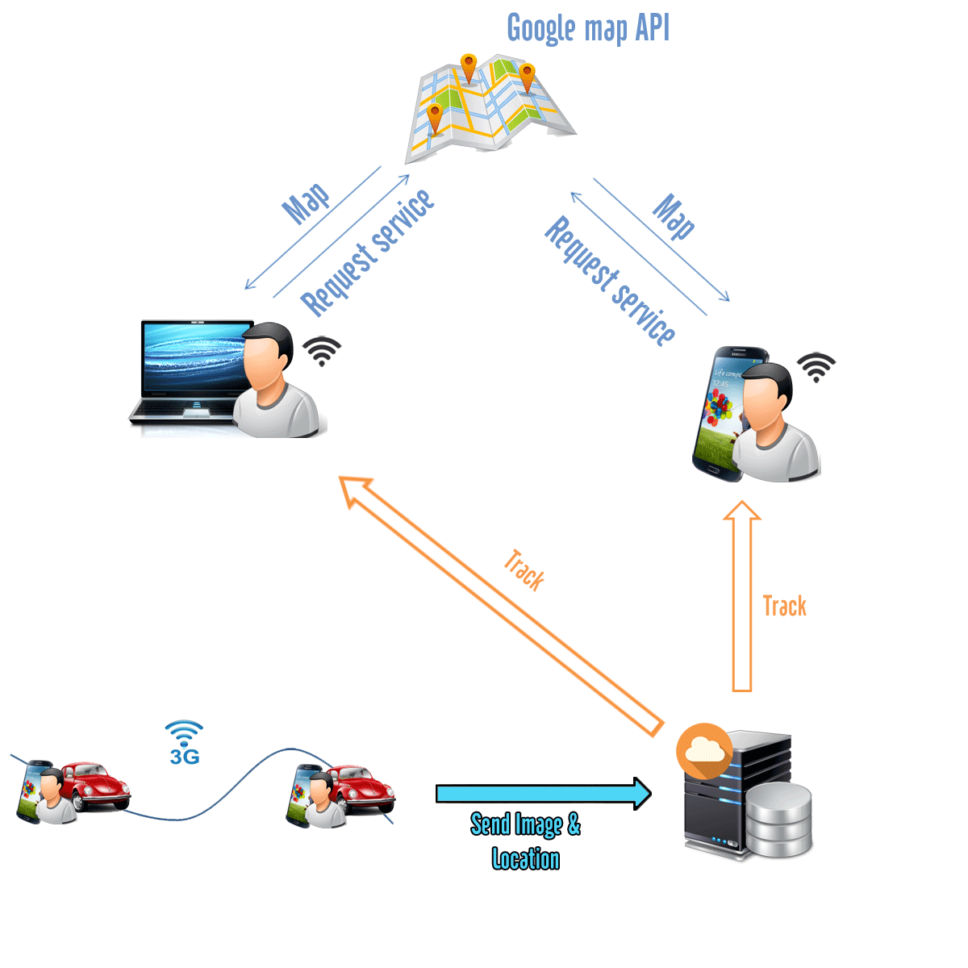

Figure 1: System operation

#### Boundaries of the System

This application will be developed from scratch, follow the process from getting requirement to designing, testing and deploying product.

The final outputs of this Capstone project include:

* Mobile application:
  + A mobile application running on Android OS platform
  + A camera module to manage taking picture
  + A GPS module to manage recording location coordinate
  + Upload management module for uploading data to server
* Web application:
  + A trajectory module for user to track their own trajectories as well as others trajectories
  + A friend module for user to manage their friends whom will be tracked by user
* Web service:
  + A service module (connector module) for managing interactions between Mobile application and database on server.

#### Development Environment

Below is the list of hardware and software requirements needed for the development environment of the project.

**Hardware requirements**

* Personal computers for developing with configuration: 2 Gb of RAM, 50Gb of hard drive, Core 2 Duo 2.0 Ghz;
* Cloud server with configuration: 4 Gb of RAM, 100Gb of hard drive, Core 2 Duo 2.0 Ghz;
* Smart mobile devices running on Android OS platform with configuration: 1Gb of RAM, 1GB of hard memory, CPU 1.0 Ghz;
* All computers must be connected to the internet
* Smart mobile devices must be connected to the internet via Wifi or 3G

**Software requirements**

* Operating system: Windows 7 or above;
* Web Server: IIS Express 8;
* Framework: .NET Framework 4.0;
* IDE: Visual Studio 2013;
* DBMS: SQL Server 2008 R2;
* Web Browser: Google Chrome 18, Firefox 20, Internet Explorer 9.0
* Source Control:
  + Google code with Tortoise SVN for managing source code;
  + Github for managing the deployment of source code to AppHabor cloud server;

## Project organization



### Software Process Model

We use waterfall software lifecycle model for development of this project. Below figure, we describe five main processes in our waterfall model. Moving to a new phase can only be done by finish previous phase. If we have problems at a phase then we have to move back to previous phase.

Requirement Specifications

Architecture Design and Detail Designs

Implementation and Unit Testing

Integration Testing and System Testing

Deployment and Maintenance

Figure 2: The waterfall software lifecycle model

### Roles and Responsibilities

|  |  |  |  |
| --- | --- | --- | --- |
| No | Full name | Role | Responsibilities |
| 1 | Phạm Công Thiện | Supervisor | * Give advice on business and technical problems; * Review and approve of project documents, project report and deliverables; * Keep track of progress; * Assess the performance of team. |
| 2 | Đặng Minh Khiêm | Team Leader,  Developer,  Tester | * Assign tasks to other members; * Monitor the development process, project progress and output of each phase; * Work on architecture design and detailed designs of mobile side and server side; * Implement; * Prepare documents; * Perform unit testing; * Deploy the final product. |
| 3 | Phạm Đình Năng | Developer, Designer | * Work on detailed designs of server side; * Design user interfaces for web application; * Implement; * Prepare documents; * Perform unit testing, system testing, and integration test. |
| 4 | Lý Khánh Duy Bảo | Developer, Designer | * Work on detailed designs of mobile side; * Design user interfaces for mobile application; * Implement; * Prepare documents; * Perform unit testing, system testing, and integration test. |
| 5 | Nguyễn Minh Toàn | Developer, Tester | * Create project management plan; * Work on detailed designs of server side; * Implement; * Prepare documents; * Perform unit testing, system testing, and integration test. |
| 6 | Nguyễn Kiều Thoa | Developer, Tester | * Manage Q&A list; * Work on detailed designs of server side; * Implement; * Prepare documents; * Perform unit testing, system testing, and integration test. |

### Tools

The following tools that are used in development environment include:

* *Developing tools:* Eclipse ADT, Microsoft Visual Studio 2013; Microsoft SQL Server 2008 R2
* *Modeling tools:* Microsoft Visio 2013, StarUML 5.0
* *Document tools:* Microsoft Office 2010

## Project management plan



### Tasks

Below is the sequence of task the will be performed during the development of this project.



#### Task 1: Initiating

|  |  |
| --- | --- |
| ***Task name*** | Initiating |
| ***Descriptions*** | Perform research on project domain, include existed mobile surveillance system, camera and GPS technology on Android OS, Cloud server. At the same time, investigate and decide which technology will be used in project. |
| ***Deliverables*** | Report 1 – Project Introduction |
| ***Resources needed*** | All team members; 6 days |
| ***Dependencies and constraints*** | N/A |
| ***Risks*** | Team members have very low background working in Mobile Programming, Web service. |

#### Task 2: Planning

|  |  |
| --- | --- |
| ***Task name*** | Planning |
| ***Descriptions*** | Create the project management plan; analyze the system into modules and assign tasks to each member. |
| ***Deliverables*** | Report 2 – Software Project Management Plan |
| ***Resources needed*** | All team members; 6 days |
| ***Dependencies and constraints*** | Task 1 has done |
| ***Risks*** | Too many tasks not to be planned |

#### Task 3: Specifying requirements

|  |  |
| --- | --- |
| ***Task name*** | Specifying requirements |
| ***Descriptions*** | Analyze system functions base on requirement, document detailed descriptions of all the functions which will be developed. |
| ***Deliverables*** | Report 3 – Software Requirement Specification |
| ***Resources needed*** | All team members; 12 days |
| ***Dependencies and constraints*** | Task 2 has finished |
| ***Risks*** | Too many require that related to several difference field |

#### Task 4: Designing database

|  |  |
| --- | --- |
| ***Task name*** | Designing database |
| ***Descriptions*** | Base on requirement analysis, database is designed in 2 steps: concept design, physical design. |
| ***Deliverables*** | ERD and the physical database |
| ***Resources needed*** | All team members; 4 days |
| ***Dependencies and constraints*** | Task 3 has finished |
| ***Risks*** | Some function could make change in database structure |

#### Task 5: Creating Software Design Description

|  |  |
| --- | --- |
| ***Task name*** | Creating Software Design Description |
| ***Descriptions*** | Base on analyzed function, we design architecture of the whole system, detail design for each module. Design user interface for user interaction with HTML5, CSS, Javascript on web application and activity layout for mobile application. |
| ***Deliverables*** | Report 4 – Software Design Description |
| ***Resources needed*** | All team members; 12 days |
| ***Dependencies and constraints*** | Task 4 has finished |
| ***Risks*** | Some functions could lead to a lot change in designing. Mobile programming is new technology for the team, so it is hard to design because of little understanding in mobile frameworks. |

#### Task 6: Implementing

|  |  |
| --- | --- |
| ***Task name*** | Implementing |
| ***Descriptions*** | Each team member implement all function that he or she was assigned; Code are regularly checked in Google code by Tortoise SVN and at the same time, do self-review and peer-review for member’s code matching initial design or not. |
| ***Deliverables*** | The implemented Mobile application and Website |
| ***Resources needed*** | All team members; 24 days |
| ***Dependencies and constraints*** | Task 5 has finished |
| ***Risks*** | Some function that take too many time to implemented |

#### Task 7: Performing Testing

|  |  |
| --- | --- |
| ***Task name*** | Performing Unit Testing |
| ***Descriptions*** | Create unit test case for all main functions; perform unit test base on designed test case; log all results; fix bugs |
| ***Deliverables*** | Report 5 – Software Test Documentation |
| ***Resources needed*** | All team members; 12 days |
| ***Dependencies and constraints*** | Task 6 has finished |
| ***Risks*** | Require a lot of effort to make intensive testing for each function as well as performance of the whole system. Unfamiliar with Japanese test report |

#### Task 8: Writing User’s Manual

|  |  |
| --- | --- |
| ***Task name*** | Writing User’s Manual |
| ***Descriptions*** | Writing a user’s manual to instruct the users to use Mobile application to make trajectory path, and website application to track trajectory paths. |
| ***Deliverables*** | Report 6 – User’s Manual |
| ***Resources needed*** | All team members; 6 days |
| ***Dependencies and constraints*** | Task 7 has finished |
| ***Risks*** | Writing user manual by Japanese could be a heavy work for the whole team because lacking of writing experience in real software document. |

#### Task 9: Deploying the Website

|  |  |
| --- | --- |
| ***Task name*** | Deploying the Website |
| ***Descriptions*** | Perform acceptance testing and deploy the Mobile application to Google Play as well as deploy Web application to AppHabor cloud server. |
| ***Deliverables*** | The completed Mobile application and Website |
| ***Resources needed*** | All team members; 2 days |
| ***Dependencies and constraints*** | Task 8 has finished |
| ***Risks*** | Deploying my take a lot of effort |



#### Task 10: Finalizing and Closing

|  |  |
| --- | --- |
| ***Task name*** | Finalizing and Closing |
| ***Descriptions*** | Prepare for presentation |
| ***Deliverables*** | Presentation slide |
| ***Resources needed*** | All team members; all days left |
| ***Dependencies and constraints*** | Task 9 has finished |
| ***Risks*** | Inexperience in making introduction project presentation |

### Task sheet

Refer to the next page for the detailed task sheet of the project plan.

|  |  |  |  |  |  |  |
| --- | --- | --- | --- | --- | --- | --- |
| No | Task Name | Duration | Start | Finish | Predecessors | Resource Names |
|  | **Initiating** | **6 days** | **Wed 1/1/14** | **Wed 1/8/14** |  |  |
| 001 | Start Project | 0 days |  |  |  |  |
| 002 | Identify key stakeholders | 1 day | Wed 1/1/14 | Wed 1/1/14 | 1 | BaoLKD,ToanNM |
| 003 | Research & discuss about business and technology for Web | 2 days | Sat 1/4/14 | Mon 1/6/14 | 2 | NangPD,ThoaNK,ToanNM |
| 004 | Research & discuss about business and technology for Device Platform | 2 days | Sat 1/4/14 | Mon 1/6/14 | 2 | BaoLKD,KhiemDM |
| 005 | Research on similar existing system | 1 day | Tue 1/7/14 | Tue 1/7/14 | 2 | KhiemDM,NangPD |
| 006 | Hold project kick-off meeting | 0.5 days | Wed 1/8/14 | Wed 1/8/14 | 3, 4, 5 | KhiemDM |
| 007 | Report 1 – Project Introduction | 0.5 days | Wed 1/8/14 | Wed 1/8/14 | 6 | KhiemDM |
|  | **Planning** | **5 days** | **Thu 1/9/14** | **Wed 1/15/14** |  |  |
| 008 | Hold team planning meeting | 0.5 days | Thu 1/9/14 | Thu 1/9/14 | 7 | KhiemDM |
| 009 | Prepare problem abstract, proposed solution, coding convention | 0.5 days | Thu 1/9/14 | Thu 1/9/14 | 8 | KhiemDM |
| 010 | Prepare major tasks for the whole team | 1 day | Fri 1/10/14 | Fri 1/10/14 | 8 | BaoLKD |
| 011 | Prepare management plan and determine task resources, durations, and dependencies | 1 day | Sat 1/11/14 | Sat 1/11/14 | 8 | KhiemDM |
| 012 | Configure Team Foundation Server | 1 day | Sun 1/12/14 | Sun 1/12/14 | 8 | KhiemDM |
| 013 | Configure Team Foundation Server (continue) | 1 day | Mon 1/13/14 | Mon 1/13/14 | 12 | KhiemDM |
| 014 | Report 2 – Project Management Plan | 1 day | Tue 1/14/14 | Tue 1/14/14 | 9, 10, 11, 13 | NangPD |
|  | **Specifying requirements** | **12 days** | **Wed 1/15/14** | **Thu 1/30/14** |  |  |
| 015 | Identify users and users’ requirements for Website | 1.5 days | Wed 1/15/14 | Thu 1/16/14 |  | ToanNM,NangPD,ThoaNK |
| 016 | Identify users and users’ requirements for Device Application | 1.5 days | Thu 1/16/14 | Fri 1/17/14 |  | BaoLKD,KhiemDM |
| 017 | Define system requirements | 1 day | Sat 1/18/14 | Sat 1/18/14 | 15, 16 | KhiemDM |
| 018 | Define non-functional requirements | 1 day | Sun 1/19/14 | Sun 1/19/14 | 15, 16 | BaoLKD |
| 019 | Determine main flows | 3 days | Mon 1/20/14 | Wed 1/22/14 | 17, 18 | NangPD,BaoLKD,KhiemDM |
| 020 | Specify functional requirements for Login, Register | 2 days | Wed 1/22/14 | Thu 1/23/14 | 17, 18 | ThoaNK |
| 021 | Specify functional requirements for Recover Password, Change Password | 2 days | Fri 1/24/14 | Mon 1/27/14 | 17, 18 | ThoaNK |
| 022 | Specify functional requirements for Search, Edit, Delete, View Trajectory | 2 days | Wed 1/22/14 | Thu 1/23/14 | 17, 18 | NangPD |
| 023 | Specify functional requirements for Remove Location, Remove Image | 3 days | Fri 1/24/14 | Tue 1/28/14 | 17, 18 | NangPD |
| 024 | Specify functional requirements for View Profile, Change Private Information | 1 day | Wed 1/22/14 | Wed 1/22/14 | 17, 18 | ToanNM |
| 025 | Specify functional requirements for View Friend, Search Friend | 1 day | Thu 1/23/14 | Thu 1/23/14 | 17, 18 | ToanNM |
| 026 | Specify functional requirements for Search All Users, Add Friend, Track User, Unfriend | 2 days | Fri 1/24/14 | Mon 1/27/14 | 17, 18 | ToanNM |
| 027 | Specify functional requirements for Manage Request Inbox | 1 day | Tue 1/28/14 | Tue 1/28/14 | 17, 18 | ToanNM |
| 028 | Specify functional requirements for Load Suggest Friend, List Mutual Friend | 2 days | Wed 1/29/14 | Thu 1/30/14 | 17, 18 | ToanNM |
| 029 | Specify Mobile functional requirements for Login, Register | 1 day | Wed 1/22/14 | Wed 1/22/14 | 17, 18 | KhiemDM |
| 030 | Specify Mobile functional requirements for Create, Delete, Update, Search Trajectory | 2 days | Thu 1/23/14 | Fri 1/24/14 | 17, 18 | KhiemDM |
| 031 | Specify Mobile functional requirements for View Trajectory, Track On Map | 1 day | Sat 1/25/14 | Sat 1/25/14 | 17, 18 | KhiemDM |
| 032 | Specify Mobile functional requirements for Upload Image | 1 day | Sun 1/26/14 | Sun 1/26/14 | 17, 18 | KhiemDM |
| 033 | Specify Mobile functional requirements for View Uploaded Image | 1 day | Mon 1/27/14 | Mon 1/27/14 | 17, 18 | KhiemDM |
| 034 | Specify Mobile functional requirements for Take Picture | 2 days | Wed 1/22/14 | Thu 1/23/14 | 17, 18 | BaoLKD |
| 035 | Specify Mobile functional requirements for View Friend | 2 days | Fri 1/24/14 | Mon 1/27/14 | 17, 18 | BaoLKD |
| 036 | Report 3 – Software Requirement Specification | 3 days | Tue 1/28/14 | Thu 1/30/14 | 19, 20, 21, 22, 23, 24, 25, 26, 27, 28, 29, 30, 31, 32, 33, 34, 35 | KhiemDM |
|  | **Designing database** | **4 days** | **Fri 1/31/14** | **Wed 2/5/14** |  |  |
| 037 | Discuss on conceptual data model | 0.5 days | Fri 1/31/14 | Fri 1/31/14 | 36 | BaoLKD,KhiemDM,NangPD,ToanNM |
| 038 | Creating ERD | 0.5 days | Sat 2/1/14 | Sat 2/1/14 | 37 | KhiemDM |
| 039 | Validate ERD against software requirements | 1 day | Sun 2/2/14 | Sun 2/2/14 | 38 | BaoLKD,NangPD,ThoaNK,ToanNM |
| 040 | Create logical model and physical database | 1 day | Mon 2/3/14 | Mon 2/3/14 | 37 | KhiemDM |
|  | **Creating Software Design Description** | **12 days** | **Wed 2/5/14** | **Thu 2/20/14** |  |  |
| 041 | Start Creating Design | 0 days |  |  |  |  |
| 042 | Discuss on system architecture | 0.5 days | Wed 2/5/14 | Wed 2/5/14 | 40 | BaoLKD,KhiemDM,NangPD |
| 043 | Configure development environment | 0.5 days | Thu 2/6/14 | Thu 2/6/14 | 41 | KhiemDM |
| 044 | Design for Login, Register | 1 day | Wed 2/5/14 | Wed 2/5/14 | 40 | ThoaNK |
| 045 | Design for Recover Password, Change Password | 1 day | Thu 2/6/14 | Thu 2/6/14 | 40 | ThoaNK |
| 046 | Design for Search, Edit, View Trajectory | 2 days | Wed 2/5/14 | Thu 2/6/14 | 40 | NangPD |
| 047 | Design for Remove Location, Remove Image | 3 days | Fri 2/7/14 | Tue 2/11/14 | 40 | NangPD |
| 048 | Design for View Profile, Change Private Information | 1 day | Wed 2/5/14 | Wed 2/5/14 | 40 | ToanNM |
| 049 | Design for View Friend, Search Friend | 1 day | Mon 1/6/14 | Mon 1/6/14 | 40 | ToanNM |
| 050 | Design for Search All Users, Add Friend, Track User, Unfriend | 2 days | Tue 1/7/14 | Wed 1/8/14 | 40 | ToanNM |
| 051 | Design for Manage Request Inbox | 0.5 days | Sun 2/9/14 | Sun 2/9/14 | 40 | ToanNM |
| 052 | Design for Load Suggest Friend, List Mutual Friend | 1.5 days | Sun 2/9/14 | Mon 2/10/14 | 40 | ToanNM |
| 053 | Design for Mobile App Create, Update Trajectory | 1 day | Wed 2/5/14 | Wed 2/5/14 | 40 | KhiemDM |
| 054 | Design for Mobile App View Trajectory, Track On Map | 2 days | Thu 2/6/14 | Fri 2/7/14 | 40 |  |
| 055 | Design for Mobile App Search Trajectory | 1 day | Sat 2/8/14 | Sat 2/8/14 | 40 | KhiemDM |
| 056 | Design for Mobile App Upload Image, View Uploaded Image | 1 day | Sun 2/9/14 | Sun 2/9/14 | 40 |  |
| 057 | Design for Mobile App Take Picture | 2 days | Wed 2/5/14 | Thu 2/6/14 | 40 | BaoLKD |
| 058 | Design for Mobile App View Friend | 2 days | Sat 2/8/14 | Mon 2/10/14 | 40 | BaoLKD |
| 059 | Design Web service modules | 1 days | Mon 2/10/14 | Tue 2/11/14 | 40 | KhiemDM |
| 060 | Report 4 – Software Design Description | 3 days | Wed 2/12/14 | Fri 2/14/14 | 44, 45, 46, 47, 48,49, 50, 51, 52, 53, 54, 55, 56, 57, 58, 59 | KhiemDM |
|  | **Implementing** | **24 days** | **Thu 2/20/14** | **Tue 3/25/14** |  |  |
| 061 | Starting Implementing | 0 days |  |  | 60 |  |
| 062 | Login, Logout | 2 days | Fri 2/21/14 | Mon 2/24/14 | 61 | ThoaNK |
| 063 | Register | 1 day | Tue 2/25/14 | Tue 2/25/14 | 61 | ThoaNK |
| 064 | Review for Login, Logout, Register | 1 day | Wed 2/26/14 | Wed 2/26/14 | 62, 63 | NangPD |
| 065 | Recover Password, Change Password | 3 days | Thu 2/27/14 | Mon 3/3/14 | 61 | ThoaNK |
| 066 | Review for Recover Password, Change Password | 0.5 days | Tue 3/4/14 | Tue 3/4/14 | 65 | ToanNM |
| 067 | View Trajectory | 2 days | Fri 2/21/14 | Mon 2/24/14 | 61 | NangPD |
| 068 | Search, Edit Trajectory | 2 days | Tue 2/25/14 | Wed 2/26/14 | 61 | NangPD |
| 069 | Review for View, Search, Edit Trajectory | 1 day | Thu 2/27/14 | Thu 2/27/14 | 67, 68 | ToanNM |
| 070 | Remove Location | 2 days | Fri 2/28/14 | Mon 3/3/14 | 61 | NangPD |
| 071 | Remove Image | 2 days | Tue 3/4/14 | Wed 3/5/14 | 61 | NangPD |
| 072 | Review for Remove Location, Image | 1 day | Thu 3/6/14 | Thu 3/6/14 | 70, 71 | ThoaNK |
| 073 | View Profile, Change Private Information | 1 day | Fri 2/21/14 | Fri 2/21/14 | 61 | ToanNM |
| 074 | Review for View Profile, Change Private Information | 1 day | Sat 2/22/14 | Sat 2/22/14 | 73 | ThoaNK |
| 075 | View Friend, Search Friend | 1 day | Sun 2/23/14 | Sun 2/23/14 | 61 | ToanNM |
| 076 | Review for View Friend, Search Friend | 2 days | Tue 2/25/14 | Wed 2/26/14 | 75 | NangPD |
| 077 | Search All Users | 2 days | Thu 2/27/14 | Fri 2/28/14 | 61 | ToanNM |
| 078 | Add Friend, Track User, Unfriend | 2 days | Sat 3/1/14 | Mon 3/3/14 | 61 | ToanNM |
| 079 | Review for Search All User | 3 days | Tue 3/4/14 | Thu 3/6/14 | 77 | NangPD |
| 080 | Manage Request Inbox | 2 days | Fri 3/7/14 | Mon 3/10/14 | 61 | ToanNM |
| 081 | Review for Inbox | 1 day | Tue 3/11/14 | Tue 3/11/14 | 80 | ThoaNK |
| 082 | Load Suggest Friend | 2 days | Wed 3/12/14 | Thu 3/13/14 | 61 | ToanNM |
| 083 | List Mutual Friend | 1 day | Fri 3/14/14 | Fri 3/14/14 | 61 | ToanNM |
| 084 | Review for Suggest Friend | 2 days | Sat 3/15/14 | Mon 3/17/14 | 82 | NangPD |
| 085 | Mobile App Create, Update Trajectory | 2 days | Fri 2/21/14 | Mon 2/24/14 | 61 | KhiemDM |
| 086 | Review for Create, Update Trajectory | 1 day | Tue 2/25/14 | Tue 2/25/14 | 85 | BaoLKD |
| 087 | Mobile App View Trajectory | 1 day | Wed 2/26/14 | Wed 2/26/14 | 61 | KhiemDM |
| 088 | Mobile App Track On Map | 1 day | Thu 2/27/14 | Thu 2/27/14 | 61 | KhiemDM |
| 089 | Review for View Trajectory, Track map | 1 day | Fri 2/28/14 | Fri 2/28/14 | 87, 88 | BaoLKD |
| 090 | Mobile App Search Trajectory | 2 days | Sat 3/1/14 | Mon 3/3/14 | 61 | KhiemDM |
| 091 | Review for Search Trajectory | 1 day | Tue 3/4/14 | Tue 3/4/14 | 80 | BaoLKD |
| 092 | Mobile App Upload Image | 2 days | Wed 3/5/14 | Thu 3/6/14 | 61 | KhiemDM |
| 093 | Mobile App View Uploaded Image | 1 day | Fri 3/7/14 | Fri 3/7/14 | 61 | KhiemDM |
| 094 | Web service Create, Delete, Update, Load Trajectory | 1 day | Sat 3/8/14 | Sat 3/8/14 | 61 | KhiemDM |
| 095 | Web service Upload Images | 1 day | Mon 3/10/14 | Mon 3/10/14 | 61 | KhiemDM |
| 096 | Web service Load Friend, Images, Location | 1 day | Tue 3/11/14 | Tue 3/11/14 | 61 | KhiemDM |
| 097 | Review for Web service | 1 day | Wed 3/12/14 | Wed 3/12/14 | 94, 95, 96 | BaoLKD |
| 098 | Mobile App Take Picture | 3 day | Sat 3/8/14 | Sat 3/8/14 | 61 | BaoLKD |
| 099 | Mobile App Take Picture (Continue) | 3 days | Fri 2/21/14 | Mon 2/24/14 | 98 | BaoLKD |
| 100 | Review for Take Picture | 1 day | Wed 3/5/14 | Wed 3/5/14 | 99 | NangPD |
| 101 | Mobile App View Friend | 1 days | Mon 2/24/14 | Wed 2/26/14 | 61 | BaoLKD |
| 102 | Review for View Friend | 1 day | Thu 2/27/14 | Thu 2/27/14 | 101 | ThoaNK |
| 103 |  |  |  |  |  |  |
|  | **Performing Testing** | **12 days** | **Wed 3/26/14** | **Thu 4/10/14** |  |  |
| 104 | Start Testing | 0 days |  |  |  |  |
| 105 | Write appropriate unit test cases for the functions each member implemented in Web | 3 days | Wed 3/26/14 | Fri 3/28/14 | 104 | NangPD,ThoaNK,ToanNM |
| 106 | Write appropriate unit test cases for the functions each member implemented on Device |  |  |  | 104 | KhiemDM,BaoLKD |
| 107 | Perform unit testing and record the results (Automation Test) | 2 days | Sat 3/29/14 | Mon 3/31/14 | 105, 106 | ToanNM |
| 108 | Fix the bugs discovered during unit testing | 3 days | Tue 4/1/14 | Thu 4/3/14 | 107 | NangPD,ToanNM |
| 109 | Complete code review checklists | 1 day | Fri 4/4/14 | Fri 4/4/14 | 64, 66, 69, 72, 74, 76, 79, 81, 84, 86, 89, 91, 97, 100, 102 | ThoaNK |
| 110 | Report 5 – Software Test Documentation | 1 day | Sat 4/5/14 | Sat 4/5/14 | 107, 108, 109 | ThoaNK |
| 111 | Perform integration test and fix the bugs discovered | 2 days | Sun 4/6/14 | Mon 4/7/14 | 110 | BaoLKD |
|  | **Writing Users’ Manual** | **6 days** | **Fri 4/11/14** | **Fri 4/18/14** |  |  |
| 112 | Write users’ manual for all the functions that each member implemented | 4 days | Fri 4/11/14 | Wed 4/16/14 | 109 | KhiemDM |
| 113 | Check if the users’ manual and software requirements are consistent | 2 days | Thu 4/17/14 | Fri 4/18/14 | 112 | ThoaNK |
|  | **Deploying the Website and Device Application** | **6 days** | **Sat 4/19/14** | **Fri 4/25/14** |  |  |
| 114 | Add more data to the database | 2 days | Sat 4/19/14 | Mon 4/21/14 | 109 | KhiemDM,BaoLKD,NangPD,ToanNM |
| 115 | Deploy the website the a real host | 1 day | Tue 4/22/14 | Tue 4/22/14 | 114 | ThoaNK,NangPD,ToanNM |
| 116 | Deploy the application for device | 1 day | Tue 4/22/14 | Tue 4/22/14 | 109 | KhiemDM,BaoLKD |
| 117 | Test the website on the real host | 3 days | Wed 4/23/14 | Fri 4/25/14 | 115 | ThoaNK,NangPD,ToanNM |
| 118 | Test the application on the real host | 3 days | Wed 4/23/14 | Fri 4/25/14 | 116 | KhiemDM,BaoLKD |
|  | **Finalizing and closing** | **6 days** | **Sat 4/26/14** | **Fri 5/2/14** |  |  |
| 119 | Prepare final project report | 3 days | Sat 4/26/14 | Tue 4/29/14 |  | KhiemDM,BaoLKD |
| 120 | Prepare final project presentation | 2 days | Wed 4/30/14 | Thu 5/1/14 |  | Team,NangPD,ToanNM |
| 121 | Submit Project for Council | 0 days |  |  |  |  |
| 122 | Final team meeting | 1 day | Fri 5/2/14 | Fri 5/2/14 |  | KhiemDM |
| 123 | Close the project | 0 days | Fri 5/2/14 | Fri 5/2/14 |  | KhiemDM |

## Coding Convention

Implementation of the system must follow coding convention of C# language recommended by Microsoft at <http://msdn.microsoft.com/en-us/library/ff926074.aspx> and Java language recommended by Oracle at <http://www.oracle.com/technetwork/java/codeconv-138413.html>.



# Report No.3 Software System Design (SRS)



## User Requirement Specification

The system should allow 2 types of actors, namely Guest and User. Each of these types of user is granted a set of functions as specified below.



### Guest Requirements

A guest is an unauthenticated user of the website. He or she can:

* Log in with his authorized account.
* Register a new account.
* Request the system to reset password to his/her email if he/she forget the password.

### User Requirements

A user is an authenticated one (e.g., a guest who logged on to the system with a valid username and password).

If using Web Application, they can:

* Manage their account (Change password, Change private information)
* Manage their own Trajectories (Search, Edit, Remove, Tracking On Map)
* Manage their own Friend List (Search Friend, Make/Accept Friend Request, Unfriend)
* Manage their Inbox (Accept or Deny Friend Request)
* View Friend’s Trajectories
* Log out

If using Mobile Application, they can:

* Manage their own Trajectories (Search, Create, Edit, Remove, Tracking On Map)
* Manage their own Friend List (Search Friend)
* View Friend’s Trajectories
* Take Picture (Manual taking picture and Auto taking picture)
* Upload images
* Review uploaded images



## System Requirement Specification



### External Interface Requirements



#### User Interfaces

The website and application should adopt an attractive and user-friendly interface so that the users of the system can get a good experience browsing the site.

The pages should be well linked together to promote seamless navigation between them. The instructions should be specific and suggestive, so that the users will not be confused about what to do next.

#### Hardware Interfaces

The system can be reached by personal computers that support Internet connection and Web browsers (if using Web Application) or Mobile Surveillance Application (if using Mobile Application). In order to get the best experience, the following conditions should be satisfied:

* 512 kbps Internet connection or faster;

#### Software Interfaces

The software listed below is needed for the system to operate normally:

**For Desktop:**

|  |  |
| --- | --- |
| **Software Name** | **Provider** |
| At least one of the following web browsers:   * Internet Explorer 8–10 inclusive (Windows) * Current or previous version of Chrome (Windows, Mac OS X, Linux) * Current or previous version of Firefox (Windows, Mac OS X, Linux) * Current or previous version of Safari (Mac OS X) | Microsoft  Google  Mozilla  Apple |

**For Android:**

Mobile device with Android OS 4.0+

Mobile Surveillance Application installed

**For Server:**

|  |  |
| --- | --- |
| **Software Name** | **Provider** |
| Microsoft SQL Server 2008 R2 or more | Microsoft |
| Microsoft .NET Framework version 4.0+ | Microsoft |

### Main flow overviews

Main flow of this system is Remote Tracking. The flow contains the followings steps:

1. The first user create a trajectory and then captures some pictures and record location coordinate which belong to this trajectory by mobile device and uploads it to server.
2. The second user (is a friend of the first user on system) use web browser or Mobile Surveillance application to track.
3. There are some markers on map, each marker stand for one location of one or more images when it’s captured. If user clicks on one marker, it shows all images that belong to this marker.

### Functional Requirement



#### Overall Web Application System Use Case Diagram

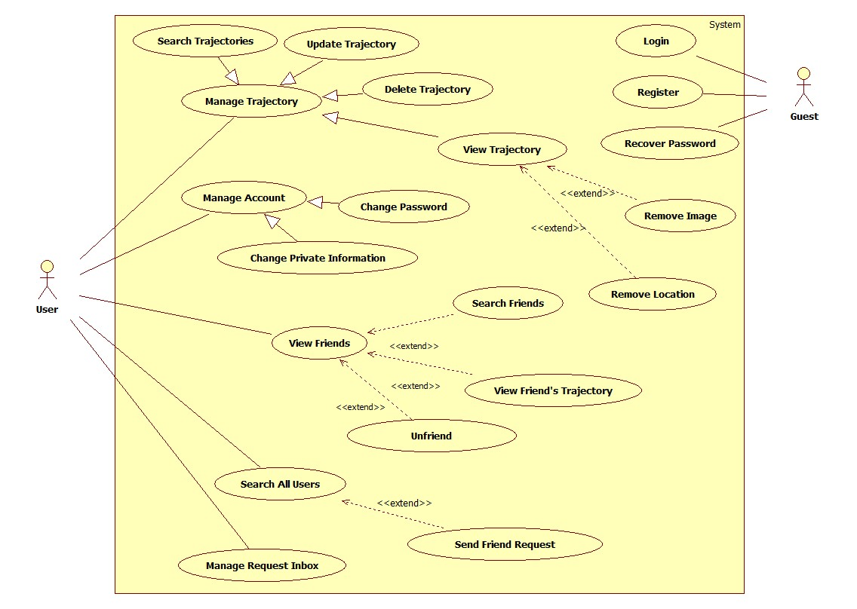

Diagram 1: Use Case diagram: Web Application System

#### Overall Mobile Application Use Case Diagram

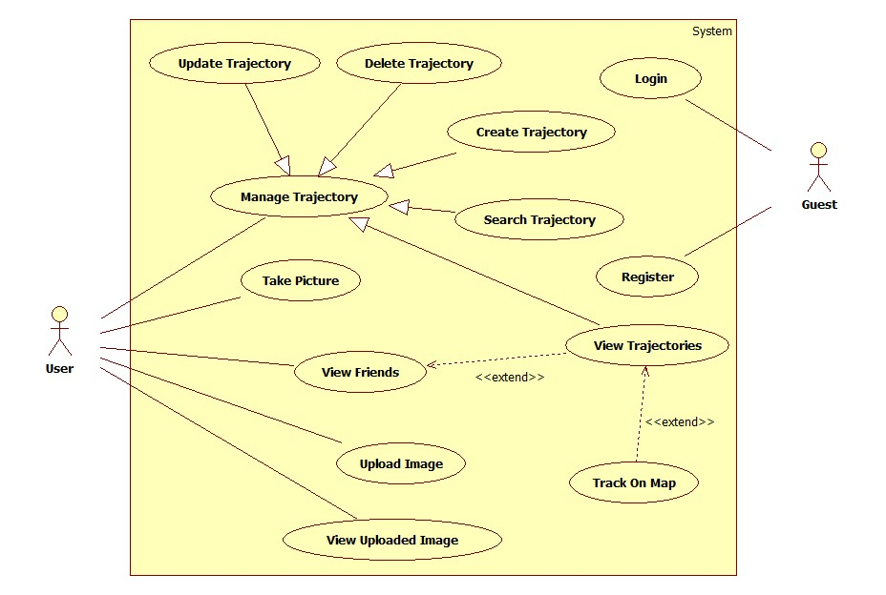

Diagram 2: Use Case diagram: Mobile Application System

Note that only important and business-related use cases are described in details in the section below.

#### Web Application System

##### Login

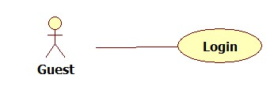

|  |  |  |  |  |
| --- | --- | --- | --- | --- |
| **LOGIN – SPECIFICATION** | | | | |
| **Use-case No.** | UCW001 | **Use-case Version** | | 1.0 |
| **Use-case Name** | Login | | | |
| **Author** | Nguyễn Kiều Thoa | | | |
| **Date** | 21/01/2014 | **Priority** | Low | |
| **Actor:** Guest  **Summary:** This use case allows a user to login to the system in order to user other function..  **Triggers:** User open Mobile Surveillance Application  **Preconditions:** Login page is loaded  **Post Conditions:**  *On success:* User will receive welcome message and be redirected to Trajectories page.  *On failure:* An error message is displayed. User will be redirect to login page to re-enter user name and password.  **Main Success Scenario:**   |  |  |  | | --- | --- | --- | | **Step** | **User Action** | **System Response** | | 1 | Enter valid username, password |  | | 2 | Press Login | Redirect to user’s Trajectories page |   **Alternative Scenario:** N/A  **Exceptions:** N/A  **Business Rules:** N/A | | | | |

##### Register

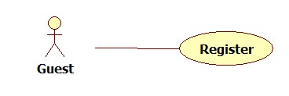

|  |  |  |  |  |
| --- | --- | --- | --- | --- |
| **REGISTER – SPECIFICATION** | | | | |
| **Use-case No.** | UCW002 | **Use-case Version** | | 1.0 |
| **Use-case Name** | Register | | | |
| **Author** | Nguyễn Kiều Thoa | | | |
| **Date** | 21/01/2014 | **Priority** | Low | |
| **Actor:** Guest  **Summary:** This use case allows user register a new account on the system.  **Triggers:** The user clicks on the button “Register” on the Login page.  **Preconditions:** The Register page is loaded  **Post Conditions:**  *On success:* Successful message displayed. Redirect user to login page with registered username.  *On failure:* An error message is displayed. User will be asked to re-enter information  **Main Success Scenario:**   |  |  |  | | --- | --- | --- | | **Step** | **User Action** | **System Response** | | 1 | Enter old password, new password and confirm new password is the same, press submit | Change user password into the new password, redirect to the login page, user must login again |   **Alternative Scenario:** N/A  **Exceptions:**   |  |  |  | | --- | --- | --- | | **No** | **User Action** | **System Response** | | 1 | Enter new password is less than 6 characters | Show an error message, said that new password must be at least 6 characters |   **Business Rules:** N/A | | | | |

##### Recover Password

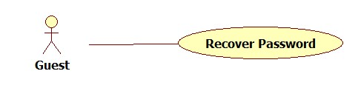

|  |  |  |  |  |
| --- | --- | --- | --- | --- |
| **RECOVER PASSWORD – SPECIFICATION** | | | | |
| **Use-case No.** | UCW003 | **Use-case Version** | | 1.0 |
| **Use-case Name** | Recover Password | | | |
| **Author** | Nguyễn Kiều Thoa | | | |
| **Date** | 22/01/2014 | **Priority** | Low | |
| **Actor:** Guest  **Summary:** This use case allows a user get back their lost password.  **Triggers:** The user clicks on the button “Forgot Password” on the login page.  **Preconditions:** The login page is being displayed.  **Post Conditions:**  *On success:* An email contain a key for user to change their new password.  *On failure:* An error message is displayed. The content of the error message will be specified in the Exception Scenario section based on the type of failure.  **Main Success Scenario:**   |  |  |  | | --- | --- | --- | | **Step** | **User Action** | **System Response** | | 1. | User press on the “Forgot Password”, enter the registered email and press submit | System send the key to the email | | 2 | User enter the key, new password and confirm new password | System change the user password to new password |   **Alternative Scenario:** N/A  **Exceptions:** N/A  **Relationships:** N/A  **Business Rules:** N/A | | | | |

##### Change Password

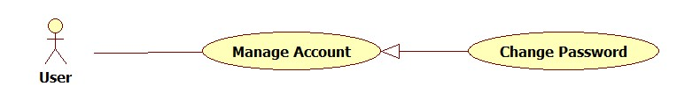

|  |  |  |  |  |
| --- | --- | --- | --- | --- |
| **CHANGE PASSWORD – SPECIFICATION** | | | | |
| **Use-case No.** | UCW005 | **Use-case Version** | | 1.0 |
| **Use-case Name** | Change Password | | | |
| **Author** | Nguyễn Kiều Thoa | | | |
| **Date** | 22/01/2014 | **Priority** | Low | |
| **Actor:** User  **Summary:** Allow user to change their password  **Triggers:** The user clicks on the button “Change Password” on menu bar  **Preconditions:** N/A  **Post Conditions:**  *On success:* Reload the Trajectories page with new information  *On failure:* An error message is displayed. User will be asked to re-enter password  **Main Success Scenario:**   |  |  |  | | --- | --- | --- | | **Step** | **User Action** | **System Response** | | 1. | User enter valid information and press enter | Update user’s information, reload the Trajectories page |   **Alternative Scenario:** N/A  **Exceptions:**   |  |  |  | | --- | --- | --- | | **No** | **User Action** | **System Response** | | 1. | User enter new full name less than 6 characters | Notify user that full name must more than 6 characters | | 2 | User enter not valid birthdate | Notify user that birthdate must between 01/01/1930 and 31/12/2014 |   **Business Rules:** N/A | | | | |

##### Change Private Information

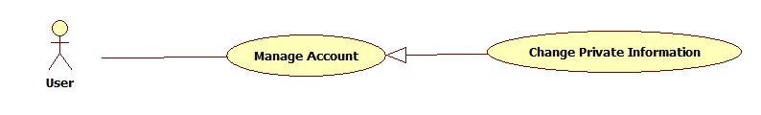

|  |  |  |  |  |
| --- | --- | --- | --- | --- |
| **CHANGE PRIVATE INFORMATION – SPECIFICATION** | | | | |
| **Use-case No.** | UCW005 | **Use-case Version** | | 1.0 |
| **Use-case Name** | Change Private Information | | | |
| **Author** | Nguyễn Minh Toàn | | | |
| **Date** | 22/01/2014 | **Priority** | Medium | |
| **Actor:** User  **Summary:** This use case allows a User to change their profile information.  **Triggers:** The user clicks on the button “Profile Setting” on the Trajectories page.  **Preconditions:** The profile information page is being displayed with old information.  **Post Conditions:**  *On success:* Reload the Trajectories page with new information  *On failure:* An error message will be displayed base on the type of failure.  **Main Success Scenario:**   |  |  |  | | --- | --- | --- | | **Step** | **User Action** | **System Response** | | 1. | User enter valid information and press enter | Update user’s information, reload the Trajectories page |   **Alternative Scenario:** N/A  **Exceptions:**   |  |  |  | | --- | --- | --- | | **No** | **User Action** | **System Response** | | 1. | User enter new full name less than 6 characters | Notify user that full name must more than 6 characters | | 2 | User enter not valid birthdate | Notify user that birthdate must between 01/01/1930 and 31/12/2014 |   **Business Rules:** N/A | | | | |

##### Search Trajectories

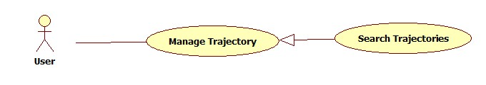

|  |  |  |  |  |
| --- | --- | --- | --- | --- |
| **SEARCH TRAJECTORIES – SPECIFICATION** | | | | |
| **Use-case No.** | UCW006 | **Use-case Version** | | 1.0 |
| **Use-case Name** | Search Trajectories | | | |
| **Author** | Phạm Đình Năng | | | |
| **Date** | 22/01/2014 | **Priority** | Medium | |
| **Actor:** User  **Summary:** Allows a user to search their trajectories  **Triggers:** The user enter the criteria and clicks on the button “Search Trajectory”  **Preconditions:** The Trajectories page or the search page is being displayed.  **Post Conditions:**  *On success:* A list of matched trajectory is displayed to the user.  *On failure:* Notify user the error  **Main Success Scenario:**   |  |  |  | | --- | --- | --- | | **Step** | **User Action** | **System Response** | | 1. | User enter the criteria and clicks on button “Search Trajectory” | Show all trajectories that match the criteria |   **Alternative Scenario:**   |  |  |  | | --- | --- | --- | | **No** | **User Action** | **System Response** | | 1. | User do not enter anything and clicks on button “Search Trajectories” | Show all trajectories of that person |   **Exceptions:** N/A  **Business Rules:** N/A | | | | |

##### Update Trajectory

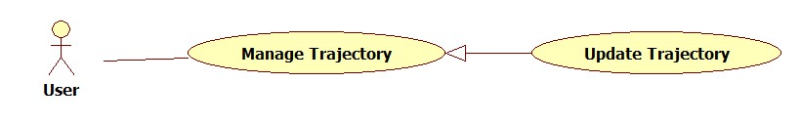

|  |  |  |  |  |
| --- | --- | --- | --- | --- |
| **EDIT TRAJECTORY – SPECIFICATION** | | | | |
| **Use-case No.** | UCW007 | **Use-case Version** | | 1.0 |
| **Use-case Name** | Edit Trajectory | | | |
| **Author** | Phạm Đình Năng | | | |
| **Date** | 22/01/2014 | **Priority** | Medium | |
| **Actor:** User  **Summary:** Allows a user to edit their trajectory.  **Triggers:** The user clicks on the button “Edit Trajectories” on the search result page.  **Preconditions:** The Trajectories page is being displayed.  **Post Conditions:** Success message is display, return to the Trajectories  **Main Success Scenario:**   |  |  |  | | --- | --- | --- | | **Step** | **User Action** | **System Response** | | 1. | User enter valid information and press “Submit” | Update trajectory’s information and reload Trajectories page |   **Alternative Scenario:** N/A  **Exceptions:** N/A  **Business Rules:** N/A | | | | |

##### Delete Trajectory

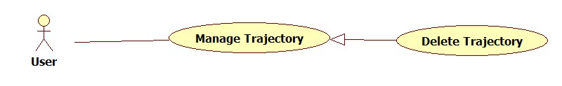

|  |  |  |  |  |
| --- | --- | --- | --- | --- |
| **DELETE TRAJECTORY – SPECIFICATION** | | | | |
| **Use-case No.** | UCW008 | **Use-case Version** | | 1.0 |
| **Use-case Name** | Delete Trajectory | | | |
| **Author** | Phạm Đình Năng | | | |
| **Date** | 22/01/2014 | **Priority** | Medium | |
| **Actor:** User  **Summary:** Allow user to delete their trajectory.  **Triggers:** The user clicks on button “Delete Trajectory” of one trajectory on Trajectories page  **Preconditions:** The search result page or trajectory information page is being displayed.  **Post Conditions:** Success message is display, reload the Trajectories page  **Main Success Scenario:**   |  |  |  | | --- | --- | --- | | **Step** | **User Action** | **System Response** | | 1. | Click on button “Delete Trajectory” of one trajectory | Show the message ask user that are they sure | | 2 | Chose Yes | Reload Trajectories page with this trajectory is disappear |   **Alternative Scenario:** N/A  **Exceptions:** N/A  **Business Rules:**   |  |  | | --- | --- | | **No** | **Business Rule Description** | | 1 | After one trajectory is removed, all locaions and images that belong to that trajectory will be removed too. | | | | | |

##### View Trajectory

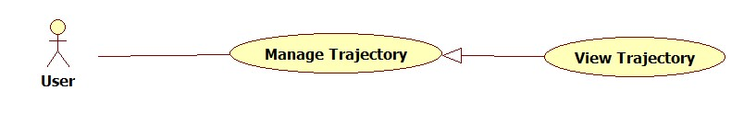

|  |  |  |  |  |
| --- | --- | --- | --- | --- |
| **VIEW TRAJECTORY – SPECIFICATION** | | | | |
| **Use-case No.** | UCW009 | **Use-case Version** | | 1.0 |
| **Use-case Name** | View Trajectory | | | |
| **Author** | Phạm Đình Năng | | | |
| **Date** | 22/01/2014 | **Priority** | Medium | |
| **Actor:** User  **Summary:** Allow user to view their trajectory detail  **Triggers:** The user clicks on one trajectory in Trajectories page  **Preconditions:** The Trajectories page is being displayed.  **Post Conditions:** Show a map of that trajectory and it’s information  **Main Success Scenario:**   |  |  |  | | --- | --- | --- | | **Step** | **User Action** | **System Response** | | 1 | Click on one trajectory that store some images in Trajectories page | Show a map of that trajectory with some marker and it’s information | | 2 | Click on one marker on map | Show all image that belong to that marker |   **Alternative Scenario:**   |  |  |  | | --- | --- | --- | | **No** | **User Action** | **System Response** | | 1 | Click on one trajectory that store no image | Show a map of that trajectory with no marker and it’s information |   **Exceptions:** N/A  **Business Rules:**   |  |  | | --- | --- | | **No** | **Business Rule Description** | | 1 | Each marker on map is one location that has one or some captured images.  If user capture many images that near each other, just show that images on one marker | | | | | |

##### Remove Location

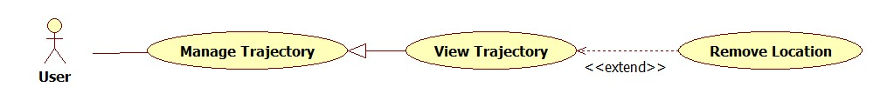

|  |  |  |  |  |
| --- | --- | --- | --- | --- |
| **REMOVE LOCATION – SPECIFICATION** | | | | |
| **Use-case No.** | UCW010 | **Use-case Version** | | 1.0 |
| **Use-case Name** | Remove Location | | | |
| **Author** | Phạm Đình Năng | | | |
| **Date** | 22/01/2014 | **Priority** | Medium | |
| **Actor:** User  **Summary:** Allow user to remove an location and it’s images  **Triggers:** The user clicks on button “Remove Location” on Manage Location Image page  **Preconditions:** The Manage Location Image page is displaying  **Post Conditions:** Redirect to View Trajectory page with a map that this location has been removed  **Main Success Scenario:**   |  |  |  | | --- | --- | --- | | **Step** | **User Action** | **System Response** | | 1. | Click on button “Manage” of one location on list of location on Trajectory page | Show all information of that location and it’s images | | 2 | Click on button “Remove Location” | Show message ask user that are they sure? | | 3 | Chose Yes | Redirect to View Trajectory page with a map that this location has been removed |   **Alternative Scenario:** N/A  **Exceptions:** N/A  **Business Rules:**   |  |  | | --- | --- | | **No** | **Business Rule Description** | | 1 | After one location has been removed, all images that belong to that location will be removed too. | | | | | |

##### Remove Image

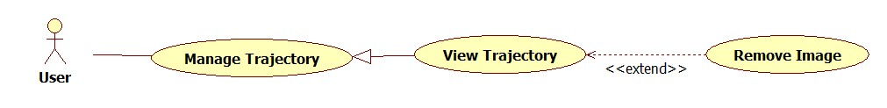

|  |  |  |  |  |
| --- | --- | --- | --- | --- |
| **REMOVE IMAGE – SPECIFICATION** | | | | |
| **Use-case No.** | UCW011 | **Use-case Version** | | 1.0 |
| **Use-case Name** | Remove Image | | | |
| **Author** | Phạm Đình Năng | | | |
| **Date** | 22/01/2014 | **Priority** | Medium | |
| **Actor:** User  **Summary:** Allow user to remove an image  **Triggers:** The user clicks on button “Remove Image” on Manage Location Image page  **Preconditions:** The Manage Location Image page is displaying  **Post Conditions:** Redirect to View Trajectory page with a map that this location has been removed  **Main Success Scenario:**   |  |  |  | | --- | --- | --- | | **Step** | **User Action** | **System Response** | | 1. | Click on button “Manage” of one location on list of location on Trajectory page | Show all information of that location and it’s images | | 2 | Click on button “Remove Image” of one image | Show message ask user that are they sure? | | 3 | Chose Yes | Reload the Manage Location Image page with this image is disappear |   **Alternative Scenario:** N/A  **Exceptions:** N/A  **Business Rules:**   |  |  | | --- | --- | | **No** | **Business Rule Description** | | 1 | After remove one image, if this location is store no image left, remove this location too. | | | | | |

##### View Friends

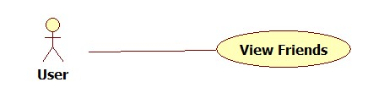

|  |  |  |  |  |
| --- | --- | --- | --- | --- |
| **VIEW FRIENDS – SPECIFICATION** | | | | |
| **Use-case No.** | UCW012 | **Use-case Version** | | 1.0 |
| **Use-case Name** | View Friends | | | |
| **Author** | Nguyễn Minh Toàn | | | |
| **Date** | 22/01/2014 | **Priority** | Medium | |
| **Actor:** User  **Summary:** This use case allows a logged in user view all friend of them.  **Triggers:** The user clicks on the button “Friends” on menu bar  **Preconditions:** User has logged in  **Post Conditions:** A list of all their friends of the user is display  **Main Success Scenario:**   |  |  |  | | --- | --- | --- | | **Step** | **User Action** | **System Response** | | 1. | Click on “Friends” button on menu bar | Show all friends of that user | | 2 | Click on one friend in the result page | Redirect to User Detail page with this friend information |   **Alternative Scenario:** N/A  **Exceptions:** N/A  **Business Rules:** N/A | | | | |

##### Search Friends

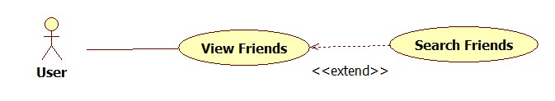

|  |  |  |  |  |
| --- | --- | --- | --- | --- |
| **SEARCH FRIENDS – SPECIFICATION** | | | | |
| **Use-case No.** | UCW013 | **Use-case Version** | | 1.0 |
| **Use-case Name** | Search Friends | | | |
| **Author** | Nguyễn Minh Toàn | | | |
| **Date** | 22/01/2014 | **Priority** | Medium | |
| **Actor:** User  **Summary:** Allow user to search a friend in their friend list  **Triggers:** Enter some criteria in search text field on menu bar and press enter  **Preconditions:** User has logged in  **Post Conditions:** Show all friend that has username or full name that match the criteria  **Main Success Scenario:**   |  |  |  | | --- | --- | --- | | **Step** | **User Action** | **System Response** | | 1 | Enter some criteria in “Search Friend” text field and press enter | Show all friend that’s username or full name that match the criteria | | 2 | Click on one friend | Show this friend’s information, their public trajectories and “Unfriend” button |   **Alternative Scenario:** N/A  **Exceptions:** N/A  **Business Rules:** N/A | | | | |

##### Unfriend

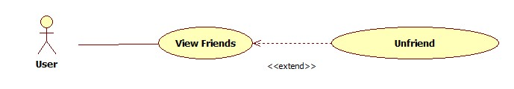

|  |  |  |  |  |
| --- | --- | --- | --- | --- |
| **UNFRIEND – SPECIFICATION** | | | | |
| **Use-case No.** | UCW014 | **Use-case Version** | | 1.0 |
| **Use-case Name** | Unfriend | | | |
| **Author** | Nguyễn Minh Toàn | | | |
| **Date** | 22/01/2014 | **Priority** | Medium | |
| **Actor:** User  **Summary:** Allow user to unfriend a friend in their friend list.  **Triggers:** User click on “Unfriend” button  **Preconditions:** This person must be friend with the current user  **Post Conditions:** This friend is removed in the user friend list  **Main Success Scenario:**   |  |  |  | | --- | --- | --- | | **Step** | **User Action** | **System Response** | | 1. | Click on “Unfriend” button on User Detail page | Ask user that are they sure | | 2 | Chose Yes | Remove this friend in friend list |   **Alternative Scenario:** N/A  **Exceptions:** N/A  **Business Rules:** N/A | | | | |

##### View Friend’s Trajectory

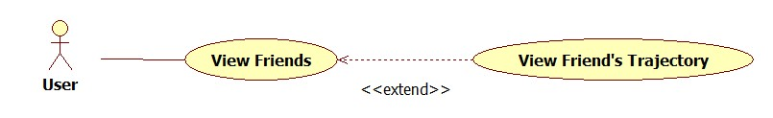

|  |  |  |  |  |
| --- | --- | --- | --- | --- |
| **VIEW TRAJECTORY – SPECIFICATION** | | | | |
| **Use-case No.** | UCW015 | **Use-case Version** | | 1.0 |
| **Use-case Name** | View Friend’s Trajectory | | | |
| **Author** | Nguyễn Minh Toàn | | | |
| **Date** | 22/01/2014 | **Priority** | Medium | |
| **Actor:** User  **Summary:** Allow user to view their friend trajectory  **Triggers:** User click on “Track User” button of one friend  **Preconditions:** This user must in the current user friend list  **Post Conditions:** Show this friend trajectories  **Main Success Scenario:**   |  |  |  | | --- | --- | --- | | **Step** | **User Action** | **System Response** | | 1 | Click on “Track User” button of one friend on User Detail page | Show all trajectory that is set to public of this friend | | 2 | Click on one trajectory that store some images in Trajectories page | Show a map of that trajectory with some marker and it’s information | | 3 | Click on one marker on map | Show all image that belong to that marker |   **Alternative Scenario:**   |  |  |  | | --- | --- | --- | | **No** | **User Action** | **System Response** | | 1 | Click on “Track User” button of one friend on View Friend page | Show all trajectory that is set to public of this friend | | 2 | Click on one trajectory that store no image | Show a map of that trajectory with no marker and it’s information |   **Exceptions:** N/A  **Business Rules:**   |  |  | | --- | --- | | **No** | **Business Rule Description** | | 1 | Show only public trajectories, not show private trajectories | | | | | |

##### Search All Users

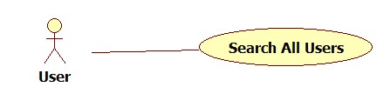

|  |  |  |  |  |
| --- | --- | --- | --- | --- |
| **SEARCH ALL USER – SPECIFICATION** | | | | |
| **Use-case No.** | UCW016 | **Use-case Version** | | 1.0 |
| **Use-case Name** | Search All User | | | |
| **Author** | Nguyễn Minh Toàn | | | |
| **Date** | 22/01/2014 | **Priority** | Medium | |
| **Actor:** User  **Summary:** Allow user to search all user on system  **Triggers:** Enter some criteria in search text field on menu bar and press enter  **Preconditions:** User has logged in  **Post Conditions:** Show all user that has username or full name that match the criteria  **Main Success Scenario:**   |  |  |  | | --- | --- | --- | | **Step** | **User Action** | **System Response** | | 1 | Enter some criteria in search text field on menu bar and press enter | Show all user that’s username or full name that match the criteria | | 2 | Click on one person | Redirect to User Detail page with this person information |   **Alternative Scenario:** N/A  **Exceptions:** N/A  **Business Rules:**   |  |  | | --- | --- | | **No** | **Business Rule Description** | | 1. | People that is the user’s friend is show on top, next is people that is A-Friend-Of-A-Friend of that user, next is the other. | | 2 | If the one on result is already a friend of this current user, show a “Track User” button under this one avatar. | | 3 | If the one on result is not in current user’s friend list, show “Send Request” button under this one’s avatar | | 4 | If the one on result is not the current user’s friend, but this one has sent to the current user a friend request, show “Accept Request” and “Deny Request” under this one avatar | | 5 | If the one on result is not the current user’s friend, but the current user has sent to this user a friend request, show “Cancel Request” button under this one avatar, on click will cancel the sent request . | | | | | |

##### Send Friend Request

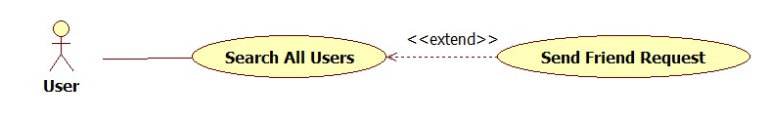

|  |  |  |  |  |
| --- | --- | --- | --- | --- |
| **SEND FRIEND REQUEST– SPECIFICATION** | | | | |
| **Use-case No.** | UCW017 | **Use-case Version** | | 1.0 |
| **Use-case Name** | Send Friend Request | | | |
| **Author** | Nguyễn Minh Toàn | | | |
| **Date** | 22/01/2014 | **Priority** | Medium | |
| **Actor:** User  **Summary:** Allow user to send a friend request to another user  **Triggers:** Click on “Send Request” button  **Preconditions:** This person not in the current user friend list  **Post Conditions:** A request is appear on this person inbox  **Main Success Scenario:**   |  |  |  | | --- | --- | --- | | **Step** | **User Action** | **System Response** | | 1 | Click on “Send Request” button | Send a friend request to the receiver user, reload the page of the sender user, change the “Send Request” button to “Cancel Request” button |   **Alternative Scenario:**   |  |  |  | | --- | --- | --- | | **No** | **User Action** | **System Response** | | 1 | Click on “Cancel Request” button after sent a request | Remove the request in the receiver user’s inbox, change the “Cancel Request” button on sender user screen back to “Send Request” button. |   **Exceptions:** N/A  **Business Rules:** N/A | | | | |

##### Manage Request Inbox

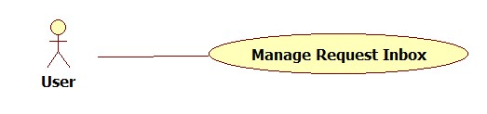

|  |  |  |  |  |
| --- | --- | --- | --- | --- |
| **MANAGE REQUEST INBOX – SPECIFICATION** | | | | |
| **Use-case No.** | UCW018 | **Use-case Version** | | 1.0 |
| **Use-case Name** | Manage Request Inbox | | | |
| **Author** | Nguyễn Minh Toàn | | | |
| **Date** | 22/01/2014 | **Priority** | Medium | |
| **Actor:** User  **Summary:** Allow user accept or deny friend requests  **Triggers:** The user clicks on the button “Inbox” on menu bar.  **Preconditions:** User has logged in  **Post Conditions:** List of request is displayed  **Main Success Scenario:**   |  |  |  | | --- | --- | --- | | **Step** | **User Action** | **System Response** | | 1. | Click on “Inbox” on menu bar | Show list of friend request that has been sent to that user from another user | | 2 | Click on “Accept” button of one request | Reload the Inbox page with this request has been disappear, add the sender to friend list |   **Alternative Scenario:**   |  |  |  |  | | --- | --- | --- | --- | | **No** | **Step** | **User Action** | **System Response** | | 1 | 1. | Click on “Inbox” on menu bar | Show list of friend request that has been sent to that user from another user | | 2 | Click on “Deny” button of one request | Reload the Inbox page with this request has been disappear |   **Exceptions:** N/A  **Business Rules:** N/A | | | | |

#### Mobile Application System

##### Login

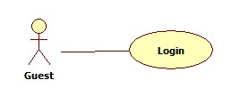

|  |  |  |  |  |
| --- | --- | --- | --- | --- |
| **LOGIN – SPECIFICATION** | | | | |
| **Use-case No.** | UCM001 | **Use-case Version** | | 1.0 |
| **Use-case Name** | Login | | | |
| **Author** | Đặng Minh Khiêm | | | |
| **Date** | 21/01/2014 | **Priority** | Low | |
| **Actor:** User  **Summary:** This use case allows a user to login to the system in order to user other function.  **Triggers:** User open Mobile Surveillance Application  **Preconditions:** Login page is loaded  **Post Conditions:**  *On success:* User will receive welcome message and be redirected to Trajectories page.  *On failure:* Error message is displayed, redirect to login page.  **Main Success Scenario:**   |  |  |  | | --- | --- | --- | | **Step** | **User Action** | **System Response** | | 1 | Enter valid username, password |  | | 2 | Press Login | Redirect to user’s Trajectories page |   **Alternative Scenario:** N/A  **Exceptions:**   |  |  |  | | --- | --- | --- | | **No** | **User Action** | **System Response** | | 1 | Do not enter username and press Login | Show message notify that username field is empty | | 2 | Enter username but not enter password | Show message notify that password field is empty | | 3 | Enter wrong username or password | Show message notify that user or password is incorrect |   **Business Rules:** N/A | | | | |
|  | | | | |

##### Register

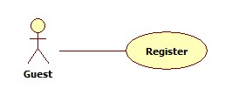

|  |  |  |  |  |
| --- | --- | --- | --- | --- |
| **REGISTER – SPECIFICATION** | | | | |
| **Use-case No.** | UCM002 | **Use-case Version** | | 1.0 |
| **Use-case Name** | Register | | | |
| **Author** | Đặng Minh Khiêm | | | |
| **Date** | 21/01/2014 | **Priority** | Low | |
| **Actor:** User  **Summary:** This use case allows user register a new account on the system.  **Triggers:** The user clicks on the button “Register” on the Login page.  **Preconditions:** The Register page is loaded  **Post Conditions:**  *On success:* Successful message displayed. Redirect to login page with registered username.  *On failure:* An error message is displayed. User will be asked to re-enter information  **Main Success Scenario:**   |  |  |  | | --- | --- | --- | | **Step** | **User Action** | **System Response** | | 1 | Enter all information |  | | 2 | Press Register | Redirect to Login page with the registered username |   **Alternative Scenario:** N/A  **Exceptions:**   |  |  |  | | --- | --- | --- | | **No** | **User Action** | **System Response** | | 1 | Enter an existed username | Show an error message, said the this username is existed | | 2 | Enter some field and skip some field | Show all error message for missing fields | | 3 | Enter username less than 5 characters | Show an error message, said that the username must be at least 5 characters | | 4 | Enter username with special characters (not from a -> z and 0 -> 9) | Show an error message, said that user has entered invalid characters | | 5 | Enter password difference from confirm password | Show an error message, said that password and confirm password do not match | | 6 | Enter an email with invalid pattern | Show an error message, said that email is invalid pattern | | 7 | Enter a wrong security code | Show an error message, said that the security code is wrong |   **Business Rules:** N/A | | | | |

##### View Trajectory

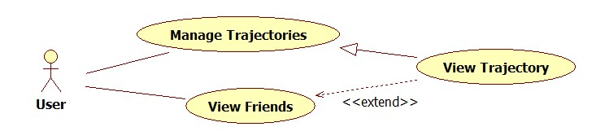

|  |  |  |  |  |
| --- | --- | --- | --- | --- |
| **VIEW TRAJECTORY – SPECIFICATION** | | | | |
| **Use-case No.** | UCM003 | **Use-case Version** | | 1.0 |
| **Use-case Name** | View Trajectory | | | |
| **Author** | Đặng Minh Khiêm | | | |
| **Date** | 22/01/2014 | **Priority** | Medium | |
| **Actor:** User  **Summary:** Allow user to see their trajectory or their friend trajectory  **Triggers:** User touch on one trajectory in trajectory list  **Preconditions:** The “Trajectories” page are showed  **Post Conditions:** Show a map that constant trajectory’s picture  **Main Success Scenario:**   |  |  |  | | --- | --- | --- | | **Step** | **User Action** | **System Response** | | 1 | Touch on one trajectory in list while device internet is connecting | Show a map of that trajectory, trajectory’s information with some markers |   **Alternative Scenario:**   |  |  |  | | --- | --- | --- | | **No** | **User Action** | **System Response** | | 1 | Touch on an trajectory with no image in list | Show the a map with no marker |   **Exceptions:**   |  |  |  | | --- | --- | --- | | **No** | **User Action** | **System Response** | | 1 | Touch on one trajectory in list while device internet is not connecting | Notify user to check their connection |   **Business Rules:** N/A | | | | |

##### Track On Map

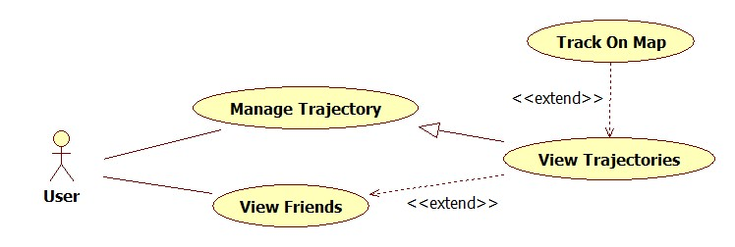

|  |  |  |  |  |
| --- | --- | --- | --- | --- |
| **TRACK ON MAP – SPECIFICATION** | | | | |
| **Use-case No.** | UCM004 | **Use-case Version** | | 1.0 |
| **Use-case Name** | Track On Map | | | |
| **Author** | Đặng Minh Khiêm | | | |
| **Date** | 22/01/2014 | **Priority** | Medium | |
| **Actor:** User  **Summary:** Allow user to track the showed map  **Triggers:** Touch on one tracker on map  **Preconditions:** The map are showed  **Post Conditions:** Show images that belong to that tracker  **Main Success Scenario:**   |  |  |  | | --- | --- | --- | | **Step** | **User Action** | **System Response** | | 1 | Touch on one marker on map while device internet is connecting | Show a page with all images belong to that marker on small size | | 2 | Choose one image | Show this image with full size |   **Alternative Scenario:** N/A  **Exceptions:**   |  |  |  |  | | --- | --- | --- | --- | | **No** | **Step** | **User Action** | **System Response** | | 1 | 1 | Touch on one marker while device is no connecting | Load no image, notify user that the connection is lost | | 2 | 1 | Touch on one marker while device is connecting | Load all images at that marker | | 2 | Touch on one image while device is no connecting | Load no image, notify user that the connection is lost |   **Business Rules:** N/A | | | | |

##### Create Trajectory

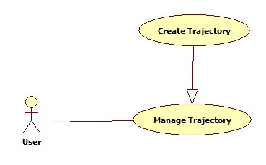

|  |  |  |  |  |
| --- | --- | --- | --- | --- |
| **CREATE TRAJECTORY – SPECIFICATION** | | | | |
| **Use-case No.** | UCM005 | **Use-case Version** | | 1.0 |
| **Use-case Name** | Create Trajectory | | | |
| **Author** | Đặng Minh Khiêm | | | |
| **Date** | 22/01/2014 | **Priority** | Medium | |
| **Actor:** User  **Summary:** This use case allows a logged in user to create a trajectory  **Triggers:** User touch on the button “Create Trajectory” in menu bar  **Preconditions:** The “Trajectories” page are showed  **Post Conditions:**  *On Success:* Success message is display, return to the page contents all of the trajectory  *On Failure:* rror message is displayed, user is asked to re-enter trajectory’s information  **Main Success Scenario:**   |  |  |  | | --- | --- | --- | | **Step** | **User Action** | **System Response** | | 1 | Press on “Create Trajectory” button on menu bar | Show a new page for user enter new trajectory’s information | | 2 | Enter trajectory’s name and description |  | | 3 | Press “Save” while the device’s internet is connecting | The new trajectory is created on both server database and device application screen |   **Alternative Scenario:**   |  |  |  |  | | --- | --- | --- | --- | | **No** | **Step** | **User Action** | **System Response** | | 1 | 1 | Press on “Create Trajectory” button on menu bar | Show a page for user enter new trajectory’s information | | 2 | Enter trajectory’s name and description |  | | 3 | Press “Save”, but the device’s internet is currently not connect | The new trajectory is created in device application screen | | 4 | The device’s internet is connected | This trajectory is created on server database |   **Exceptions:**   |  |  |  |  | | --- | --- | --- | --- | | **No** | **Step** | **User Action** | **System Response** | | 1 | 1 | Press on “Create Trajectory” button on menu bar | Show a page for user enter new trajectory’s information | | 2 | Enter trajectory’s name less than 6 characters |  | | 3 | Press Save | Show error message said that Trajectory’s name must be at least 6 character |   **Business Rules:** N/A | | | | |

##### Delete Trajectory

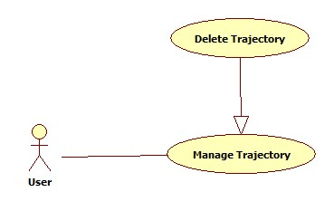

|  |  |  |  |  |
| --- | --- | --- | --- | --- |
| **DELETE TRAJECTORY – SPECIFICATION** | | | | |
| **Use-case No.** | UCM006 | **Use-case Version** | | 1.0 |
| **Use-case Name** | Delete Trajectory | | | |
| **Author** | Đặng Minh Khiêm | | | |
| **Date** | 22/01/2014 | **Priority** | Medium | |
| **Actor:** User  **Summary:** This use case allows a logged in user to delete a specified trajectory.  **Triggers:** Touch on “Delete Trajectory” on menu bar  **Preconditions:** One trajectory has been chosen  **Post Conditions:** Return to page that content all trajectories  **Main Success Scenario:**   |  |  |  |  | | --- | --- | --- | --- | | **No** | **Step** | **User Action** | **System Response** | | 1 | 1 | Select one trajectory |  | | 2 | Press “Delete Trajectory” button on menu bar while the device’s internet is currently connected | The trajectory is deleted on both server database and device application screen |   **Alternative Scenario:**   |  |  |  |  | | --- | --- | --- | --- | | **No** | **Step** | **User Action** | **System Response** | | 1 | 1 | Press on “Delete Trajectory”, but the device’s internet is currently not connect | The trajectory is deleted in device application screen | | 2 | The device’s internet is connected | The trajectory is deleted on server database |   **Exceptions:** N/A  **Business Rules:** N/A | | | | |

##### Update Trajectory

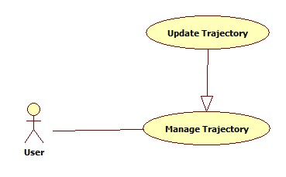

|  |  |  |  |  |
| --- | --- | --- | --- | --- |
| **UPDATE TRAJECTORY – SPECIFICATION** | | | | |
| **Use-case No.** | UCM007 | **Use-case Version** | | 1.0 |
| **Use-case Name** | Update Trajectory | | | |
| **Author** | Đặng Minh Khiêm | | | |
| **Date** | 22/01/2014 | **Priority** | Medium | |
| **Actor:** User  **Summary:** This use case allows a logged in user to edit a specified trajectory  **Triggers:** User touch on the button “Update Trajectory” on the menu bar  **Preconditions:** User chose one trajectory  **Post Conditions:**  *On success:* Success message is display, return to the page contents all trajectories  *On failure:* An error message is displayed, ask user to re-enter trajectory’s information.  **Main Success Scenario:**   |  |  |  | | --- | --- | --- | | **Step** | **User Action** | **System Response** | | 1 | Press on “Edit Trajectory” button on menu bar | Show a page that load old trajectory’s information for user edit | | 2 | Edit trajectory’s information |  | | 3 | Press “Save” while the device’s internet is connecting | The trajectory is updated on both server database and device application screen |   **Alternative Scenario:**   |  |  |  |  | | --- | --- | --- | --- | | **No** | **Step** | **User Action** | **System Response** | | 1 | 1 | Press on “Edit Trajectory” button on menu bar | Show a page that load old trajectory’s information for user edit | | 2 | Edit trajectory’s information |  | | 3 | Press “Save”, but the device’s internet is currently not connect | The trajectory is updated in device application screen | | 4 | The device’s internet is connected | This trajectory is updated on server database |   **Exceptions:**   |  |  |  |  | | --- | --- | --- | --- | | **No** |  | **User Action** | **System Response** | | 1 | 1 | Enter trajectory’s name less than 6 characters |  | | 2 | Press Save | Show error message said that Trajectory’s name must be at least 6 character |   **Business Rules:** N/A. | | | | |

##### Search Trajectory

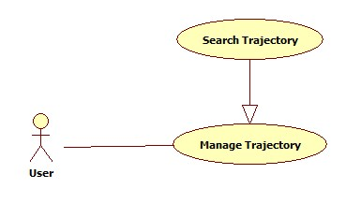

|  |  |  |  |  |
| --- | --- | --- | --- | --- |
| **SEARCH TRAJECTORY – SPECIFICATION** | | | | |
| **Use-case No.** | UCM008 | **Use-case Version** | | 1.0 |
| **Use-case Name** | Search Trajectory | | | |
| **Author** | Đặng Minh Khiêm - Lý Khánh Duy Bảo | | | |
| **Date** | 22/01/2014 | **Priority** | Medium | |
| **Actor:** User  **Summary:** This use case allows a logged in user to search trajectories in user’s trajectory list  **Triggers:** User touch on Search button on menu bar, type the name of Trajectory on the Search field and press Enter on visual keyboard  **Preconditions:** The trajectory page is being displayed.  **Post Conditions:**  *On success:* A list of matched trajectory is displayed to the user.  *On failure:* An error message is displayed. The content of the error message will be specified in the Exception Scenario section based on the type of failure.  **Main Success Scenario:**   |  |  |  | | --- | --- | --- | | **Step** | **User Action** | **System Response** | | 1 | Touch on “Search” button on menu bar | Show search text field | | 2 | Enter the key word |  | | 3 | Press “Enter” on visual keyboard while device’s internet is connected | Show all trajectories that’s name match to keyword |   **Alternative Scenario:** N/A  **Exceptions:**   |  |  |  |  | | --- | --- | --- | --- | | **No** | **Step** | **User Action** | **System Response** | | 1 | 1. | Touch on “Search” button on menu bar | Show search text field | | 2 | Enter the key word |  | | 3 | Press “Enter” on visual keyboard while device’s internet is not connected | Show an empty trajectory list, notify user to check connection |   **Business Rules:** N/A | | | | |

##### Take picture

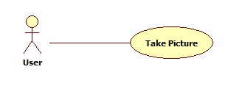

|  |  |  |  |  |
| --- | --- | --- | --- | --- |
| **TAKE PICTURE – SPECIFICATION** | | | | |
| **Use-case No.** | UCM009 | **Use-case Version** | | 1.0 |
| **Use-case Name** | Take Picture | | | |
| **Author** | Lý Khánh Duy Bảo | | | |
| **Date** | 22/01/2014 | **Priority** | Medium | |
| **Actor:** User  **Summary:** Allow user to take picture and get current location  **Triggers:** Press on “Capture” button  **Preconditions:** The “Take picture” page is opened  **Post Conditions:**  *On success:* The capture image will be saved in device  *On failure:* An error message is displayed.  **Main Success Scenario:**   |  |  |  | | --- | --- | --- | | **Step** | **User Action** | **System Response** | | 1 | User press on “Capture” button | Take picture and save it to device |   **Alternative Scenario:**   |  |  |  |  | | --- | --- | --- | --- | | **No** | **Step** | **User Action** | **System Response** | | 1 | 1 | Press on “Start” button on “Auto Capture” label | The number on label starting show countdown time, the “Start” button is change to “Stop” button | | 2 | Countdown count to 0 | Take a picture and save it to device | | 2 | 1 | Press on “Start” button on “Auto Capture” label | The number on label starting show countdown time, the “Start” button is change to “Stop” button | | 2 | Press on “Stop” button on “Auto Capture” label | Stop countdown, the “Stop” button is change to “Start” button | | 3 | Press “Start” button on “Auto Capture” label again | Continue countdown, the “Start” button is change to “Stop” button | | 4 | Countdown count to 0 | Take a picture and save it to device |   **Exceptions:**   |  |  |  |  | | --- | --- | --- | --- | | **No** | **Step** | **User Action** | **System Response** | | 1 | 1 | User press on “Capture” button while device cannot get location | Notify user that cannot get location information | | 2 | 1 | Press on “Start” button on “Auto Capture” label | The number on label starting show countdown time, the “Start” button is change to “Stop” button | | 2 | Countdown count to 0 while device cannot get location | Notify user that cannot get location information |   **Business Rules:** N/A. | | | | |

##### Upload Images

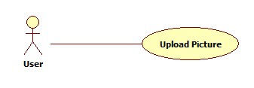

|  |  |  |  |  |
| --- | --- | --- | --- | --- |
| **UPLOAD IMAGES – SPECIFICATION** | | | | |
| **Use-case No.** | UCM010 | **Use-case Version** | | 1.0 |
| **Use-case Name** | Upload Images | | | |
| **Author** | Đặng Minh Khiêm | | | |
| **Date** | 22/01/2014 | **Priority** | Medium | |
| **Actor:** User  **Summary:** Allow user upload pictures that they toke before**.**  **Triggers:** Press on “Upload” button on “Upload Manager” page  **Preconditions:** All captured pictures are showed, at least one picture is selected  **Post Conditions:** All selected picture are uploaded to server  **Main Success Scenario:**   |  |  |  | | --- | --- | --- | | **Step** | **User Action** | **System Response** | | 1 | Chose pictures want to upload |  | | 2 | Press on “Upload” button on menu bar while the device internet is connected | All selected picture disappear from “Upload Manager” page, upload that pictures | |  |  | When upload finish, notify user that all picture has been uploaded successful |   **Alternative Scenario:**   |  |  |  |  | | --- | --- | --- | --- | | **No** | **Step** | **User Action** | **System Response** | | 1 | 1 | Chose pictures want to upload |  | | 2 | Press on “Upload” button on menu bar while the device internet is not currently connected | All selected picture disappear from “Upload Manager” page | | 3 | The device’s internet is connected | Upload that pictures | | 4 | The device connection is lost again | Upload process is paused | | 5 | The device internet is re-connected | Upload process is continue upload | | 6 |  | When upload finish, notify user that all picture has been uploaded successful | | 2 | 1 | Press on one picture on pictures list | Open this picture with default picture view program of device |   **Exceptions:** N/A  **Business Rules:** N/A. | | | | |

##### View Uploaded Images

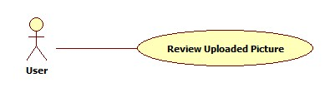

|  |  |  |  |  |
| --- | --- | --- | --- | --- |
| **VIEW UPLOADED IMAGES – SPECIFICATION** | | | | |
| **Use-case No.** | UCM011 | **Use-case Version** | | 1.0 |
| **Use-case Name** | View Uploaded Images | | | |
| **Author** | Đặng Minh Khiêm | | | |
| **Date** | 22/01/2014 | **Priority** | Medium | |
| **Actor:** User  **Summary:** Allow user review uploaded pictures if it wasn’t deleted  **Triggers:** Press on “Uploaded Pictures” button on main menu  **Preconditions:** N/A  **Post Conditions:** All undeleted uploaded pictures are show  **Main Success Scenario:**   |  |  |  | | --- | --- | --- | | **Step** | **User Action** | **System Response** | | 1 | Press on “Uploaded Pictures” button on main menu | Show all undeleted uploaded pictures | | 2 | Press on one picture on list | Open this picture with default picture view program of device |   **Alternative Scenario:** N/A  **Exceptions:** N/A  **Business Rules:** N/A. | | | | |

##### View Friends

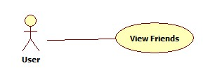

|  |  |  |  |  |
| --- | --- | --- | --- | --- |
| **VIEW FRIENDS – SPECIFICATION** | | | | |
| **Use-case No.** | UCM012 | **Use-case Version** | | 1.0 |
| **Use-case Name** | View Friends | | | |
| **Author** | Lý Khánh Duy Bảo | | | |
| **Date** | 22/01/2014 | **Priority** | Medium | |
| **Actor:** User  **Summary:** Allow user to view their friend, also their friend’s information and trajectories  **Triggers:** User press on “Friends” button on main menu  **Preconditions:** N/A  **Post Conditions:** Show this friend’s information and trajectories  **Main Success Scenario:**   |  |  |  | | --- | --- | --- | | **Step** | **User Action** | **System Response** | | 1 | Press on “Friend” button on main menu while device internet is connecting | Show user’s friend list that just loaded from server | | 2 | Touch on one friend in list while device internet is connecting | Show this friend’s information and trajectories which is public |   **Alternative Scenario:**   |  |  |  |  | | --- | --- | --- | --- | | **No** | **Step** | **User Action** | **System Response** | | 1 | 1 | Press on “Friend” button on main menu while device internet is not connecting | Show an last-know friend list, notify user to check their connection |   **Exceptions:**   |  |  |  |  | | --- | --- | --- | --- | | **No** | **Step** | **User Action** | **System Response** | | 1 | 1 | Press on “Friend” button on main menu while device internet is connecting | Show user’s friend list | | 2 | Touch on one friend in list while device internet is not connecting | Show an empty trajectory list, notify user to check their connection |   **Business Rules:** N/A | | | | |

### Non-Functional Requirement

#### Reliability

Because almost time using application is outside, so connection to sever is by 3G. Application must handle the internet connected and disconnected event to do synchronize task.

#### Availability

Server system uptime is 99%.

#### Security

Users are required to login successfully before performing any function.

#### Maintainability

All infrastructure issues are solved within 4 hours.

All application related issues are solved within 8 hours.

#### Portability

User can connect to the system by personal computer with web browser, or device using OS is android 4.0 or higher with application.

#### Performance

100 concurrent accesses are accepted.

## Entity Relationship Diagram

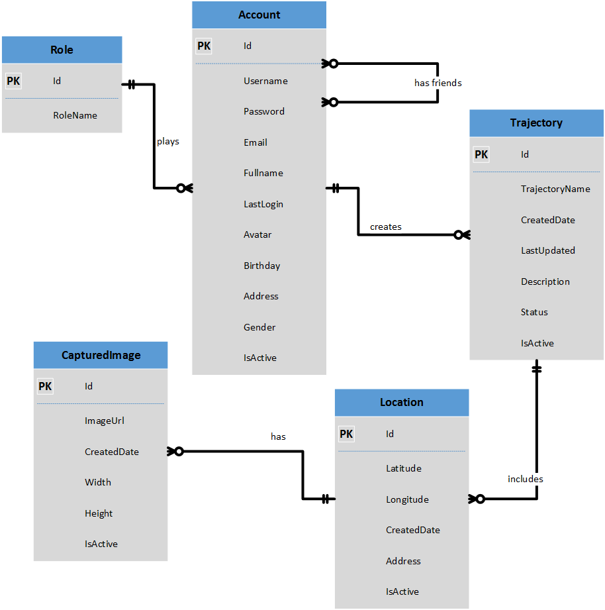



Diagram 3: Entity Relationship Diagram

# Report No.4 Software Design Description (SDD)



## Design Overview

The SDD describes system architectural design and detail designs, including graphic user interface and database design of the system.

For architectural design of Web application, we use MVC II pattern to implement.

For architectural design of Mobile application, we use 3 layers architecture to implement.

For architectural design of Web service, we use REST Web service to implement.

The mobile application interacts with Web service as client-server architecture.

The detail designs follow basic theory of software design, including “high cohesion”, “loose coupling” principles.

Summarize of each section will be described below:

Section 4.2: Describes overall architecture of the system.

Section 4.3: Describes all components of the system.

Section 4.4: Gives detail designs of each component, describe by class diagram.

Section 4.5: Describes sequence diagrams for main important functions, which previous described in use case diagram in SRS.

Section 4.6: Describes user interfaces of the system, including mobile application and web application.

Section 4.7: Describe database design, including logical database design base on choosing relational model and physical database which implemented on Microsoft SQL Server 2008.



## System Architectural Design

### Choice of System Architecture

The MVC II (Model – View - Controller) pattern is used as overall architecture of the web application system. MVC separates each component so that it gives clear responsibilities for each component and is appropriate in develop Web Application.

Mobile application will interact with server data storage through REST Web service because it is lightweight and give faster results and simple transactions, appropriate for application with simple data operations, easy to implement, maintenance and testing.

The three layers architecture will be used for designing of mobile application because it gives ability to reuse functionalities exposed by each layer and the maintenance of application is easier because of the low coupling between layers.

**MVC Architecture:**

8. Response

1. Request

Event Invocations

Events

3. Exchange data

4. Result

7. Changes made

2. Invoke methods

User Gestures

5. Selects view

6. Query states

Model

1. Encapsulates application state
2. Responds to state queries
3. Exposes application functionality
4. Notifies views of changes

Controller

* Defines application behavior
* Maps user action to model updates
* Selects view for response for each request

View

* Renders the models
* Requests updates from models
* Sends user gestures to controller
* Allows controller to select view

Database Sever

Diagram 4: Architecture Design: MVC

**Web service Architecture:**

Mobile Application

(Client)

REST

Web Service

(Server)

Database

Server

XML/JSON Response

HTTP Request (Get, Post, Put, Delete)

Exchange Data

Result

Diagram 5: Architecture Design: Web Service

**Mobile Architecture:**

Exchange data

Presentation Layer

Business Logic Layer

Data Access Layer

Database

Diagram 6: Architecture Design: Three layers

## Component Diagram

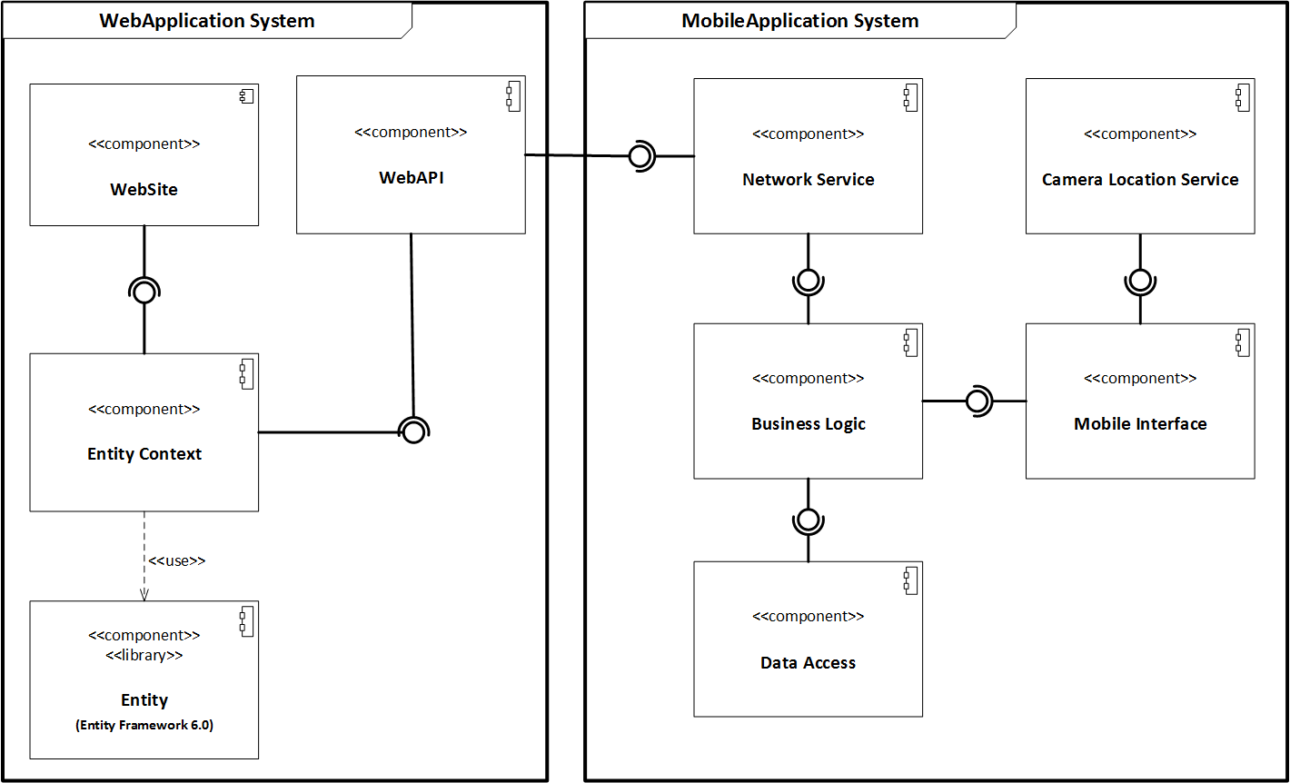

Diagram 7: Component Diagram

The MobileSurveillance system includes 2 sub-systems, they are WebApplication System and MobileApplication System. The following will describe components of each sub system.

* WebApplication System:
  + **Entity:** Using Entity Framework 6.0, an object-relational mapper that enables working with relational data persistence using domain-specific objects.
  + **Entity Context**: Provide data access functionalities, communicate with database using Entity Framework.
  + **WebSite**: A WebApplication that helps exposes functionalities to end users.
  + **WebAPI**: A WebService that provides interface for client applications to interact with server’s data storage.
* MobileApplication System:
  + **Network Service:** A service that enables mobile application to interact with server data storage via network by making request and get response.
  + **Data Access:** Provide data access function to interact with temporally local data storage.
  + **Business Logic**: Provide business logic functions for mobile application by using interface exposes by Network Service and Data Access component.
  + **Camera Location Service:** Provide service for taking picture using device’s camera and service for getting GPS location.
  + **Mobile Interface**: User interfaces of Mobile application, which allow user to interact and use majors functions of Mobile application.

Using MVC II pattern, component Entity Framework, Entity Context will belong to Model part, Controller and View are wrapped into the WebSite component. WebAPI component will belong to Web Service. Network Service, Data Access, Business Logic, Mobile Interface, Camera Location Service, all these three components will belong to Mobile Application.

## Detailed Description of Components

### Entity Component

#### Class Diagram

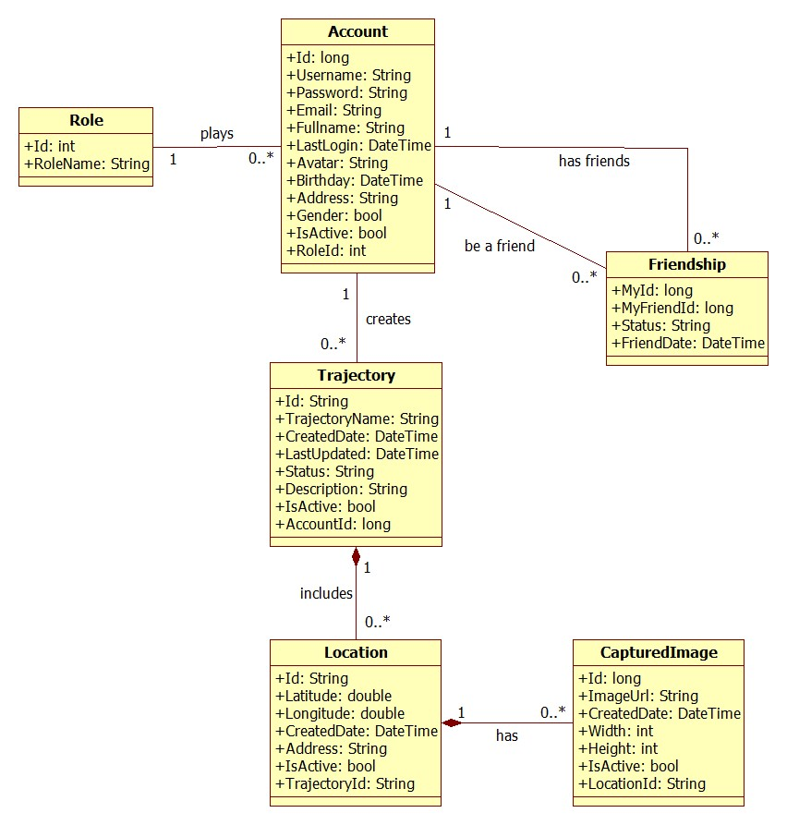

Diagram 8: Class Diagram: Entity

#### Role Class

**Properties**

|  |  |  |  |
| --- | --- | --- | --- |
| Property name | Type | Visibility | Description |
| Id | long | public | Unique id that differentiates a role from the others |
| RoleName | String | public | Name of role |

**Operations:** N/A

#### Account Class

**Properties**

|  |  |  |  |
| --- | --- | --- | --- |
| Property name | Type | Visibility | Description |
| Id | String | public | Unique id that differentiates an account from the others |
| UserName | String | public | Unique name that will be used to log into the system |
| Password | String | public | Security code for each account, use to log into the system |
| Email | String | public | Email of user, uses for password recovery |
| FullName | String | public | Fullname of user |
| LastLogin | DateTime | public | Last time user logged into the system |
| Avatar | String | public | A link which link to avatar of user |
| Birthday | DateTime | public | Birthday of user |
| Address | String | public | Address of user |
| IsActive | bool | public | Check if user is activated by the system or not |
| RoleId | int | public | RoleId of user |

**Operations:** N/A

#### Friendship Class

**Properties**

|  |  |  |  |
| --- | --- | --- | --- |
| Property name | Type | Visibility | Description |
| MyId | long | public | Id of user reference to relation Account |
| MyFriendId | long | public | Id of another user (friend) reference to relation Account |
| Status | String | public | Indicate status of relationship between 2 users |
| FriendDate | DateTime | public | The time when a user make/accept friend request |

**Operations:** N/A

#### Trajectory Class

**Properties**

|  |  |  |  |
| --- | --- | --- | --- |
| Property name | Type | Visibility | Description |
| Id | String | public | Unique id that differentiates a trajectory from the others |
| TrajectoryName | String | public | Name of trajectory |
| CreatedDate | DateTime | public | Datetime which user create trajectory |
| LastUpdated | DateTime | public | Datetime which user updated trajectory last time |
| Status | String | public | Status of trajectory to be public to share or private |
| Description | String | public | Description of trajectory |
| IsActive | bool | public | Whether or not this trajectory is available for user to operate |
| AccountId | long | public | User account Id which trajectory belongs to |

**Operations:** N/A

#### Location Class

**Properties**

|  |  |  |  |
| --- | --- | --- | --- |
| Property name | Type | Visibility | Description |
| Id | String | public | Unique id that differentiates a location from the others |
| Latitude | double | public | Latitude coordinate of location |
| Longitude | double | public | Longitude coordinate of location |
| CreatedDate | DateTime | public | Datetime which location was recorded |
| Address | String | public | Address which location belong to |
| IsActive | bool | public | Whether or not this location is available in a trajectory |
| TrajectoryId | String | public | Trajectory Id which location belongs to |

**Operations:** N/A

#### CapturedImage Class

**Properties**

|  |  |  |  |
| --- | --- | --- | --- |
| Property name | Type | Visibility | Description |
| Id | long | public | Unique id that differentiates an image from the others |
| ImageUrl | String | public | A link which link to the storage where image is stored |
| CreatedDate | DateTime | public | Datetime which image was taken |
| Width | int | public | Width of image |
| Height | int | public | Height of image |
| IsActive | bool | public | Whether or not this image is visible in a location |
| LocationId | String | public | Location Id which image belongs to |

**Operations:** N/A

### Entity Context Component

#### Class Diagram

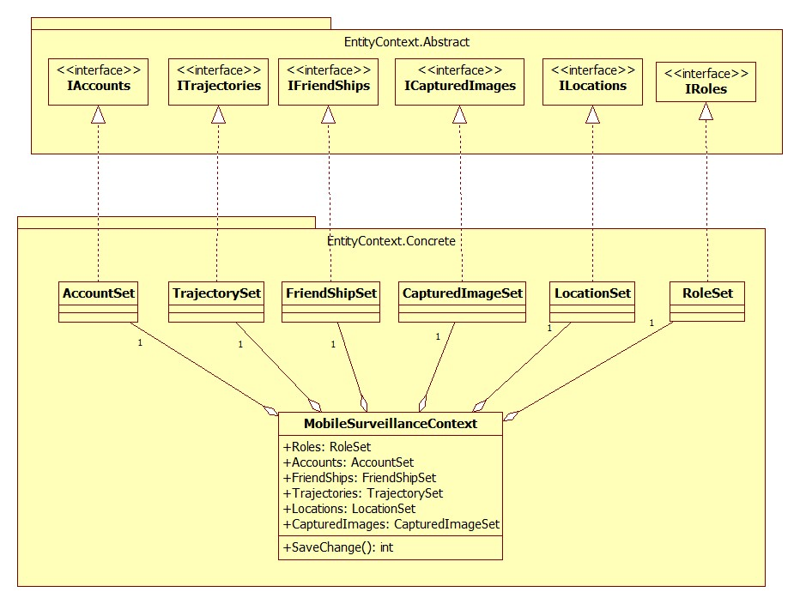

Diagram 9: Class Diagram: Entity Context

#### IAccounts Interface

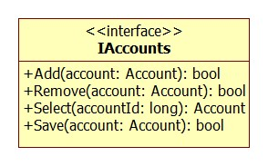

**Properties: N/A**

**Operations**

|  |  |  |
| --- | --- | --- |
| Signature: bool Add(Account account)  Description: Add an account to the database  Return: The bool value indicate added operation is successful or not | | |
| Parameter | **Type** | **Description** |
| account | Account | An account object which will be added to database |

|  |  |  |
| --- | --- | --- |
| Signature: bool Remove(Account account)  Description: Remove an account from the database  Return: The bool value indicate removed operation is successful or not | | |
| Parameter | **Type** | **Description** |
| account | Account | An account object which will be remove from database |

|  |  |  |
| --- | --- | --- |
| Signature: Account Select(long accountId)  Description: Get an account from database giving its id  Return: The Account object which has accountId | | |
| Parameter | **Type** | **Description** |
| accountId | long | Id of the account which will be retrieved from database |

|  |  |  |
| --- | --- | --- |
| Signature: bool Save(Account account)  Description: Update any changes of an account information to database  Return: The bool value indicate updated operation is successful or not | | |
| Parameter | **Type** | **Description** |
| account | Account | An account object which will be updated to database |

#### ITrajectories Interface

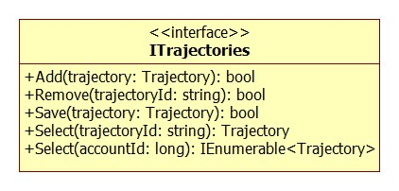

**Properties:** N/A

**Operations**

|  |  |  |
| --- | --- | --- |
| Signature: bool Add(Trajectory trajectory)  Description: Add a trajectory to the database  Return: The bool value indicate added operation is successful or not | | |
| Parameter | **Type** | **Description** |
| trajectory | Trajectory | A trajectory object which will be added to database |

|  |  |  |
| --- | --- | --- |
| Signature: bool Remove(Trajectory trajectory)  Description: Remove a trajectory from the database  Return: The bool value indicate removed operation is successful or not | | |
| Parameter | **Type** | **Description** |
| trajectory | Trajectory | An trajectoryobject which will be remove from database |

|  |  |  |
| --- | --- | --- |
| Signature: Trajectory Select(String trajectoryId)  Description: Get a trajectory from database giving its id  Return: The Trajectory object which has trajectoryId | | |
| Parameter | **Type** | **Description** |
| trajectoryId | String | Id of the trajectory which will be retrieved from database |

|  |  |  |
| --- | --- | --- |
| Signature: IEnumerable<Trajectory> Select(long accountId)  Description: Get a list of trajectories which a specific user has  Return: The list of Trajectory objects which an account has | | |
| Parameter | **Parameter** | **Description** |
| accountId | long | The id of a specific user account |

|  |  |  |
| --- | --- | --- |
| Signature: bool Save(Trajectory trajectory)  Description: Update any changes of an trajectory information to database  Return: The bool value indicate updated operation is successful or not | | |
| Parameter | **Type** | **Description** |
| trajectory | Trajectory | An trajectoryobject which will be updated to database |

#### IFriendships Interface

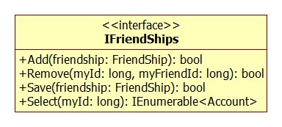

**Properties:** N/A

**Operations**

|  |  |  |
| --- | --- | --- |
| Signature: bool Add(Friendship friendship)  Description: Create a friendship between 2 users and insert to the database  Return: The bool value indicate added operation is successful or not | | |
| Parameter | **Type** | **Description** |
| friendship | Friendship | An friendship object which will be added to database |

|  |  |  |
| --- | --- | --- |
| Signature: bool Remove(long myId, long myFriendId)  Description: Remove a friendship from the database  Return: The bool value indicate removed operation is successful or not | | |
| Parameter | **Type** | **Description** |
| myId | long | The accountId of the user who want to have friend relationship with another user |
| myFriendId | long | The accountId of the user which any other users can make friend relationship with |

|  |  |  |
| --- | --- | --- |
| Signature: IEnumerable<Account> Select(long myId)  Description: Get a list of friend which a specific user has  Return: The list of Account objects | | |
| Parameter | **Type** | **Description** |
| myId | long | The accountId of the user who want to have friend relationship with another user |

|  |  |  |
| --- | --- | --- |
| Signature: bool Save(Friendship friendship)  Description: Update any changes of an account information to database  Return: The bool value indicate updated operation is successful or not | | |
| Parameter | **Type** | **Description** |
| friendship | Friendship | A friendship object which will be updated to database |

#### IRoles Interface

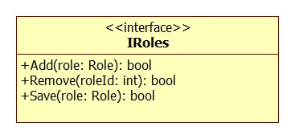

**Properties:** N/A

**Operations**

|  |  |  |
| --- | --- | --- |
| Signature: bool Add(Role role)  Description: Add a role to the database  Return: The bool value indicate added operation is successful or not | | |
| Parameter | **Type** | **Description** |
| role | Role | A role object which will be added to database |

|  |  |  |
| --- | --- | --- |
| Signature: bool Remove(int RoleId)  Description: Remove a role from the database giving its role id  Return: The bool value indicate removed operation is successful or not | | |
| Parameter | **Type** | **Description** |
| roleId | Role | A role object which will be remove from database |

|  |  |  |
| --- | --- | --- |
| Signature: bool Save(Role role)  Description: Update any changes of role information item to database  Return: The bool value indicate updated operation is successful or not | | |
| Parameter | **Type** | **Description** |
| role | Role | A role object which will be updated to database |

#### ILocations Interface

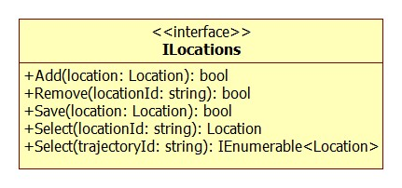

**Properties:** N/A

**Operations**

|  |  |  |
| --- | --- | --- |
| Signature: bool Add(Location location)  Description: Add a location to the database  Return: The bool value indicate added operation is successful or not | | |
| Parameter | **Type** | **Description** |
| location | Location | A location object which will be added to database |

|  |  |  |
| --- | --- | --- |
| Signature: bool Remove(Location location)  Description: Remove a location from the database  Return: The bool value indicate removed operation is successful or not | | |
| Parameter | **Type** | **Description** |
| location | Location | A location object which will be remove from database |

|  |  |  |
| --- | --- | --- |
| Signature: Location Select(String locationId)  Description: Get a location from database giving its id  Return: The Location object which has locationId | | |
| Parameter | **Type** | **Description** |
| locationId | String | Id of the location which will be retrieved from database |

|  |  |  |
| --- | --- | --- |
| Signature: IEnumerabe<Location> Select(String trajectoryId)  Description: Get a list location from database which belong to a specific trajectory  Return: The list of Location objects which a trajectory has | | |
| Parameter | **Type** | **Description** |
| trajectoryId | String | Id of the trajectory which has locations |

|  |  |  |
| --- | --- | --- |
| Signature: bool Save(location Location)  Description: Update any changes of a location information to database  Return: The bool value indicate updated operation is successful or not | | |
| Parameter | **Type** | **Description** |
| location | Location | A location object which will be updated to database |

#### ICapturedImages Interface

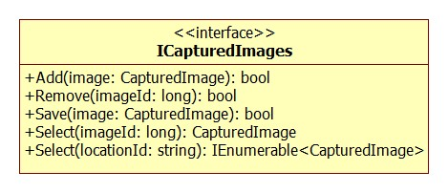

**Properties:** N/A

**Operations**

|  |  |  |
| --- | --- | --- |
| Signature: bool Add(CapturedImage image)  Description: Add an image to the database  Return: The bool value indicate added operation is successful or not | | |
| Parameter | **Type** | **Description** |
| image | CapturedImage | A image object which will be added to database |

|  |  |  |
| --- | --- | --- |
| Signature: bool Remove(CapturedImage image:)  Description: Remove an image from the database  Return: The bool value indicate removed operation is successful or not | | |
| Parameter | **Type** | **Description** |
| image | CapturedImage | A image object which will be remove from database |

|  |  |  |
| --- | --- | --- |
| Signature: CapturedImage Select(long imageId)  Description: Get an image from database giving its id  Return: The CapturedImage object which has imageId | | |
| Parameter | **Type** | **Description** |
| imageId | long | Id of the image which will be retrieved from database |

|  |  |  |
| --- | --- | --- |
| Signature: IEnumerabe< CapturedImage > Select(String locationId)  Description: Get a list images from database which belong to a specific location  Return: The list of CapturedImage objects which a location contains | | |
| Parameter | **Type** | **Description** |
| locationId | String | Id of the location which has images |

|  |  |  |
| --- | --- | --- |
| Signature: bool Save(Image: image)  Description: Update any changes of an image information to database  Return: The bool value indicate updated operation is successful or not | | |
| Parameter | **Type** | **Description** |
| image | CapturedImage | A image object which will be updated to database |

#### MobileSurveillanceContext Class

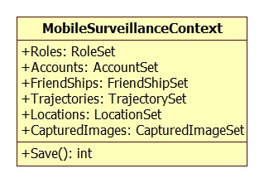

**Properties:**

|  |  |  |  |
| --- | --- | --- | --- |
| Property name | Type | Visibility | Description |
| Accounts | AccountSet | public | Set of Accounts mapping with table Account in database, provide CRUD mechanism on the database |
| Roles | RoleSet | public | Set of Roles mapping with table Role in database, provide CRUD mechanism on the database |
| Friendships | FriendshipSet | public | Set of Friendships mapping with table Friendship in database, provide CRUD mechanism on the database |
| Trajectories | TrajectorySet | public | Set of Trajectories mapping with table Trajectory in database, provide CRUD mechanism on the database |
| Locations | LocationSet | public | Set of Locations mapping with table Location in database, provide CRUD mechanism on the database |
| CapturedImages | CapturedImageSet | public | Set of CapturedImages mapping with table CapturedImage in database, provide CRUD mechanism on the database |

**Operations**

|  |  |  |
| --- | --- | --- |
| Signature: int SaveChange()  Description: Commit all changes which previous made to database  Return: The number of records which has been committed successfully | | |
| Parameter | **Type** | **Description** |
| N/A | N/A | N/A |

### WebAPI Component

#### Class Diagram

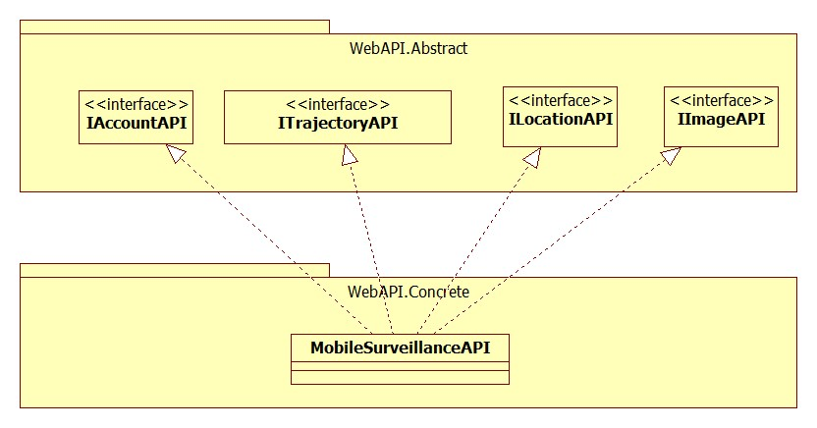

Diagram 10: Class Diagram: WebAPI

#### IAccountAPI Interface

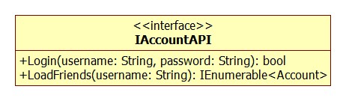

**Properties:** N/A

**Operations**

|  |  |  |
| --- | --- | --- |
| Signature: bool Login(String username, String password)  Description: Authenticate a specific user by username and password  Return: The bool value indicate login operation is successful or not | | |
| Parameter | **Type** | **Description** |
| username | String | User account username |
| password | String | User Account password |

|  |  |  |
| --- | --- | --- |
| Signature: IEnumerable<Account> LoadFriends(String username)  Description: Get a list of friends of a specific user  Return: The list of Account objects consider as friends of a user | | |
| Parameter | **Type** | **Description** |
| username | String | The username of user who want to get his/her friends list |

#### ITrajectoryAPI Interface

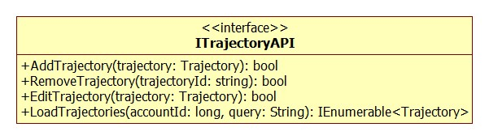

**Properties:** N/A

**Operations**

|  |  |  |
| --- | --- | --- |
| Signature: bool AddTrajectory(Trajectory trajectory)  Description: Add a trajectory to database  Return: The bool value indicate added operation is successful or not | | |
| Parameter | **Type** | **Description** |
| trajectory | Trajectory | The trajectory which will be inserted to database |

|  |  |  |
| --- | --- | --- |
| Signature: bool RemoveTrajectory(String trajectoryId)  Description: Remove a trajectory base on it Id, this method will mark trajectory inactive from database  Return: The bool value indicate removed operation is successful or not | | |
| Parameter | **Type** | **Description** |
| trajectoryId | String | The trajectory which will be remove from database |

|  |  |  |
| --- | --- | --- |
| Signature: bool EditTrajectory(Trajectory trajectory)  Description: Update a trajectory information  Return: The bool value indicate updated operation is successful or not | | |
| Parameter | **Type** | **Description** |
| trajectory | Trajectory | The trajectory which will be updated to database |

|  |  |  |
| --- | --- | --- |
| Signature: IEnumerable<Trajectory> LoadTrajectories(long accountId)  Description: Get a list of trajectories which has query condition and belong to a specific user  Return: The List of Trajectory objects | | |
| Parameter | **Type** | **Description** |
| accountId | long | The id of the user |
| query | String | The query which giving condition to load trajectories |

#### ILocationAPI Interface

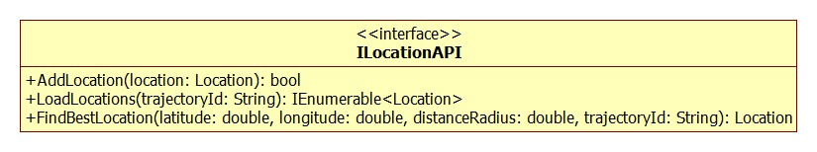

**Properties:** N/A

**Operations**

|  |  |  |
| --- | --- | --- |
| Signature: bool AddLocation(location Location)  Description: Add a location to the database  Return: The bool value indicate added operation is successful or not | | |
| Parameter | **Type** | **Description** |
| location | Location | The location object which will be inserted to database |

|  |  |  |
| --- | --- | --- |
| Signature: IEnumerable<Location> LoadLocations(String trajectoryId)  Description: Get a list of locations of a specific trajectory  Return: The list of Location objects | | |
| Parameter | **Type** | **Description** |
| trajectoryId | String | The id of trajectory which has list of locations |

|  |  |  |
| --- | --- | --- |
| Signature: Location FindBestLocation(double latitude, double longitude, double distanceRadius)  Description: Find the nearest location compare to current location (latitude, longitude) within distance radius  Return: The most appropriate Location object or null if cannot found | | |
| Parameter | **Type** | **Description** |
| latitude | double | Latitude of current location |
| longitude | double | Longitude of current location |
| distanceRadius | double | The distance which current location and finding location must satisfy |
| trajectoryId | String | The id of trajectory which has list of locations to find |

#### IImageAPI Interface

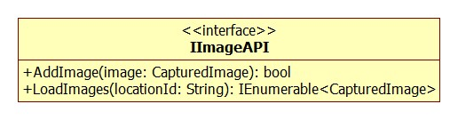

**Properties:** N/A

**Operations**

|  |  |  |
| --- | --- | --- |
| Signature: bool AddImage(image CapturedImage)  Description: Add an image object to the database  Return: The bool value indicate added operation is successful or not | | |
| Parameter | **Type** | **Description** |
| image | CapturedImage | The image object which will be inserted to database |

|  |  |  |
| --- | --- | --- |
| Signature: IEnumerable<CapturedImage> LoadImages(String locationId)  Description: Get a list of image objects in a specific location  Return: The list of CapturedImage objects | | |
| Parameter | **Type** | **Description** |
| locationId | String | The id of location which has list of images |

### Network Service Component

#### Class Diagram

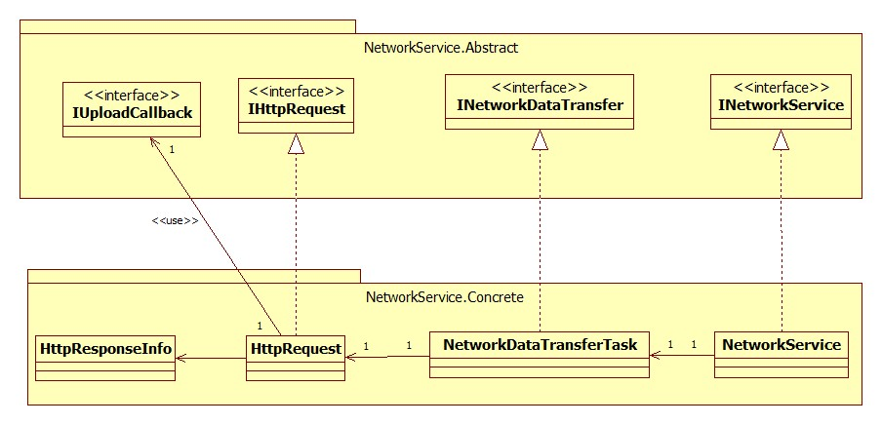

Diagram 11: Class Diagram: Network Service

#### INetworkDataTransfer Interface

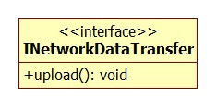

**Properties:** N/A

**Operations**

|  |  |  |
| --- | --- | --- |
| Signature: void upload()  Description: upload all data to server  Return: N/A | | |
| Parameter | **Type** | **Description** |
| N/A | N/A | N/A |

#### IHttpRequest Interface

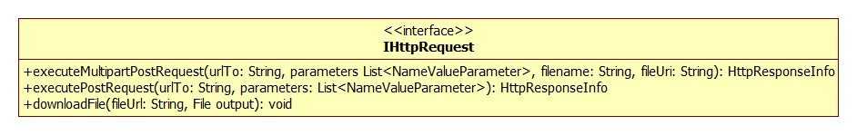

**Properties:** N/A

**Operations**

|  |  |  |
| --- | --- | --- |
| Signature: HttpResponseInfo executeMultipartPostRequest(String urlTo, List<NameValueParameter> parameters, String filename, String fileUri)  Description: Sending post request which contains parameters and file to the server.  Return: HttpResponseInfo object which contain information of the response after making request. | | |
| Parameter | **Type** | **Description** |
| urlTo | String | Url address of the server |
| parameters | List<NameValueParameters> | List of parameters use for uploading data to server |
| filename | String | The name of file which will be uploaded |
| fileUri | String | The location of file which will be uploaded |

|  |  |  |
| --- | --- | --- |
| Signature: HttpResponseInfo executePostRequest(String urlTo, List<NameValueParameter> parameters)  Description: Sending post request which contains parameters to the server.  Return: HttpResponseInfo object which contain information of the response after making request. | | |
| Parameter | **Type** | **Description** |
| urlTo | String | Url address of the server |
| parameters | List<NameValueParameters> | List of parameters use for uploading data to server |

|  |  |  |
| --- | --- | --- |
| Signature: void downloadFile(String fileUrl, File output)  Description: Download a file from server and save it to file output object  Return: N/A | | |
| Parameter | **Type** | **Description** |
| fileUrl | String | The location of file on server |
| output | File | The file which will be stored after downloaded |

#### INetworkService Interface

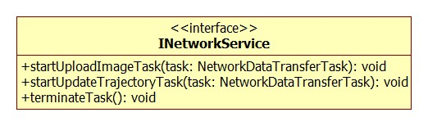

**Properties:** N/A

**Operations**

|  |  |  |
| --- | --- | --- |
| Signature: void startUploadImageTask(NetworkDataTransferTask task)  Description: Run upload image task  Return: N/A | | |
| Parameter | **Type** | **Description** |
| task | NetworkDataTransferTask | The NetworkDataTransferTask object that has been implemented from INetworkDataTransfer interface |

|  |  |  |
| --- | --- | --- |
| Signature: void startUpdateTrajectoryTask(NetworkDataTransferTask task)  Description: Update trajectory information to server  Return: N/A | | |
| Parameter | **Type** | **Description** |
| task | NetworkDataTransferTask | The NetworkDataTransferTask object that has been implemented from INetworkDataTransfer interface |

|  |  |  |
| --- | --- | --- |
| Signature: void terminateTask()  Description: Shutdown all task which previously submitted and currently running  Return: N/A | | |
| Parameter | **Type** | **Description** |
| N/A | N/A | N/A |

#### IUploadCallback Interface

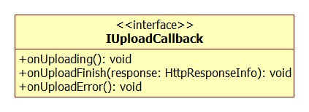

**Properties:** N/A

**Operations**

|  |  |  |
| --- | --- | --- |
| Signature: void onUploading()  Description: Fire when before making http request  Return: N/A | | |
| Parameter | **Type** | **Description** |
| N/A | N/A | N/A |

|  |  |  |
| --- | --- | --- |
| Signature: void onUploadError()  Description: Fire while making http request, exception has occurred  Return: N/A | | |
| Parameter | **Type** | **Description** |
| N/A | N/A | N/A |

|  |  |  |
| --- | --- | --- |
| Signature: void onUploadFinish(HttpResponseInfo response)  Description: Fire after making http request successfully and return the result  Return: N/A | | |
| Parameter | **Type** | **Description** |
| response | HttpResponseInfo | HttpResponseInfo object which contain information of the response after making request. |

#### IUploadCallback Interface

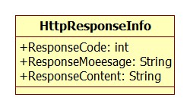

**Properties**

|  |  |  |  |
| --- | --- | --- | --- |
| Property name | Type | Visibility | Description |
| ResponseCode | int | public | The Status-Code element is a 3-digit integer result code of the attempt to understand and satisfy the request |
| ResponseMessage | String | public | The response message which equivalent to ResponseCode |
| ResponseContent | String | public | The content which server return after making request |

**Operations:** N/A

### Camera Location Service Component

#### Class Diagram

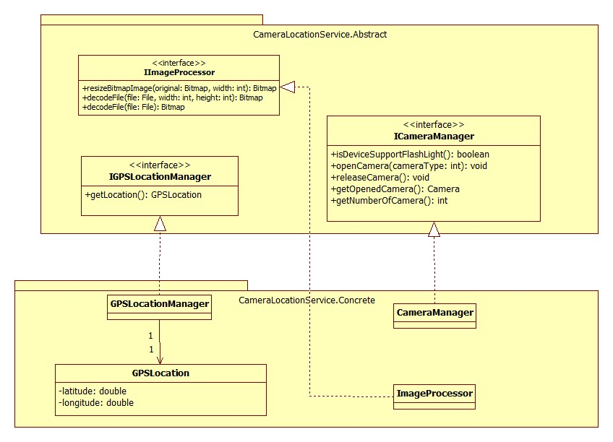

Diagram 12: Class Diagram: Camera Location Service

#### ICameraManager

**Properties:** N/A

**Operations**

|  |  |  |
| --- | --- | --- |
| Signature: boolean isDeviceSupportFlashLight()  Description: To make known that is this device supported for flash light  Return: true if supported, false if not | | |
| Parameter | **Type** | **Description** |
| N/A | N/A | N/A |

|  |  |  |
| --- | --- | --- |
| Signature: int getNumberOfCamera()  Description: To get the number of camera that are supported on this device  Return: The number of cameras | | |
| Parameter | **Type** | **Description** |
| N/A | N/A | N/A |

|  |  |  |
| --- | --- | --- |
| Signature: void openCamera(int cameraType)  Description: To open a camera, make it ready to used  Return: N/A | | |
| Parameter | **Type** | **Description** |
| cameraType | int | Camera type, may be back camera or front camera |

|  |  |  |
| --- | --- | --- |
| Signature: Camera getOpenedCamera(int cameraType)  Description: Get the camera that has been opened  Return: The camera that has been opened | | |
| Parameter | **Type** | **Description** |
| N/A | N/A | N/A |

#### IImageProcessor

**Properties:** N/A

**Operations:**

|  |  |  |
| --- | --- | --- |
| Signature: Bitmap resizeBitmapImage(Bitmap original, int width)  Description: Resize the input bitmap, do not change the ratio between width and height  Return: The output bitmap | | |
| Parameter | **Type** | **Description** |
| bitmap | Bitmap | The input bitmap |
| width | int | Width that need to resize to |

|  |  |  |
| --- | --- | --- |
| Signature: Bitmap decodeFile (File file, int reqWidth, int reqHeight)  Description: Decode an image file to a bitmap with width and height is the input width and height  Return: The output bitmap | | |
| Parameter | **Type** | **Description** |
| file | File | The input image file |
| reqWidth | int | Width of output bitmap |
| reqHeight | int | Height of output bitmap |

|  |  |  |
| --- | --- | --- |
| Signature: Bitmap decodeFile (File file)  Description: Decode an image file to a bitmap without scaling  Return: The output bitmap | | |
| Parameter | **Type** | **Description** |
| file | File | The input image file |

#### IGPSLocationManager

**Properties:** N/A

**Operations:**

|  |  |  |
| --- | --- | --- |
| Signature: GPSLocation getLocation()  Description: Try 3 provider to get the current location (GPS, Network, Passive)  Return: A GPSLocation object that store current latitude and longitude if can get location, null if can not. | | |
| Parameter | **Type** | **Description** |
| N/A | N/A | N/A |

#### GPSLocation

**Properties**

|  |  |  |  |
| --- | --- | --- | --- |
| Property name | Type | Visibility | Description |
| latitude | double | private | Current latitude |
| longitude | double | private | Current longitude |

### Data Access Component

#### Class Diagram

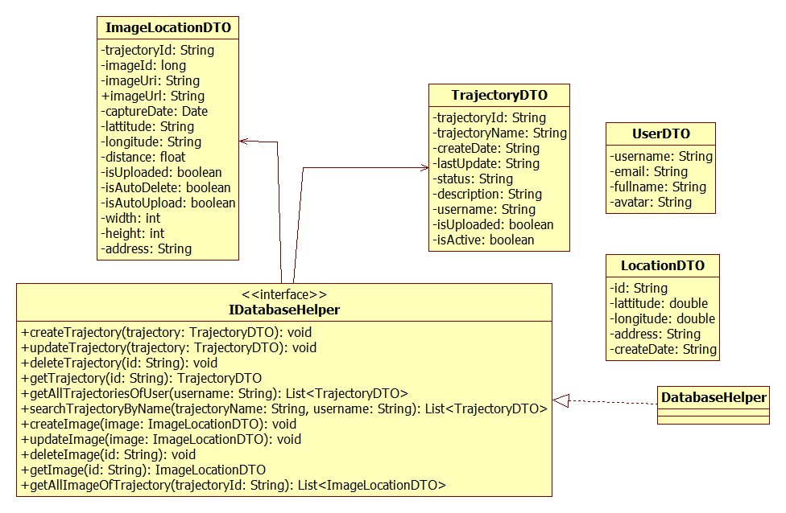

Diagram 13: Class Diagram: Data Access

#### ImageLocationDTO

**Properties**

|  |  |  |  |
| --- | --- | --- | --- |
| Property name | Type | Visibility | Description |
| trajectoryId | String | private | Id of the trajectory that this image belong to |
| imageId | String | private | Id of the image |
| imageUri | String | private | Uri of the image in local storage |
| imageUrl | String | private | Url of the image on server |
| captureDate | Date | private | Captured time |
| latitude | String | private | Latitude of the image |
| longitude | String | private | Longitude of the image |
| distance | String | private | Distance need to group image. |
| isUploaded | boolean | private | Is this image uploaded or not. |
| isAutoUpload | boolean | private | Is this image must be auto upload after take or not? |
| isAutoDelete | boolean | private | Is this image must be deleted after upload or not? |
| width | int | private | Width of the image |
| height | int | private | Height of the image |
| address | String | private | Parse from latitude and longitude by geocode |

Operations: N/A

#### TrajectoryDTO

**Properties**

|  |  |  |  |
| --- | --- | --- | --- |
| Property name | Type | Visibility | Description |
| trajectoryId | String | private | Id of the trajectory including the username, mac address and create time (yyyyMMddHHmmss) |
| trajectoryName | String | private | Name of the trajectory |
| description | String | private | Description of this trajectory |
| status | String | private | Pubic or private |
| createDate | String | private | Time when the trajectory is created (yyyyMMddHHmmss) |
| lastUpdate | String | private | The last time this trajectory is updated (yyyyMMddHHmmss) |
| username | String | private | Username of user that this trajectory is belong to |
| isUploaded | boolean | private | Is this trajectory uploaded server or not? |
| isActive | boolean | private | Is this trajectory removed or not |

Operations: N/A

#### UserDTO

**Properties:**

|  |  |  |  |
| --- | --- | --- | --- |
| Property name | Type | Visibility | Description |
| username | String | private | Username of the user |
| email | String | private | Email of the user |
| fullname | String | private | Fullname of the user |
| avatar | String | private | Url of the avatar |

Operations: N/A

#### LocationDTO

**Properties:**

|  |  |  |  |
| --- | --- | --- | --- |
| Property name | Type | Visibility | Description |
| id | String | private | Id of the location |
| latitude | double | private | Location’s latitude |
| longitude | double | private | Location’s longitude |
| address | String | private | Address of the location |
| createDate | String | private | Date the location is created |

Operations: N/A

#### IDatabaseHelper

**Properties:** N/A

**Operations**

|  |  |  |
| --- | --- | --- |
| Signature: void createTrajectory(TrajectoryDTO trajectory)  Description: Add a new trajectory to local database  Return: N/A | | |
| Parameter | **Type** | **Description** |
| trajectory | TrajectoryDTO | The trajectory store all data that need to be added into local database |

|  |  |  |
| --- | --- | --- |
| Signature: void updateTrajectory(TrajectoryDTO trajectory)  Description: Update one trajectory in local database  Return: N/A | | |
| Parameter | **Type** | **Description** |
| trajectory | TrajectoryDTO | The trajectory has all data that need to be updated |

|  |  |  |
| --- | --- | --- |
| Signature: void deleteTrajectory(String id)  Description: Delete one trajectory in local database that has id match the input id  Return: N/A | | |
| Parameter | **Type** | **Description** |
| id | String | Id of the trajectory need to be deleted |

|  |  |  |
| --- | --- | --- |
| Signature: TrajectoryDTO getTrajectory(String id)  Description: Get one trajectory from local database  Return: An “TrajectoryDTO” object that got all data of the trajectory we need | | |
| Parameter | **Type** | **Description** |
| id | String | Id of the trajectory we need |

|  |  |  |
| --- | --- | --- |
| Signature: List<TrajectoryDTO> getAllTrajectoriesOfUser(String username)  Description: get all trajectory of one user  Return: A list of “TrajectoryDTO” object | | |
| Parameter | **Type** | **Description** |
| username | String | Username of the user |

|  |  |  |
| --- | --- | --- |
| Signature: List<TrajectoryDTO> searchTrajectoryByName (String trajectoryName, String username)  Description: Search for trajectories that belong to an user and has name match the condition  Return: A list of “TrajectoryDTO” object | | |
| Parameter | **Type** | **Description** |
| trajectoryName | String | Name of the trajectory we need to search |
| username | String | Username of the user |

|  |  |  |
| --- | --- | --- |
| Signature: void createImage(ImageLocationDTO image)  Description: Add a new image to local database  Return: N/A | | |
| Parameter | **Type** | **Description** |
| image | ImageLocationDTO | The image store all data that need to be added into local database |

|  |  |  |
| --- | --- | --- |
| Signature: void updateImage(ImageLocationDTO image)  Description: Update an image of local database  Return: N/A | | |
| Parameter | **Type** | **Description** |
| image | ImageLocationDTO | The image store all data that need to |

|  |  |  |
| --- | --- | --- |
| Signature: ImageLocationDTO getImage(String id)  Description: Get one image from local database  Return: An “ImageLocationDTO” object that store all data of the image we need | | |
| Parameter | **Type** | **Description** |
| id | String | Id of the image we need |

|  |  |  |
| --- | --- | --- |
| Signature: List<ImageLocationDTO> getAllImageOfTrajectory(String trajectoryId)  Description: Get all image of  Return: A list of “ImageLocationDTO” object | | |
| Parameter | **Type** | **Description** |
| trajectoryId | String | Id of the trajectory |

### Mobile Interface Component

#### Class Diagram

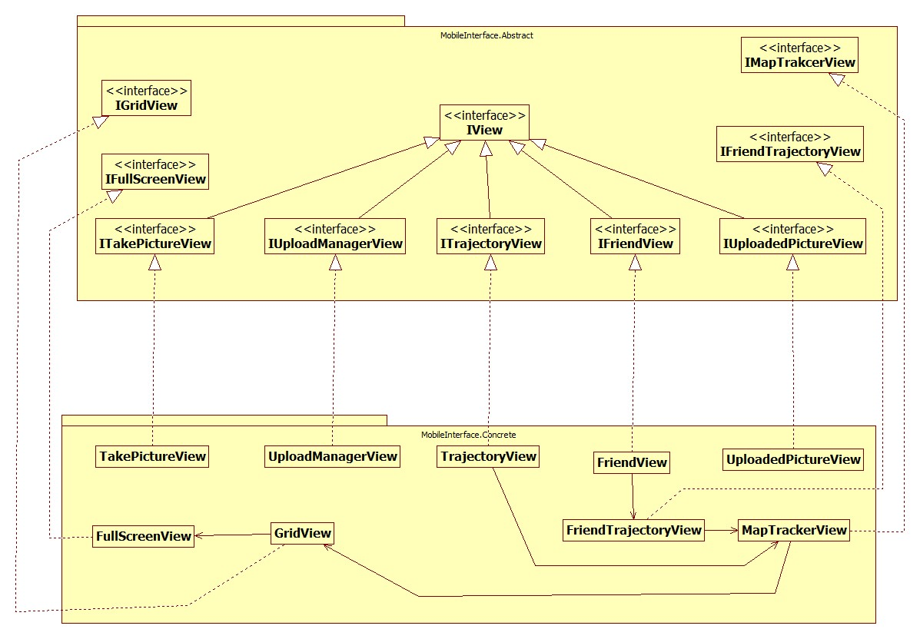

Diagram 14: Class Diagram: Mobile Interface

#### ITakePictureView

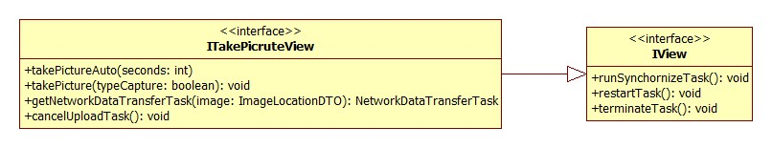

**Properties** N/A

**Operations**

|  |  |  |
| --- | --- | --- |
| Signature: void takePicture(boolean typeCapture)  Description: Take a picture, turn flash light if needed. Rotate image base on “angle”, scale image to match setting’s resolution, save it’s into “Captured Image” folder, turn flash light off if it was turned on after captured. Add image into local database with “isAutoUpload” and “isAutoDelete” base on type capture and setting.  Return: N/A | | |
| Parameter | **Type** | **Description** |
| typeCamera | boolean | MANUAL_CAPTURE or AUTO_CAPTURE |

|  |  |  |
| --- | --- | --- |
| Signature: void takePictureAuto(int seconds)  Description: Start countdown. When countdown to zero, take a picture  Return: N/A | | |
| Parameter | **Type** | **Description** |
| seconds | long | Time to countdown before capture a picture |

|  |  |  |
| --- | --- | --- |
| Signature: NetworkDataTransferTask getDataTransferTask (ImageLocationDTO image)  Description: Implement the IUploadCallback interface. Create a list of “NameValueParameter” store all image’s attribute. Create a new “NetworkDataTransferTask” , set the implemented “IUploadCallback and list of “NameValueParameter”, set “transferType” is “TRANSFER_MULTIPART_TYPE”.  Return: NetworkDataTransferTask after set | | |
| Parameter | **Type** | **Description** |
| image | ImageLocationDTO | The image we need to upload to server |

|  |  |  |
| --- | --- | --- |
| Signature: void cancelUploadTask()  Description: Cancel all uploading images  Return: N/A | | |
| Parameter | **Type** | **Description** |
| N/A | N/A | N/A |

|  |  |  |
| --- | --- | --- |
| Signature: void runSynchronizeTask()  Description: Get all images of user that has “isAutoUpload” is true and “isUploaded” is false and upload it.  Return: N/A | | |
| Parameter | **Type** | **Description** |
| N/A | N/A | N/A |

|  |  |  |
| --- | --- | --- |
| Signature: void terminateTask()  Description: Called when the connection is disconnected  Return: N/A | | |
| Parameter | **Type** | **Description** |
| N/A | N/A | N/A |

|  |  |  |
| --- | --- | --- |
| Signature: void restartTask()  Description: Be called when the connection is reconnected.  Return: N/A | | |
| Parameter | **Type** | **Description** |
| N/A | N/A | N/A |

#### TakePictureView

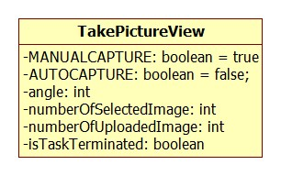

**Properties**

|  |  |  |  |
| --- | --- | --- | --- |
| Property name | Type | Visibility | Description |
| MANUAL_CAPTURE | boolean | private | Is this picture is token by manual, default value is true |
| AUTO_CAPTURE | boolean | private | Is this picture is token by auto, default value is false |
| angle | int | private | Update every screen rotated |
| numberOfSelectedImage | int | private | When you upload n image, this variable will become n |
| numberOfUploadedImage | int | private | When one image is uploaded successful, this variable will add 1 |
| isTaskTerminated | boolean | private | Change into false when the upload process is started, and change into true when upload process is finish |

**Operations**

N/A

#### ITrajectoryView

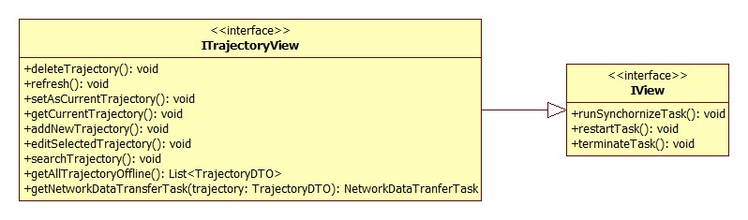

**Properties** N/A

**Operations**

|  |  |  |
| --- | --- | --- |
| Signature: void deleteTrajectory()  Description: Show an dialog ask user that are user sure. If user chose Yes, set the selected trajectory “isActive” and “isUploaded” to false, update it to local.  Return: N/A | | |
| Parameter | **Type** | **Description** |
| N/A | N/A | N/A |

|  |  |  |
| --- | --- | --- |
| Signature: void refresh()  Description: Clear the screen and call method “searchTrajectory” with parameter is “currentSearchQuery”  Return: N/A | | |
| Parameter | **Type** | **Description** |
| N/A | N/A | N/A |

|  |  |  |
| --- | --- | --- |
| Signature: void setAsCurrentTrajectory()  Description: Show a dialog to ask user that does user want to set this trajectory at current trajectory. If user chose Yes, call method “setCurrentTrajectory” of “PreferenceController” class with parameter is the selected trajectory’s id.  Return: N/A | | |
| Parameter | **Type** | **Description** |
| N/A | N/A | N/A |

|  |  |  |
| --- | --- | --- |
| Signature: void getCurrentTrajectoryInformation()  Description: Call method “getCurrentTrajectory” of “PreferenceController” class to get a trajectory. Show a dialog display this trajectory’s name and create date.  Return: N/A | | |
| Parameter | **Type** | **Description** |
| N/A | N/A | N/A |

|  |  |  |
| --- | --- | --- |
| Signature: void addNewTrajectory()  Description: Show a view for user add information, include trajectory’s name, description and status (public or private). After user insert information and press submit, add a new trajectory to local database with “isUploaded” is false.  Return: N/A | | |
| Parameter | **Type** | **Description** |
| N/A | N/A | N/A |

|  |  |  |
| --- | --- | --- |
| Signature: void editSelectedTrajectory()  Description: Show a view for user with the selected trajectory’s old information, include trajectory’s name, description and status (public or private). After user insert information and press submit, update this trajectory to local database with “isUploaded” is false.  Return: N/A | | |
| Parameter | **Type** | **Description** |
| N/A | N/A | N/A |

|  |  |  |
| --- | --- | --- |
| Signature: void searchTrajectory(String query)  Description: Call method “isConnecting” of “NetworkUtil” class. If the return is false, search trajectory that match the search query offline. If the return is true, search trajectory that match the search query online.  Return: N/A | | |
| Parameter | **Type** | **Description** |
| query | String | Name of the trajectory that user want to search |

|  |  |  |
| --- | --- | --- |
| Signature: List<TrajectoryDTO> getAllTrajectoryOffline()  Description: Get all trajectories that belong to the current user from local database.  Return: List of TrajectoryDTO with “isActive” is true | | |
| Parameter | **Type** | **Description** |
| N/A | N/A | N/A |

|  |  |  |
| --- | --- | --- |
| Signature: NetworkDataTransfer getDataTransferTask(TrajectoryDTO trajectory)  Description: Implement the IUploadCallback. Create a list of “NameValueParameter” that store all the trajectory’s attributes. Create a new “NetworkDataTransferTask” object, set NetworkCallback and Parameters, transferType is TRANSFER_NORMAL_REQUEST_TYPE  Return: NetworkDataTransferTask afer setted | | |
| Parameter | **Type** | **Description** |
| trajectory | TrajectoryDTO | The trajectory we need to upload to server |

|  |  |  |
| --- | --- | --- |
| Signature: runSynchronizeTask  Description: Upload all trajectories belong to current user that has “isUploaded” is false.  Return: N/A | | |
| Parameter | **Type** | **Description** |
| N/A | N/A | N/A |

|  |  |  |
| --- | --- | --- |
| Signature: terminateTask  Description: Call “terminateTask” method of “NetworkService” class.  Return: N/A | | |
| Parameter | **Type** | **Description** |
| N/A | N/A | N/A |

|  |  |  |
| --- | --- | --- |
| Signature: restartTask  Description: Call “runSynchronizeTask” method and “searchTrajectory”  Return: N/A | | |
| Parameter | **Type** | **Description** |
| N/A | N/A | N/A |

#### TrajectoryView

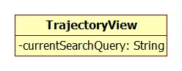

**Properties**

|  |  |  |  |
| --- | --- | --- | --- |
| Property name | Type | Visibility | Description |
| currentSearchQuery | String | private | Change every searching time |

**Operations**

N/A

#### IUploadManagerView

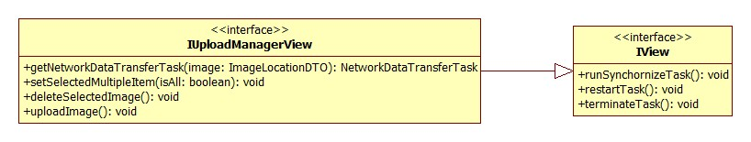

**Properties** N/A

**Operations**

|  |  |  |
| --- | --- | --- |
| Signature: void setSelectedMutipleItem(boolean isAll)  Description: For each image on displaying list, set “isSelect” to the same value of isAll  Return: N/A | | |
| Parameter | **Type** | **Description** |
| isAll | boolean | true when chose “Select All”,  false when chose “Unselect All.” |

|  |  |  |
| --- | --- | --- |
| Signature: getDataTransferTask  Description: Implement the IUploadCallback interface. Create a list of “NameValueParameter” store all image’s attribute. Create a new “NetworkDataTransferTask”, set lat, long, networkCallback, parameter, fileProperties, transferType is “TRANSFER_MULTIPART_TYPE”.  Return: NetworkDataTransferTask afer setted | | |
| Parameter | **Type** | **Description** |
| image | ImageLocationDTO | The image we need to upload to server |

|  |  |  |
| --- | --- | --- |
| Signature: void deleteSelectedImage()  Description: Delete all selected image on local database.  Return: N/A | | |
| Parameter | **Type** | **Description** |
| N/A | N/A | N/A |

|  |  |  |
| --- | --- | --- |
| Signature: uploadImage  Description: For each image is selected, create a NetworkDataTransferTask for it by method “getNetworkDataTransferTask” and start upload.  Return: N/A | | |
| Parameter | **Type** | **Description** |
| N/A | N/A | N/A |

|  |  |  |
| --- | --- | --- |
| Signature: restartTask  Description: If “isTaskKilled” is true and “isTaskCancel” is false, call “uploadImage” method and set “isTaskKilled” to false.  Return: N/A | | |
| Parameter | **Type** | **Description** |
| N/A | N/A | N/A |

|  |  |  |
| --- | --- | --- |
| Signature: terminateTask  Description: Call method “terminateTask” of “NetworkService” class.  Return: N/A | | |
| Parameter | **Type** | **Description** |
| N/A | N/A | N/A |

#### UploadManagerView

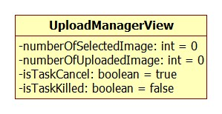

**Properties**

|  |  |  |  |
| --- | --- | --- | --- |
| Property name | Type | Visibility | Description |
| numberOfSelectedImage | int | private | When you chose n image and start upload, this variable will become n. |
| numberOfUploadedImage | int | private | When one image is uploaded successful, this variable will add 1. |
| isTaskCancel | boolean | private | Change to false when start upload, and change to true when upload finish or user kill upload process |
| isTaskKilled | boolean | private | For handle connection problem while uploading |

**Opearaions**

N/A

#### IFriendView

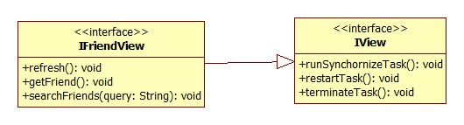

**Properties**N/A

**Operations**

|  |  |  |
| --- | --- | --- |
| Signature: void refresh()  Description: Call method “searchFriends” with parameter is “currentSearchQuery”  Return: N/A | | |
| Parameter | **Type** | **Description** |
| N/A | N/A | N/A |

|  |  |  |
| --- | --- | --- |
| Signature: void getFriend()  Description: Set “isLoadMore” to true and call method “searchFriends” with parameter is “currentSearchQuery”  Return: N/A | | |
| Parameter | **Type** | **Description** |
| N/A | N/A | N/A |

|  |  |  |
| --- | --- | --- |
| Signature: searchFriends  Description: Search friend from server with name match the search query  Return: N/A | | |
| Parameter | **Type** | **Description** |
| query | String | Name of the trajectory that user want to search |

|  |  |  |
| --- | --- | --- |
| Signature: restartTask  Description: Re-search friend list  Return: N/A | | |
| Parameter | **Type** | **Description** |
| query | String | Name of the friend that user want to search |

#### FriendView

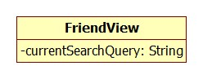

**Properties**

|  |  |  |  |
| --- | --- | --- | --- |
| Property name | Type | Visibility | Description |
| currentSearchQuery | String | private | Current search query. |

**Operations:** N/A

#### IUploadedPictureView

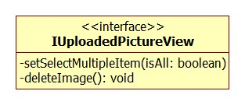

**Properties** N/A

**Operations**

|  |  |  |
| --- | --- | --- |
| Signature: void setSelectedMutipleItem (Boolean isAll)  Description: For each image on displaying list, set “isSelect” to the same value of “isAll”  Return: N/A | | |
| Parameter | **Type** | **Description** |
| isAll | boolean | true when chose “Select All”,  false when chose “Unselect All.” |

|  |  |  |
| --- | --- | --- |
| Signature: deleteImage  Description: Delete all selected image on display list and refresh screen  Return: N/A | | |
| Parameter | **Type** | **Description** |
| N/A | N/A | N/A |

#### IFriendTrajectoryView

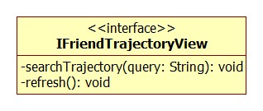

**Properties** N/A

**Operations**

|  |  |  |
| --- | --- | --- |
| Signature: void searchTrajectory(String query)  Description: Search trajectory of this friend that match the search query online  Return: N/A | | |
| Parameter | **Type** | **Description** |
| query | String | Name of the trajectory that user want to search |

|  |  |  |
| --- | --- | --- |
| Signature: void refresh()  Description: Clear the screen and and re-search with “currentSearchQuery”  Return: N/A | | |
| Parameter | **Type** | **Description** |
| N/A | N/A | N/A |

#### FriendTrajectoryView

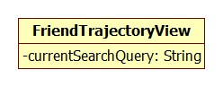

**Properties**

|  |  |  |  |
| --- | --- | --- | --- |
| Property name | Type | Visibility | Description |
| currentSearchQuery | String | private | Change every searching time |

**Operations:** N/A

#### IMaptrackerView

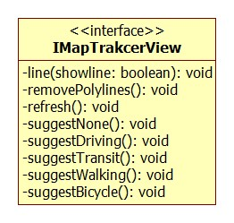

**Properties:** N/A

**Operations**

|  |  |  |
| --- | --- | --- |
| Signature: void line(boolean showline)  Description: Add or remove polylines between marker on map in order base on showline is true or false. Polylines are get from listPolylineTracker  Return: N/A | | |
| Parameter | **Type** | **Description** |
| showline | boolean | Show if true, remove if false |

|  |  |  |
| --- | --- | --- |
| Signature: void refresh()  Description: Re-load map, locations, call method boundMarker(), showline()  Return: N/A | | |
| Parameter | **Type** | **Description** |
| N/A | N/A | N/A |

|  |  |  |
| --- | --- | --- |
| Signature: void suggestNone()  Description: Call removePolyline() method  Return: N/A | | |
| Parameter | **Type** | **Description** |
| N/A | N/A | N/A |

|  |  |  |
| --- | --- | --- |
| Signature: void suggestDriving()  Description: Call removePolyline(), change suggestion mode into Driving  Return: N/A | | |
| Parameter | **Type** | **Description** |
| N/A | N/A | N/A |

|  |  |  |
| --- | --- | --- |
| Signature: void suggestDriving()  Description: Call removePolyline(), change suggestion mode into Driving  Return: N/A | | |
| Parameter | **Type** | **Description** |
| N/A | N/A | N/A |

|  |  |  |
| --- | --- | --- |
| Signature: void suggestTransit()  Description: Call removePolyline(), change suggestion mode into Transit  Return: N/A | | |
| Parameter | **Type** | **Description** |
| N/A | N/A | N/A |

|  |  |  |
| --- | --- | --- |
| Signature: void suggestWalking()  Description: Call removePolyline(), change suggestion mode into Walking  Return: N/A | | |
| Parameter | **Type** | **Description** |
| N/A | N/A | N/A |

|  |  |  |
| --- | --- | --- |
| Signature: void suggestBycicle()  Description: Call removePolyline(), change suggestion mode into Bycicle  Return: N/A | | |
| Parameter | **Type** | **Description** |
| N/A | N/A | N/A |

#### MapTrackerView

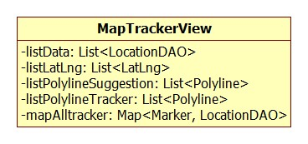

**Properties**

|  |  |  |  |
| --- | --- | --- | --- |
| Property name | Type | Visibility | Description |
| listData | List<LocationDTO> | private | List of location load from server |
| listLatLng | List<LatLng> | private | List of latitude and longitude of markers |
| listPolylineSuggestion | List<Polyline> | private | List of polyline user for suggestion |
| listPolylineTracker | List<Polyline> | private | List of polyline user for tracking |
| mapAllTracker | Map<Marker, LocationDTO> | private | A couple data of marker and location |

**Operations:** N/A

#### IGridView

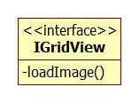

**Properties** N/A

**Operations**

|  |  |  |
| --- | --- | --- |
| Signature: void loadImage()  Description: Load all image of this location on screen with small size  Return: N/A | | |
| Parameter | **Type** | **Description** |
| N/A | N/A | N/A |

#### GridView

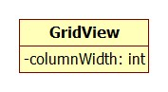

**Properties**

|  |  |  |  |
| --- | --- | --- | --- |
| Property name | Type | Visibility | Description |
| columnWidth | int | private | Width of one column in view  (total 3 column) |

#### IFullScreenView

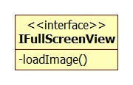

**Properties** N/A

**Operations**

|  |  |  |
| --- | --- | --- |
| Signature: void loadImage()  Description: Load an image with full size  Return: N/A | | |
| Parameter | **Type** | **Description** |
| N/A | N/A | N/A |

### Business Logic Component

#### Class Diagram

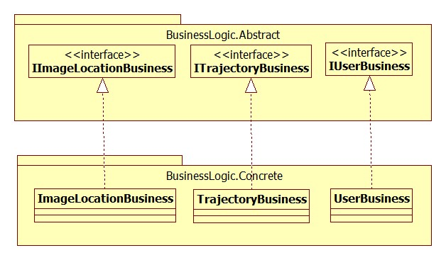

Diagram 15: Class Diagram: Business Logic

#### IImageLocationBusiness

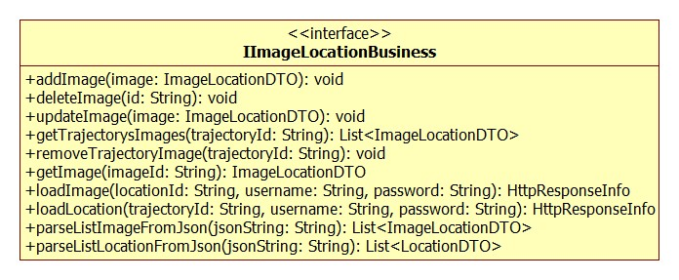

**Properties** N/A

**Operations**

|  |  |  |
| --- | --- | --- |
| Signature: void addImage(ImageLocationDTO image)  Description: Add an image to table ImageTable on local database  Return: N/A | | |
| Parameter | **Type** | **Description** |
| image | ImageLocationDTO | The image that need to be added |

|  |  |  |
| --- | --- | --- |
| Signature: void deleteImage(String id)  Description: Delete an image from table ImageTable on local database  Return: N/A | | |
| Parameter | **Type** | **Description** |
| id | String | Id of the image |

|  |  |  |  |
| --- | --- | --- | --- |
| Signature: void updateImage(ImageLocationDTO image)  Description: Update an image on table ImageTable on local database  Return: N/A | | | |
| Parameter | **Type** | | **Description** |
| image | ImageLocationDTO | | The image that need to be update |
| Signature: List<TrajectoryDTO> getTrajectoryImages (String trajectoryId)  Description: Get all image belong to this trajectory from local database  Return: List of image belong to the input trajectory | | | |
| Parameter | **Type** | **Description** | |
| trajectoryId | String | Id of the trajectory | |

|  |  |  |
| --- | --- | --- |
| Signature: void removeTrajectoryImage(String trajectoryId)  Description: Remove all image belong to this trajectory on local database  Return: N/A | | |
| Parameter | **Type** | **Description** |
| trajectoryId | String | Id of the trajectory |

|  |  |  |
| --- | --- | --- |
| Signature: ImageLocationDTO getImage (String id)  Description: Get an image from ImageTable on local database  Return: The image that we want | | |
| Parameter | **Type** | **Description** |
| id | String | Id of the image we want to get |

|  |  |  |
| --- | --- | --- |
| Signature: HttpResponseInfo loadLocation(String trajectoryId, String username, String password)  Description: When click on an trajectory, load all this trajectory’s location to show on map from server  Return: The HttpResponseInfo that store the result | | |
| Parameter | **Type** | **Description** |
| trajectoryId | String | Id of the trajectory that need to get locations from |
| username | String | Username of the current user |
| password | String | Password of the current user |

|  |  |  |
| --- | --- | --- |
| Signature: HttpResponseInfo loadImage(String location, String username, String password)  Description: When click on one location on map, load all image that belong to that location from server  Return: The HttpResponseInfo that store the result | | |
| Parameter | **Type** | **Description** |
| locationId | String | Id of the location that need to get images from |
| username | String | Username of the current user |
| password | String | Password of the current user |

|  |  |  |
| --- | --- | --- |
| Signature: List<ImageLocationDTO> parseListImageFromJson(String JsonString)  Description: Convert from a Json String to a list of ImageLocationDTO object  Return: List of ImgeDTO that has been converted | | |
| Parameter | **Type** | **Description** |
| JsonString | String | The input Json String |

|  |  |  |
| --- | --- | --- |
| Signature: List<LocationDTO> parseLisLocationFromJson(String JsonString)  Description: Convert from a Json String to a list of LocationDTO object  Return: List of LocationDTO that has been converted | | |
| Parameter | **Type** | **Description** |
| JsonString | String | The input Json String |

#### ITrajectoryBusiness

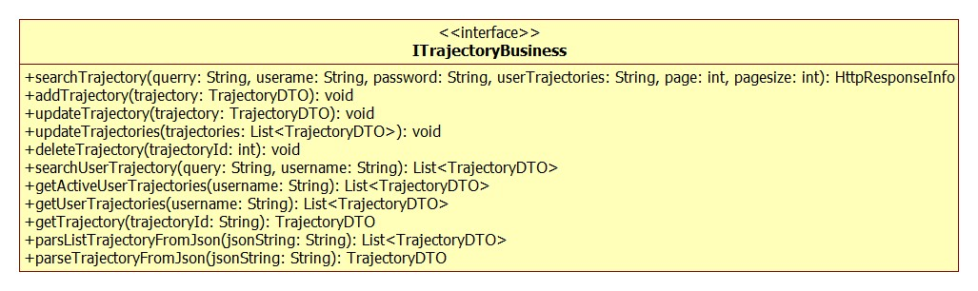

**Properties** N/A

**Operations**

|  |  |  |
| --- | --- | --- |
| Signature: HttpResponseInfo searchTrajectory(String query, String username, String password, String userTrajectories)  Description: Search Trajectory online  Return: HttpResponseInfo that store the result | | |
| Parameter | **Type** | **Description** |
| query | String | Part of the name of the trajectory want to search |
| username | String | Username of the current user, use for authorization |
| password | String | Password of the current user, use for authorization |
| userTrajectories | String | Username of the user who has trajectories |

|  |  |  |
| --- | --- | --- |
| Signature: void addTrajectory(TrajectoryDTO trajectory)  Description: Add a trajectory to local database  Return: N/A | | |
| Parameter | **Type** | **Description** |
| trajectory | TrajectoryDTO | The trajectory need to be added |

|  |  |  |
| --- | --- | --- |
| Signature: void updateTrajectory(TrajectoryDTO trajectory)  Description: Update a trajectory to local database  Return: N/A | | |
| Parameter | **Type** | **Description** |
| trajectory | TrajectoryDTO | The trajectory need to be updated |

|  |  |  |
| --- | --- | --- |
| Signature: void updateTrajectories(List<TrajectoryDTO> trajectories)  Description: Update a list of trajectory to local database  Return: N/A | | |
| Parameter | **Type** | **Description** |
| trajectories | List<TrajectoryDTO> | The list of trajectory need to be updated |

|  |  |  |
| --- | --- | --- |
| Signature: void deleteTrajectories(String trajectoryId)  Description: Delete a trajectory in local database  Return: N/A | | |
| Parameter | **Type** | **Description** |
| trajectoryId | String | Id of the trajectory need to be deleted |

|  |  |  |
| --- | --- | --- |
| Signature: List<TrajectoryDTO> searchUserTrajectory (String query, String username)  Description: Search trajectories of one user on local database  Return: List of trajectory | | |
| Parameter | **Type** | **Description** |
| query | String | Part of the name of the trajectory want to search |
| username | String | Username of the user who has this trajectory |

|  |  |  |
| --- | --- | --- |
| Signature: List<TrajectoryDTO> getActiveUserTrajectory (String username)  Description: Get all trajectory that belong to the user and active from local database  Return: List of trajectory | | |
| Parameter | **Type** | **Description** |
| username | String | Username of the user who has trajectories |

|  |  |  |
| --- | --- | --- |
| Signature: List<TrajectoryDTO> getUserTrajectory (String username)  Description: Get all trajectory that belong to the user, both active and inactive trajectory from local database  Return: List of trajectory | | |
| Parameter | **Type** | **Description** |
| username | String | Username of the user who has trajectories |

|  |  |  |
| --- | --- | --- |
| Signature: TrajectoryDTO getTrajectory(String trajectoryId)  Description: Get one trajectory by ID from local database  Return: One trajectory that has ID match the input ID | | |
| Parameter | **Type** | **Description** |
| trajectoryId | String | ID of the trajectory |

|  |  |  |
| --- | --- | --- |
| Signature: List<TrajectoryDTO> parseListTrajectoryFromJson(String jsonString)  Description: Convert an JSON in String format to a list of trajectory  Return: List of trajectory | | |
| Parameter | **Type** | **Description** |
| jsonString | String | The input JSON in String format |

|  |  |  |
| --- | --- | --- |
| Signature: TrajectoryDTO parseTrajectoryFromJson(String jsonString)  Description: Convert an JSON in String format to a trajectory  Return: One trajectory | | |
| Parameter | **Type** | **Description** |
| jsonString | String | The input JSON in String format |

#### IUserBusiness

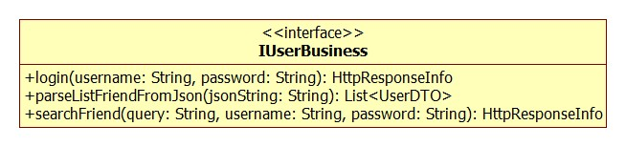

**Properties** N/A

**Operations**

|  |  |  |
| --- | --- | --- |
| Signature: HttpResponseInfo login(String username, String password)  Description: Login to system online  Return: HttpResponseInfo that store the result | | |
| Parameter | **Type** | **Description** |
| username | String | Username of the current user, use for authorization |
| password | String | Password of the current user, use for authorization |

|  |  |  |
| --- | --- | --- |
| Signature: HttpResponseInfo searchFriends(String query, String username, String password)  Description: Search Friends online  Return: HttpResponseInfo that store the result | | |
| Parameter | **Type** | **Description** |
| query | String | Part of the name of the friend want to search |
| username | String | Username of the current user, use for authorization |
| password | String | Password of the current user, use for authorization |

|  |  |  |
| --- | --- | --- |
| Signature: List<UserDTO> parseListFriendsFromJson(String jsonString)  Description: Convert an JSON in String format to a list of user  Return: List of user | | |
| Parameter | **Type** | **Description** |
| jsonString | String | The input JSON in String format |

## Sequence Diagrams

### [WebApplication] Search Trajectory

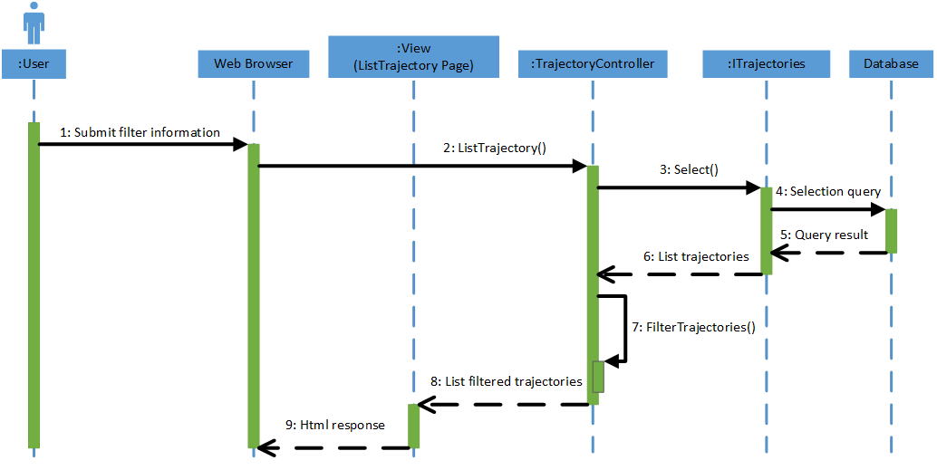

Diagram 16: Sequence Diagram: Web Application - Search Trajectory

### [WebApplication] Update Trajectory

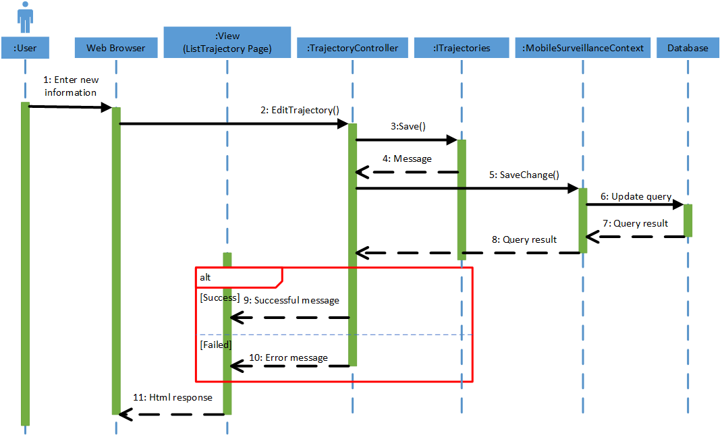

Diagram 17: Sequence Diagram: Web Application - Update Trajectory

### [WebApplication] Delete Trajectory

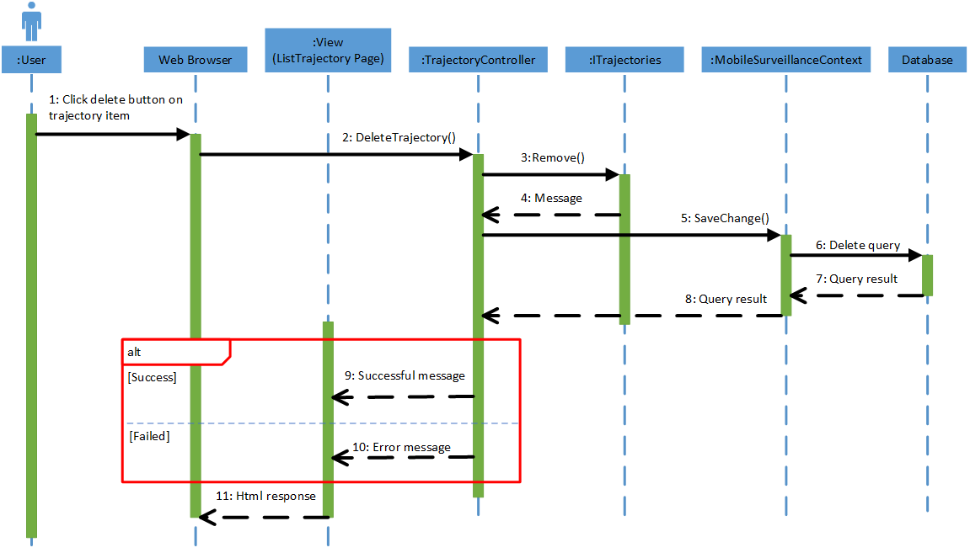

Diagram 18: Sequence Diagram: Web Application - Delete Trajectory

### [WebApplication] Remove Location

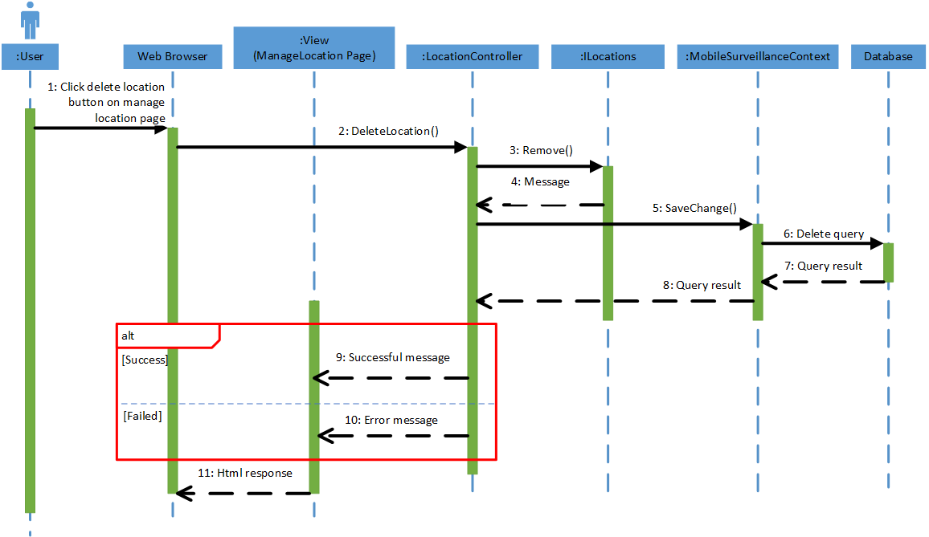

Diagram 19: Sequence Diagram: Web Application - Remove Location

### [WebApplication] Remove Image

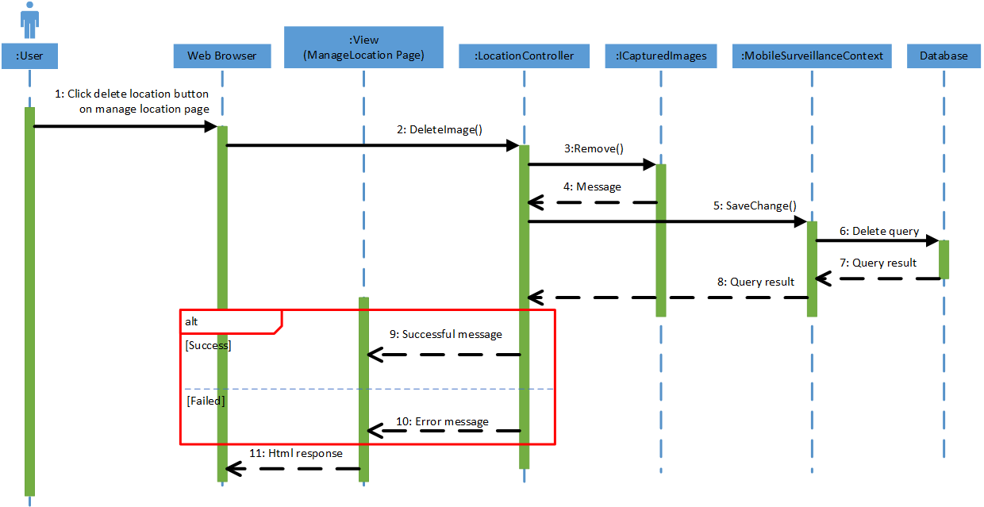

Diagram 20: Sequence Diagram: Web Application - Remove Image

### [WebApplication] Search All User

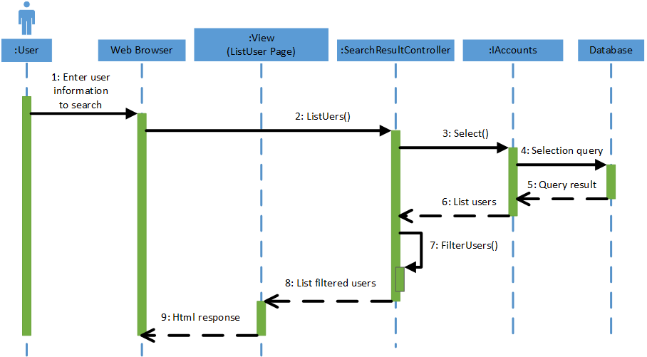

Diagram 21: Sequence Diagram: Web Application - Search All User

### [WebApplication] Send Friend Request

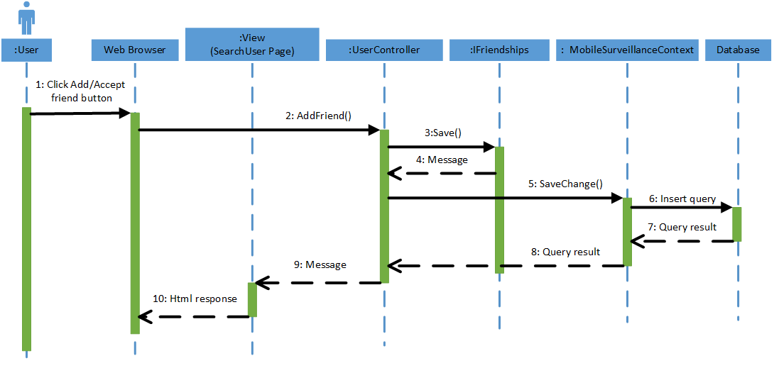

Diagram 22: Sequence Diagram: Web Application - Send Friend Request

### [WebApplication] View Trajectory

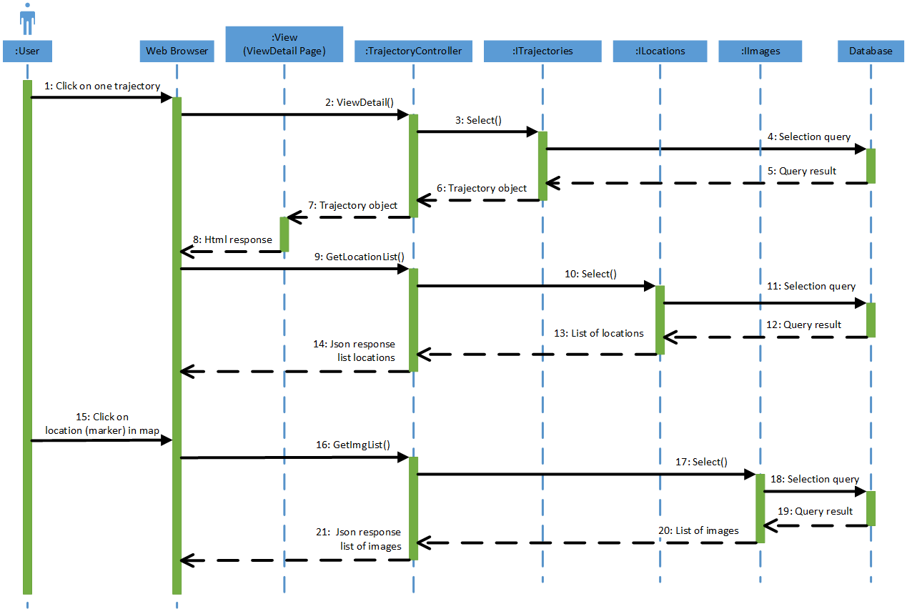

Diagram 23: Sequence Diagram: Web Application - View Trajectory

### [MobileApplication] Create Trajectory

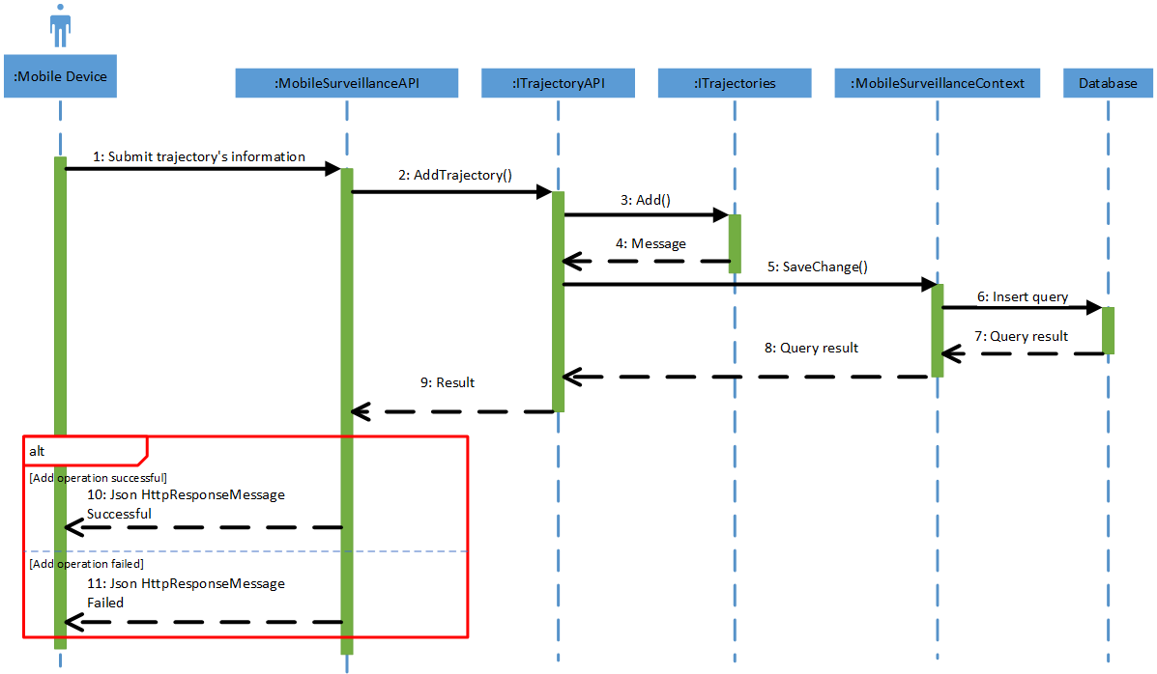

Diagram 24: Sequence Diagram: Mobile Application - Create Trajectory

### [MobileApplication] Edit Trajectory

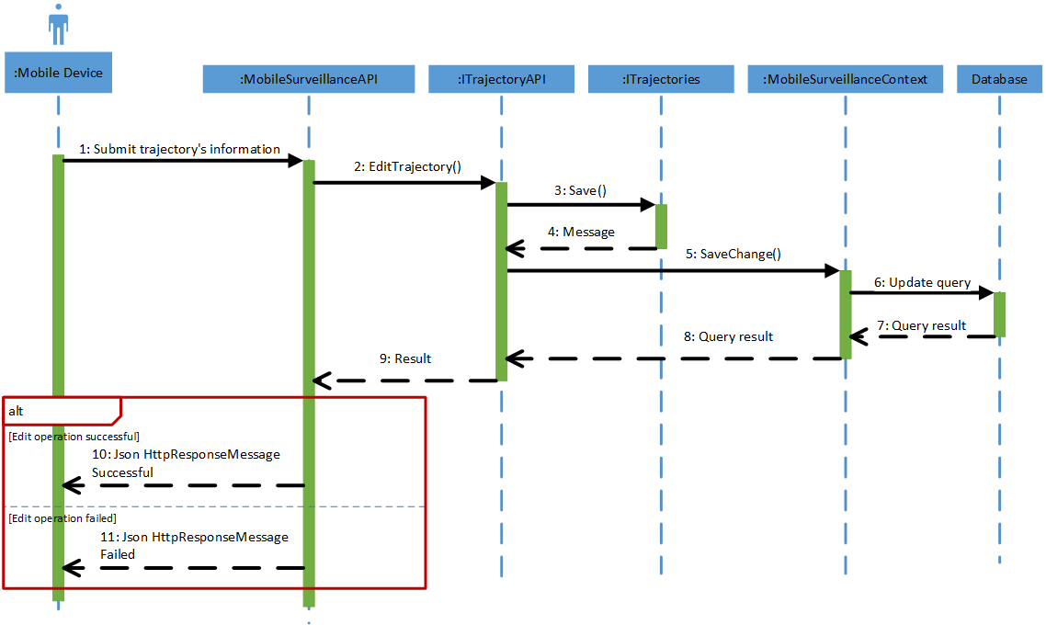

Diagram 25: Sequence Diagram: Mobile Application - Edit Trajectory

### [MobileApplication] Search Trajectory

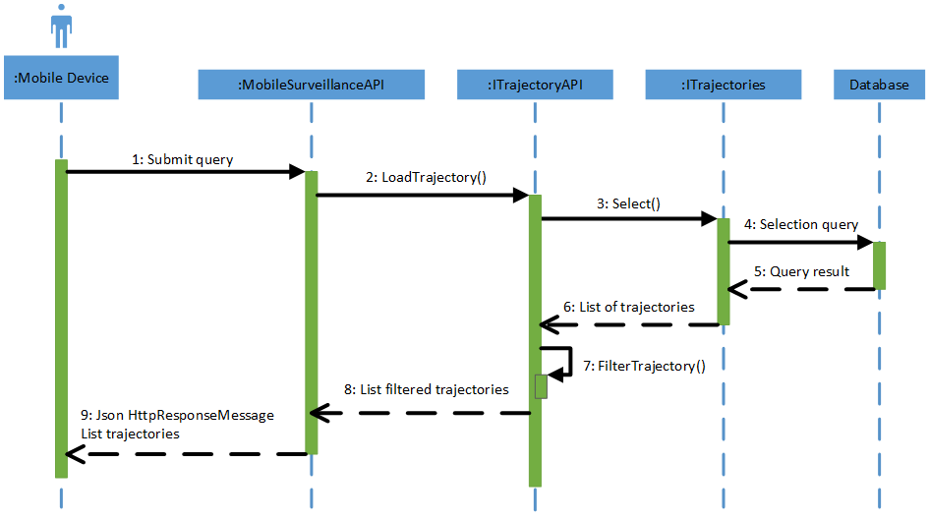

Diagram 26: Sequence Diagram: Mobile Application - Search Trajectory

### [MobileApplication] Upload Images

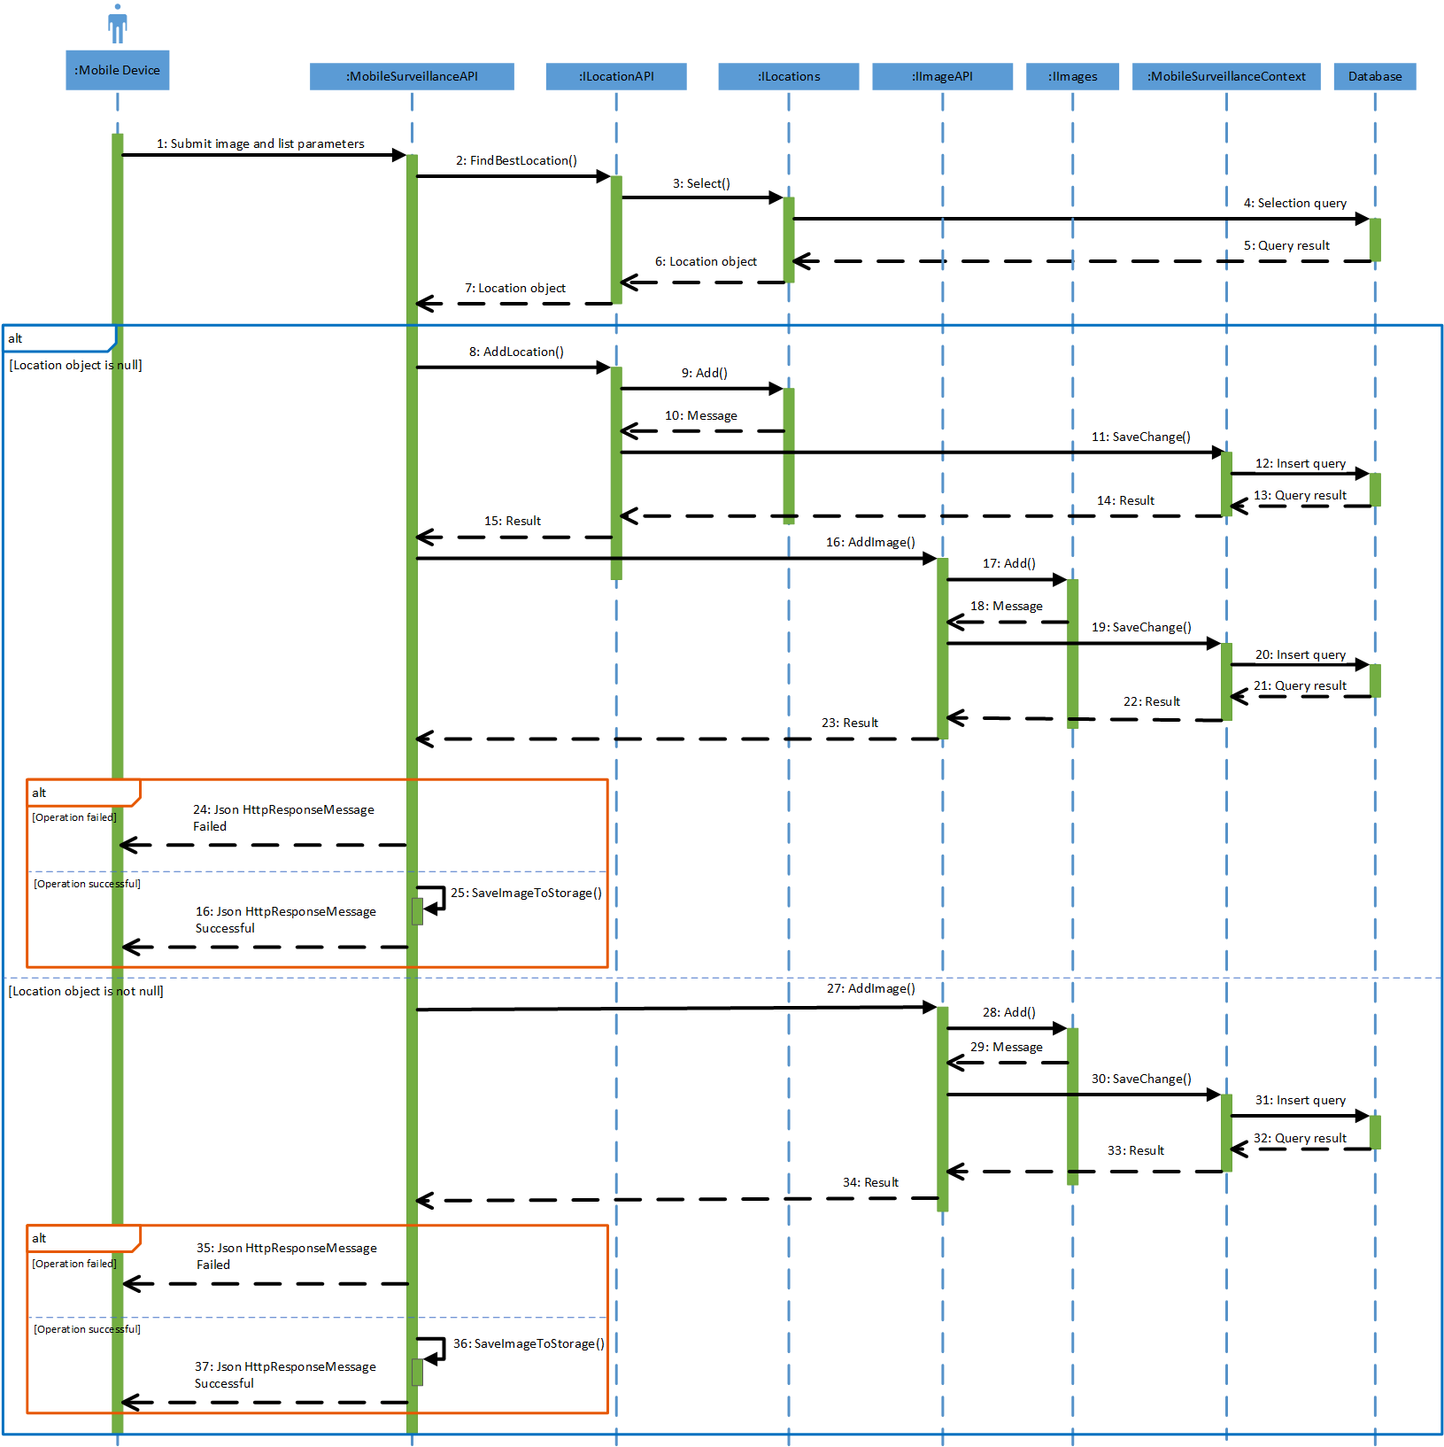

Diagram 27: Sequence Diagram: Mobile Application - Upload Images

### [MobileApplication] Track On Map

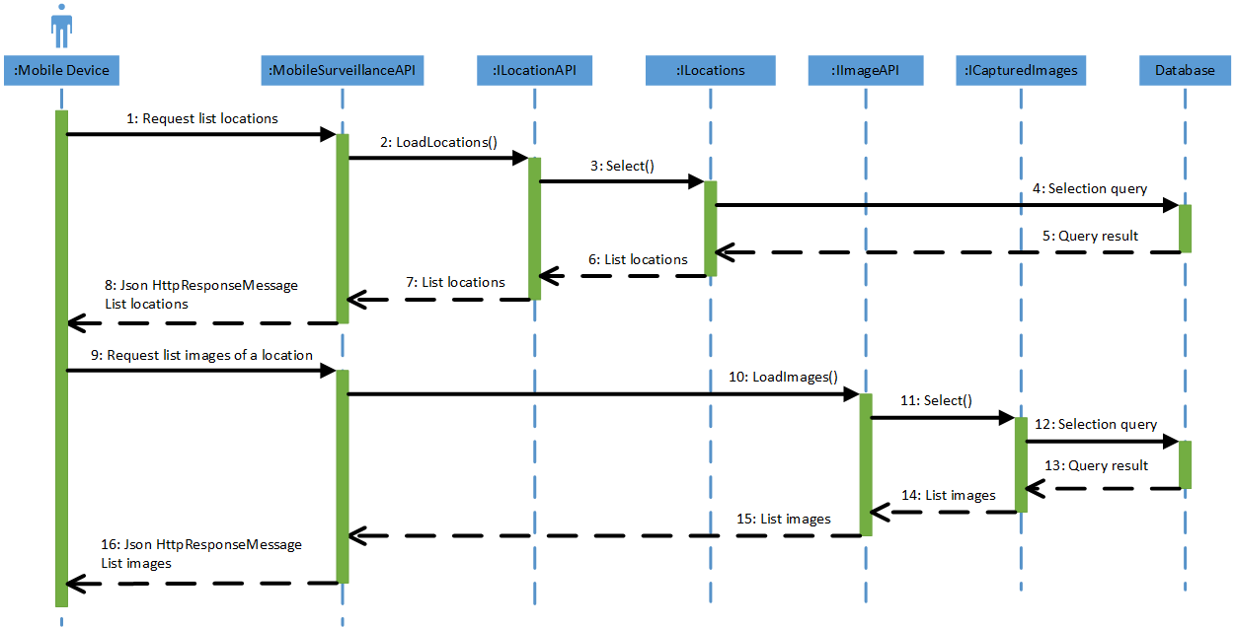

Diagram 28: Sequence Diagram: Mobile Application - Track On Map



## User Interface Design

### Mobile Application

#### Login

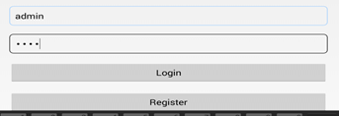

2

1

3

4

|  |  |  |  |  |  |  |
| --- | --- | --- | --- | --- | --- | --- |
| No. | Element | Description | Read Only | Mandatory | Control Type | Data type |
| 1. | Username textbox | Name of the User | No | Yes | Textbox | Text |
| 2. | Password textbox | Password of the User | No | Yes | Textbox | Text |
| 3. | Login button | The button that summit the User name and password, then the User log to application. | N/A | N/A | Button | N/A |
| 4. | Register link | The link to redirect to register page if user haven’t got the account yet. | N/A | N/A | Link | N/A |

#### Home page – Trajectories

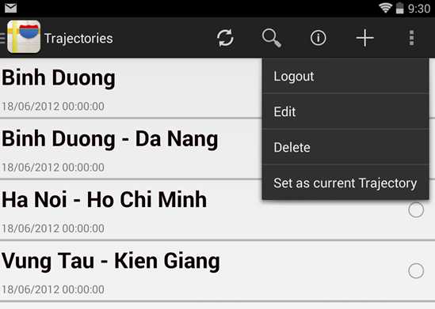

6

5

7

8

9

1

2

3

4

10

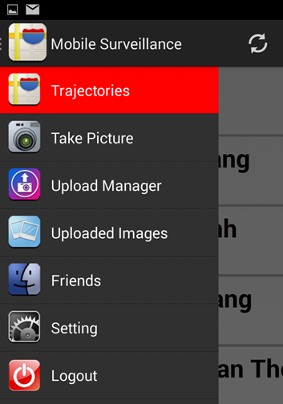

11

12

13

14

15

16

17

|  |  |  |  |  |  |  |  |
| --- | --- | --- | --- | --- | --- | --- | --- |
| No. | | Element | Description | Read Only | Mandatory | Control Type | Data type |
| 1. | | Refresh button | The button to refresh to default. | N/A | N/A | Button | N/A |
| 2. | | Search button | The button to summit the search key. | N/A | N/A | Button | N/A |
| 3. | | Information button | The button to show the information of the trajectory ( name, date time,…) | N/A | N/A | Button | N/A |
| 4. | | Create button | The button redirect to create new trajectory page. | N/A | N/A | Button | N/A |
| 5. | | “Log out” link | The link to log out from mobile | N/A | N/A | Link | N/A |
| 6. | | “Edit” link | The link to redirect to the edit trajectory page. | N/A | N/A | Link | N/A |
| 7. | | “Delete” link | The link to delete | N/A | N/A | Link | N/A |
| 8. | | “Set as current Trajectory” link | The link to set the selected trajectory as the current trajectory. | N/A | N/A | Link | N/A |
| 9. | | Select radio button | The radio button to select the trajectory. | N/A | N/A | Button | N/A |
| 10. | | Trajectory name section | Detail information of the trajectory (name, date time create). | N/A | N/A | Div | N/A |
| 11. | | “Trajectories” slider menu | The slider menu to redirect to the Trajectories page. | N/A | N/A | Link | N/A |
| 12. | | “Take picture” slider menu | The slider menu to redirect the take picture page, turn to camera mode. | N/A | N/A | Link | N/A |
| 13. | | “Upload Manager” slider menu | The slider menu to redirect to the upload manager page. | N/A | N/A | Link | N/A |
| 14. | | “Uploaded Images” slider menu | The slider menu to redirect to the uploaded Images page. | N/A | N/A | Link | N/A |
| 15. | “Friends” slider menu | | The slider menu to redirect to Friends page. | N/A | N/A | Link | N/A |
| 16. | “Setting” slider menu | | The slider menu to redirect to the setting page. | N/A | N/A | Link | N/A |
| 17. | “Logout” slider menu | | The slider menu to log out from mobile. | N/A | N/A | Link | N/A |

#### Add Trajectory

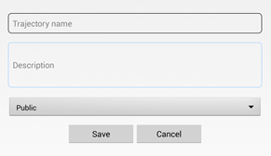

1

2

3

4

5

|  |  |  |  |  |  |  |
| --- | --- | --- | --- | --- | --- | --- |
| No. | Element | Description | Read Only | Mandatory | Control Type | Data type |
| 1. | “Trajectory name” textbox | Name of the trajectory. | No | Yes | Textbox | Text |
| 2. | “Description” textbox | Description of the trajectory. | No | Yes | Textbox | Text |
| 3. | Status dropdown box | Status(Public/Private) of the trajectory. | No | No | Dropdown box | Text |
| 4. | “Save” button | The button to create the new trajectory. | N/A | N/A | Button | N/A |
| 5. | “Cancel” button | The button to exit without create. | N/A | N/A | Button | N/A |

#### Take Picture

##### Manual Take Picture

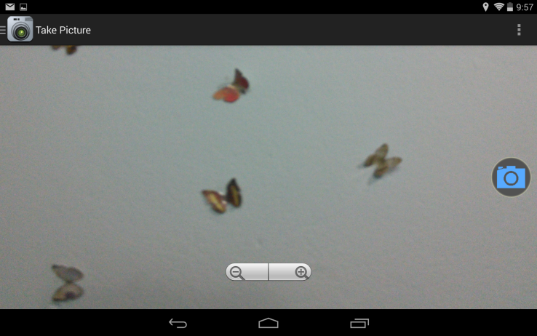

1

21

|  |  |  |  |  |  |  |
| --- | --- | --- | --- | --- | --- | --- |
| No. | Element | Description | Read Only | Mandatory | Control Type | Data type |
| 1. | Capture button | The button to take Picture | N/A | N/A | Button | N/A |
| 2. | Zoom buttons | (-) button to zoom out picture (+)button to zoom in the picture | N/A | N/A | Button | N/A |

##### Auto Take Picture

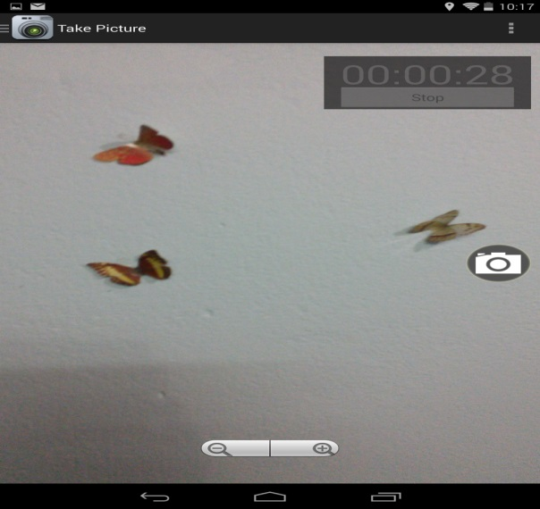

1

2

3

|  |  |  |  |  |  |  |
| --- | --- | --- | --- | --- | --- | --- |
| No. | Element | Description | Read Only | Mandatory | Control Type | Data type |
| 1. | Timer | Timer count down time take picture automatically. | N/A | N/A | Timer | N/A |
| 2. | Start/Stop button | The button to start or stop take picture automatically | N/A | N/A | Button | N/A |
| 3. | Zoom buttons | (-) button to zoom out picture (+)button to zoom in the picture | N/A | N/A | Button | N/A |

#### Upload Manager

1

4

5

6

2

3

7

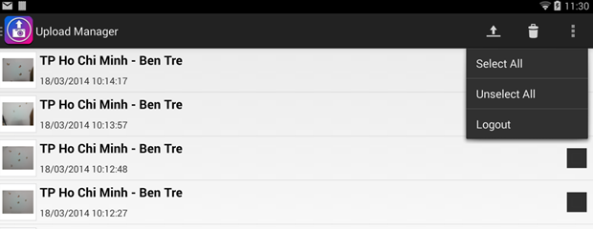

|  |  |  |  |  |  |  |
| --- | --- | --- | --- | --- | --- | --- |
| No. | Element | Description | Read Only | Mandatory | Control Type | Data type |
| 1. | Picture feature section | Detailed information about the picture (the Picture’s trajectory, date and time take picture). | N/A | N/A | Div | N/A |
| 2. | Upload button | The button to upload the selected picture to webserver | N/A | N/A | Button | N/A |
| 3. | Delete button | The button to delete the pictures. | N/A | N/A | Button | N/A |
| 4. | “Select all” link | The link to check all the pictures. | N/A | N/A | Link | N/A |
| 5. | “Unselect all” link | The link to uncheck all the pictures. | N/A | N/A | Link | N/A |
| 6. | “Logout” link | The link to log out from mobile. | N/A | N/A | Link | N/A |
| 7. | Selection checkbox | To select a picture. | N/A | N/A | Check box | N/A |

3

1

2

48

#### Friends

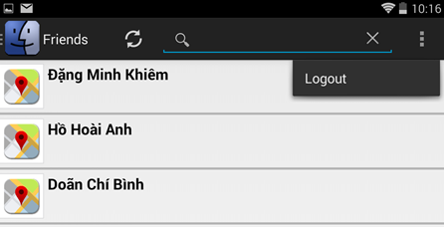

|  |  |  |  |  |  |  |
| --- | --- | --- | --- | --- | --- | --- |
| No. | Element | Description | Read Only | Mandatory | Control Type | Data type |
| 1. | Refresh button | The button to refresh page to default. | N/A | N/A | Button | N/A |
| 2. | Search textbox | The textbox to enter the search key | No | Yes | Textbox | Text |
| 3. | Friend name section | Detail information friend’s name |  |  |  |  |
| 4. | “Logout” link | The link to log out from mobile | N/A | N/A | Link | N/A |

#### Setting

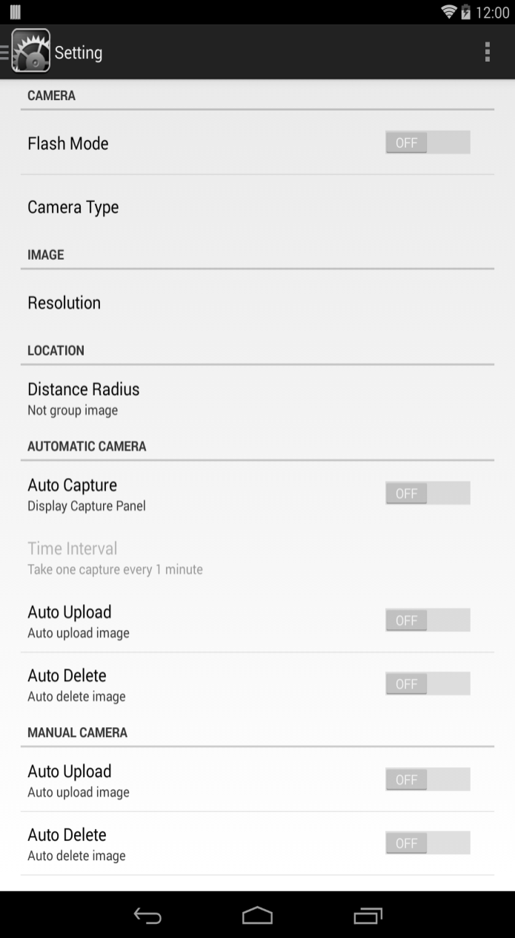

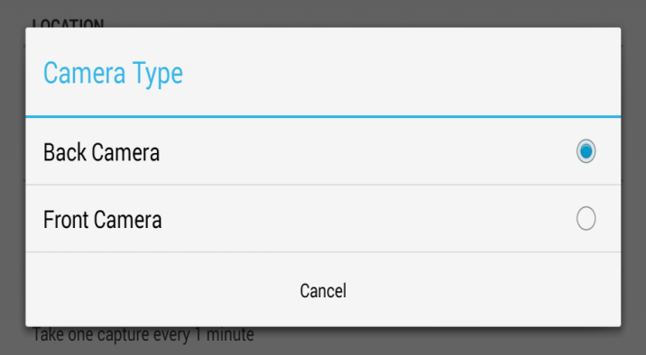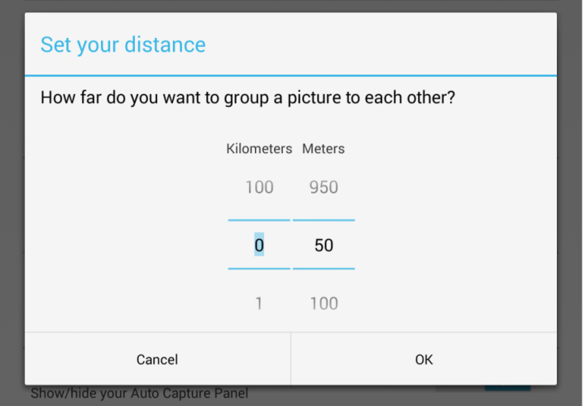

14

15

16

1

48

58

7

88

98

6

3

2

11

10

13

12

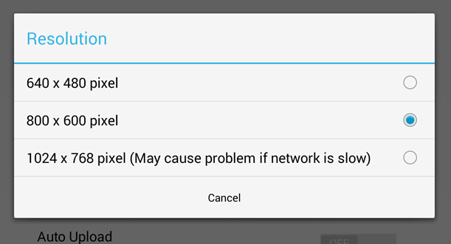

17

|  |  |  |  |  |  |  |
| --- | --- | --- | --- | --- | --- | --- |
| No. | Element | Description | Read Only | Mandatory | Control Type | Data type |
| 1. | Flash light switch | The switch (on/off) the flash light. | N/A | N/A | Switch | Boolean |
| 2. | Camera type link | The link to the pop up choose camera type | N/A | N/A | Link | N/A |
| 3. | Resolution | The link to the pop up to set the picture pixel. | N/A | N/A | Link | N/A |
| 4. | Distance radius link | The link to the pop up to set the distance to each picture | N/A | N/A | Link | N/A |
| 5. | Auto Capture switch | The switch (on/off) the auto capture mode | N/A | N/A | Switch | Boolean |
| 6. | Auto upload switch | The switch (on/off) the auto upload mode | N/A | N/A | Switch | Boolean |
| 7. | Delete after upload switch | The switch (on/off) the auto Delete after upload mode | N/A | N/A | Switch | Boolean |
| 8. | Auto upload switch | The switch (on/off) the auto upload mode | N/A | N/A | Switch | Boolean |
| 9. | Delete after upload switch | The switch (on/off) the auto Delete after upload mode | N/A | N/A | Switch | Boolean |
| 10. | Kilometers | The to set the kilometers | N/A | Yes | List | Integer |
| 11. | Meters | The to set the meters | N/A | Yes | List | Integer |
| 12. | Cancel button | The button to exit without change | N/A | N/A | Button | N/A |
| 13. | Ok button | The button to save the Compact distance. | N/A | N/A | Button | N/A |
| 14. | Back camera radio button | The radio button to choose the camera type | N/A | N/A | Button | N/A |
| 15. | Front camera button | The radio button to choose the camera type | N/A | N/A | Button | N/A |
| 16. | Cancel button | The button to exit camera type mode without change | N/A | N/A | Button | N/A |
| 17. | Select pixel radio button | The radio button to set the picture pixel | N/A | N/A | Radio button | N/A |

### Web Application

#### Login

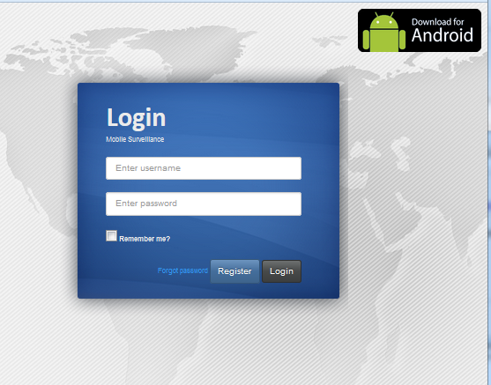

7

1

2

5

6

4

3

|  |  |  |  |  |  |  |
| --- | --- | --- | --- | --- | --- | --- |
| No. | Element | Description | Read Only | Mandatory | Control Type | Data type |
| 1. | Username textbox | The textbox to enter user name | No | Yes | Textbox | Text |
| 2. | Password textbox | The textbox to enter the user password | No | Yes | Textbox | Text |
| 3. | “Remember me?” check box | The check box to keep you from the web. | N/A | N/A | Checkbox | boolean |
| 4. | “Forgot Password” link | The link to redirect to the forgot password page. | N/A | N/A | Link | N/A |
| 5. | “Register” button | The button to redirect to the register page. | N/A | N/A | Button | N/A |
| 6. | “Login” button | The button to summit username and password to login. | N/A | N/A | Button | N/A |
| 7. | “Down load for Android” link | The link to down load file apk for mobile installation. | N/A | N/A | Link | N/A |

#### Forgot Password

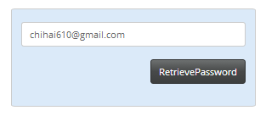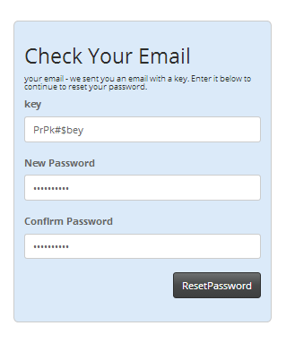

1

2

3

4

5

61

|  |  |  |  |  |  |  |
| --- | --- | --- | --- | --- | --- | --- |
| No. | Element | Description | Read Only | Mandatory | Control Type | Data type |
| 1. | “Email” textbox | The textbox to enter email | No | Yes | Textbox | Text |
| 2. | “Retrieve Password” button | The textbox to enter Password | No | Yes | Button | Text |
| 3. | “key” textbox | The textbox to enter key that mobileSuveillance had given | No | Yes | Textbox | Text |
| 4. | “New Password” textbox | The textbox to enter new password | No | Yes | Textbox | Text |
| 5. | “Confirm password” textbox | The textbox to enter new password | No | Yes | Textbox | Text |
| 6. | “Reset password” button | Button to summit. | No | Yes | Button | Text |
|  | | | | | | |

#### Register

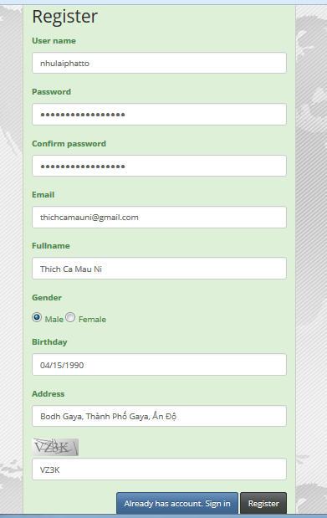

8

9

10

2

3

6

7

5

4

1

11

|  |  |  |  |  |  |  |
| --- | --- | --- | --- | --- | --- | --- |
| No. | Element | Description | Read Only | Mandatory | Control Type | Data type |
| 1. | “Username” textbox | The textbox to enter user name | No | Yes | Textbox | Text |
| 2. | “Password” textbox | The textbox to enter Password | No | Yes | Textbox | Text |
| 3. | “Confirm Password” textbox | The textbox to enter Confirm Password | No | Yes | Textbox | Text |
| 4. | “Email” textbox | The textbox to enter Email | No | Yes | Textbox | Text |
| 5. | “Full name” textbox | The textbox to enter user name | No | Yes | Textbox | Text |
| 6. | Gender radio button | The radio button to choose user gender | No | Yes | Radio button | Text |
| 7. | “Birthday” textbox | The textbox to enter Birthday | No | Yes | Textbox | Text |
| 8. | “Address” textbox | The textbox to enter Address | No | Yes | Textbox | Text |
| 9. | “Security code” textbox | The textbox to enter Security code | No | Yes | Textbox | Text |
| 10 | “Sign in” button | The button to back to the login page. | No | Yes | Button | Text |
| 11. | “Register” button | The button to summit data for register to server. | No | Yes | Button | Text |

#### Trajectories

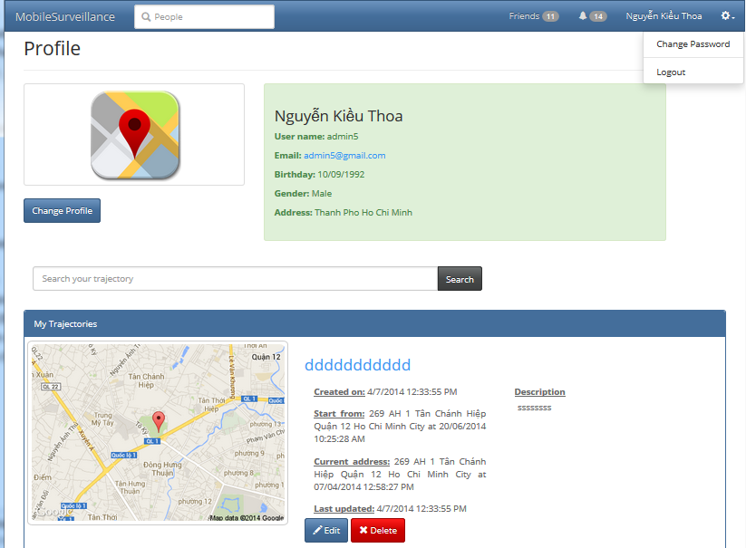

3

4

5

6

7

11

12

1

8

9

10

2

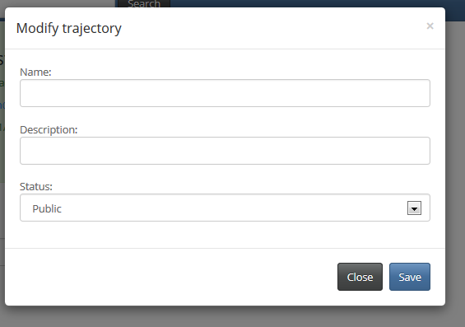

13

14

15

16

17

|  |  |  |  |  |  |  |
| --- | --- | --- | --- | --- | --- | --- |
| No. | Element | Description | Read Only | Mandatory | Control Type | Data type |
| 1. | User search box | The textbox to enter the user name to search. | No | Yes | Textbox | Text |
| 2. | User information section | Detail information of the user (avatar, name, email,…) | N/A | N/A | Div | N/A |
| 3. | Friend notification | The notification to show the friend number. | N/A | N/A | Notification | Text |
| 4. | Inbox notification | The notification to show the inbox message. | N/A | N/A | Notification |  |
| 5. | User name section | Detail information user name. | N/A | N/A | Div | N/A |
| 6. | Change password link | The link to change password page. | N/A | N/A | Div | N/A |
| 7. | Logout button | The button to log out. | N/A | N/A | Button | N/A |
| 8. | “Change profile” button | The button to redirect to the account setting page. | N/A | N/A | Button | N/A |
| 9. | Trajectory search box | The search box to search the trajectory. | N/A | N/A | Button | N/A |
| 10. | Trajectory section | Detail information trajectories. | N/A | N/A | Div | N/A |
| 11. | “Delete” button | The button to delete the trajectory. | N/A | N/A | Button | N/A |
| 12. | “Edit” button | The button to pop up the edit page. | N/A | N/A | Button | N/A |
| 13. | “Name” textbox | The textbox to enter the name of the trajectory. | No | Yes | Textbox | Text |
| 14. | “Description” textbox | The textbox to enter the trajectory description. | No | Yes | Textbox | Text |
| 15. | Status dropdown list | The drop down list to choose the status of the trajectory (public, private) | No | No | Dropdown list | Text |
| 16. | “Close” button | The button to close the pop up. | N/A | N/A | Button | N/A |
| 17. | “Save” button | The button to summit changes to database. | N/A | N/A | Button | N/A |

#### View Trajectory

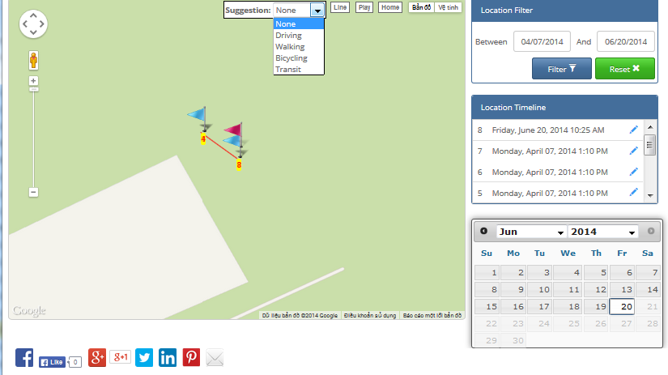

7

12

6

3

5

8

4

2

15

10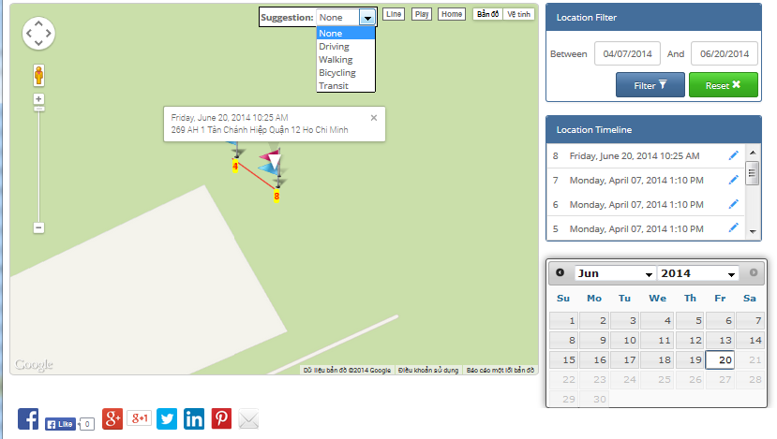

1

9

11

13

14

16

|  |  |  |  |  |  |  |
| --- | --- | --- | --- | --- | --- | --- |
| No. | Element | Description | Read Only | Mandatory | Control Type | Data type |
| 1. | Google map section | The trajectory is shown by Google map. | N/A | N/A | Map | N/A |
| 2 | Suggestion drop down list | The drop down list to help user choose direction depend on vehicle. | N/A | N/A | Drop down list | N/A |
| 3. | “Line” button | The button to shown the line from marker to marker | N/A | N/A | Button | N/A |
| 4. | “Play” button | The button to play the trajectory. | N/A | N/A | Button | N/A |
| 5. | “Home” button | The button to set map to the start marker. | N/A | N/A | Button | N/A |
| 6. | “Map” button | The button to view the trajectory on map. | N/A | N/A | Button | N/A |
| 7. | “Satellite” button | The button to view the trajectory on Satellite | N/A | N/A | Button | N/A |
| 8. | Play marker | The marker go marker to marker on trajectory when user click on play button | N/A | N/A | Marker | N/A |
| 9. | Polyline | The line connect each marker. | N/A | N/A | N/A | N/A |
| 10. | Marker | The marker to mark the pictures on map. | N/A | N/A | Marker | N/A |
| 11. | Start day text box | The textbox to enter the begin date to filter. | No | Yes | Textbox | Text |
| 12. | End day text box | The textbox to enter the end date to filter | No | Yes | Textbox | Text |
| 13. | “Filter” button | The button to shown the line from marker to marker | N/A | N/A | Button | N/A |
| 14. | “Reset button” button | The button to shown the line from marker to marker | N/A | N/A | Button | N/A |
| 15. | “Location Timeline” list | The list to show the date that user had taken photos. | N/A | N/A | List | N/A |
| 16. | Calendar | The calendar to show the date user had taken photos. | N/A | N/A | Calendar | N/A |

#### View Friend List

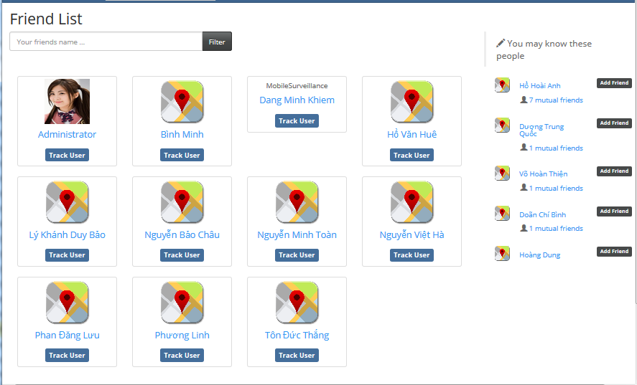

3

4

2

1

|  |  |  |  |  |  |  |
| --- | --- | --- | --- | --- | --- | --- |
| No. | Element | Description | Read Only | Mandatory | Control Type | Data type |
| 1. | Friend filter textbox | The textbox to enter the friend name to filter | No | Yes | Textbox | Text |
| 2 | Friend section | The information about friend. | N/A | N/A | Div | N/A |
| 3. | “Track user” button | The button to shown the line from marker to marker | N/A | N/A | Button | N/A |
| 4. | Suggest friends list | The list to show the suggest friends. | N/A | N/A | List | N/A |

#### Search Trajectory

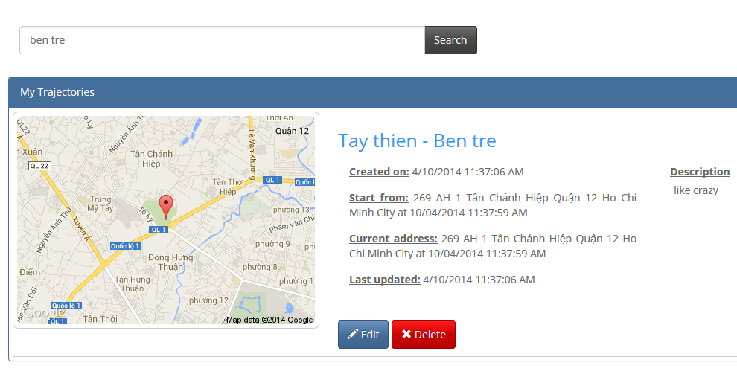

3

4

5

2

1

|  |  |  |  |  |  |  |
| --- | --- | --- | --- | --- | --- | --- |
| No. | Element | Description | Read Only | Mandatory | Control Type | Data type |
| 1. | Search trajectory textbox | The textbox to enter the search key | No | Yes | Textbox | Text |
| 2. | Trajectory name link | The link to the view trajectory on Google map. | N/A | N/A | Link | N/A |
| 3. | Details of a trajectory section | Detailed information of a trajectory. | N/A | N/A | Div | N/A |
| 4. | “Delete” button | The button to delete the trajectory | N/A | N/A | Button | N/A |
| 5. | “Edit” button | The button to edit the trajectory. | N/A | N/A | Button | N/A |

#### Search Friend

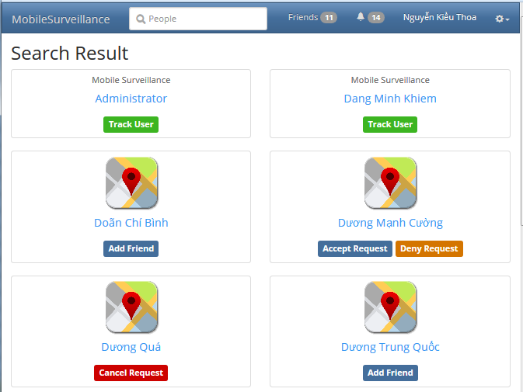

4

6

1

3

5

2

|  |  |  |  |  |  |  |
| --- | --- | --- | --- | --- | --- | --- |
| No. | Element | Description | Read Only | Mandatory | Control Type | Data type |
| 1. | Friend section | The fiend information. | N/A | N/A | Div | N/A |
| 2. | “Track User” button | Go to friend’s trajectories page. | N/A | N/A | Button | N/A |
| 3. | “Add friend” button | To send request. | N/A | N/A | Button | N/A |
| 4. | “Accept Request” button | To accept the request from friend. | N/A | N/A | Button | N/A |
| 5. | “Deny Request” button | To refuse the request from friend | N/A | N/A | Button | N/A |
| 6. | “Cancel Request” button | To cancel the request to friend. | N/A | N/A | Button | N/A |

## Database Design

### Logical database design

Base on ERD specified in the SRS, logical database design includes the following relations:

|  |  |  |
| --- | --- | --- |
| No. | Relation | Description |
| 1. | Role | Store user roles of the system. |
| 2. | Account | Stores account and relate information of user. |
| 3. | Friendship | Stores friends list of a particular user. |
| 4. | Trajectory | Stores trajectory path which user created. |
| 5. | Location | Stores all location points of a trajectory. |
| 6. | CapturedImage | Stores all images in a location. |

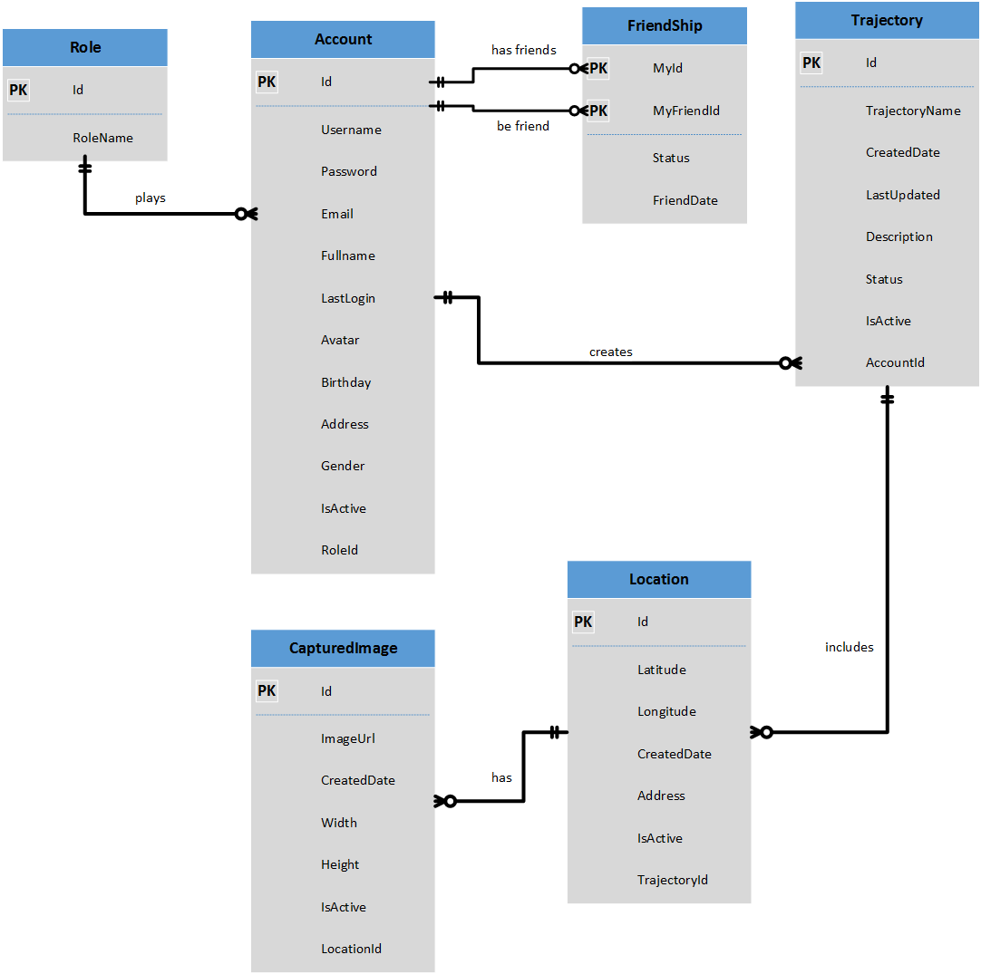

Diagram 29: Database Design: Logical

#### Role Relation

|  |  |  |  |  |  |  |
| --- | --- | --- | --- | --- | --- | --- |
| Field Name | Type | Nullable | Unique | Key | Default | Description |
| *Id* | int |  | 🗹 | PK |  | Unique id that differentiates a role from the others |
| *RoleName* | varchar(20) |  | 🗹 |  |  | Name of role |

#### Account Relation

|  |  |  |  |  |  |  |
| --- | --- | --- | --- | --- | --- | --- |
| Field Name | Type | Nullable | Unique | Key | Default | Description |
| *Id* | long |  | 🗹 | PK |  | Unique id that differentiates an account from the others |
| *Username* | varchar(50) |  | 🗹 |  |  | Unique name that will be used to log into the system |
| *Password* | varchar(50) |  |  |  |  | Security code for each account, use to log into the system |
| *Email* | varchar(50) |  | 🗹 |  |  | Email of user, uses for password recovery |
| *Fullname* | varchar(60) |  |  |  |  | Fullname of user |
| *LastLogin* | datetime |  |  |  |  | Last time user logged into the system |
| *Avatar* | varchar(100) |  |  |  |  | A link which link to avatar of user |
| *Birthday* | datetime |  |  |  |  | Birthday of user |
| *Address* | varchar(100) |  |  |  |  | Address of user |
| *IsActive* | bit |  |  |  |  | Check if user is activated by the system or not |
| *RoleId* | int |  |  | FK |  | Role id of user, reference to Role relation |

#### Friendship Relation

|  |  |  |  |  |  |  |
| --- | --- | --- | --- | --- | --- | --- |
| Field Name | Type | Nullable | Unique | Key | Default | Description |
| *MyId* | long |  |  | PK, FK |  | Id of user reference to relation Account |
| *MyFriendId* | long |  |  | PK, FK |  | Id of another user (friend) reference to relation Account |
| *Status* | varchar(20) |  |  |  |  | Indicate status of relationship between 2 users |
| *FriendDate* | datetime |  |  |  |  | The time user makes/accepts friend request |

#### Trajectory Relation

|  |  |  |  |  |  |  |
| --- | --- | --- | --- | --- | --- | --- |
| Field Name | Type | Nullable | Unique | Key | Default | Description |
| *Id* | varchar(50) |  | 🗹 | PK |  | Unique id that differentiates a trajectory from the others |
| *TrajectoryName* | varchar(1000) |  |  |  |  | Name of trajectory |
| *CreatedDate* | datetime |  |  |  |  | Date which user create trajectory |
| *LastUpdated* | datetime |  |  |  |  | Date which user updated trajectory last time |
| *Description* | varchar(5000) |  |  |  |  | Description of trajectory |
| *Status* | varchar(20) |  |  |  |  | Status of trajectory to be public to share or private |
| *IsActive* | bit |  |  |  |  | Whether or not this trajectory is available for user to operate |
| *AccountId* | long |  |  | FK |  | Reference to Id of Account relation, indicate that this trajectory belong to a user |

#### Location Relation

|  |  |  |  |  |  |  |
| --- | --- | --- | --- | --- | --- | --- |
| Field Name | Type | Nullable | Unique | Key | Default | Description |
| *Id* | varchar(50) |  | 🗹 | PK |  | Unique id that differentiates a location from the others |
| *Latitude* | float |  |  |  |  | Latitude coordinate of location |
| *Longitude* | float |  |  |  |  | Longitude coordinate of location |
| *CreatedDate* | datetime |  |  |  |  | Date which location was recorded |
| *Address* | varchar(200) |  |  |  |  | Address which location belong to |
| *IsActive* | bit |  |  |  |  | Whether or not this location is available in a trajectory |
| *TrajectoryId* | varchar(50) |  |  | FK |  | Reference to Id of Trajectory relation, indicate that this location belong to a trajectory |

#### CapturedImage Relation

|  |  |  |  |  |  |  |
| --- | --- | --- | --- | --- | --- | --- |
| Field Name | Type | Nullable | Unique | Key | Default | Description |
| *Id* | long |  | 🗹 | PK |  | Unique id that differentiates an image from the others |
| *ImageUrl* | varchar(200) |  |  |  |  | A link which link to the storage where image is stored |
| *CreatedDate* | datetime |  |  |  |  | Date which image was taken |
| *Width* | int |  |  |  |  | Width of image |
| *Height* | int |  |  |  |  | Height of image |
| *IsActive* | bit |  |  |  |  | Whether or not this image is visible in a location |
| *LocationId* | varchar(50) |  |  | FK |  | Reference to Id of Location relation, indicate that this image belong to a location |

### Physical database design

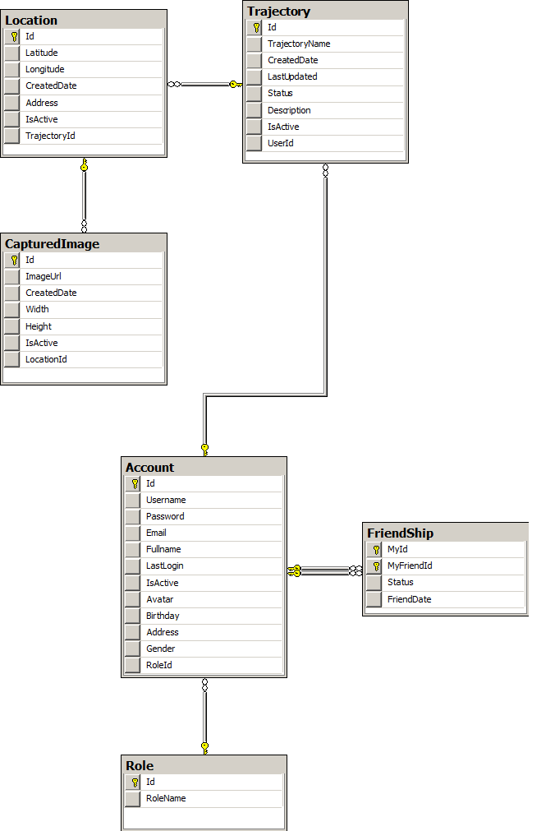

Diagram 30: Database Design: Physical

# 番５のレポート。システムの展開とテスト (SIT)



## はじめに

### システムの概要

ユーザの観点から、Mobile Surveillance システムは、次の順序に動作する。

### テストアプローチ

ユニットテスト、統合テスト、システムテスト、および受け入れテスト：システムは、主要な段階を含め、ソフトウェアプロジェクトのための通常のテスト手法は、次のテストされます。

システムはソフトウェアプロジェクトのために、通常のテスト手法どおりにテストされ、ユニットテスト、統合テスト、システムテスト、および受け入れテストという主要な段階も含める。

まず、各メンバーはが、自分が開発したユニットテストのすべてのユニットのモジュールをテストするための責任を負うことになるります。後で他のチームメンバーはが、後で、詳細設計に準拠していすることを確認することによって、開発されたモジュールを承認するします。

第二に、チームリーダーが他のチームメンバーの支援を受けて、アプリケーション全体の統合テストを実行するします。

次に、チームメンバーの全員はすべてが、システムが最初の指定した仕様要求と一致することを確認して、システムのテストを実施しますする。

最後に、プロジェクトのスーパーバイザーはが、すべてのチームメンバーの全員の支援を受けて、受け入れテストのための責任を負うことになるります。

## テストの計画

次の機能は、システム•テスト, このテストドキュメントに、結果が指定されているでしょう。テスト機能の順序は、システムのメインフローに記載されています。

以下のリストは、テストのための標的として識別された要素（ユースケース、機能要件、非機能要件）を識別する。このリストは、テストされるかを表す

### 機能要件

#### 携帯のアプリケーシオン

|  |  |  |  |
| --- | --- | --- | --- |
| 番号 | フィーチャー | 説明 | 担当者 |
| 1. | ログイン | ユーザーが承認されたリソースにアクセスする前に、ユーザーが認証されか、テストする。 | ThoaNK |
| 2. | TRAJECTORYの作成する | ユーザーが新しい軌道を追加できるかテストする。 | KhiemDM |
| 3. | 写真の撮る | ユーザーがモバイルアプリケーションで写真を撮ることができているかテストする。 | BaoLKD |
| 4. | 写真のセッティング | ユーザが画像の設定を設定することができかテストする | BaoLKD |
| 5. | 写真のアップロード | ユーザーがサーバーに画像をアップロードすることができているかテストする。 | KhiemDM |

#### ウェブアプリケーション

|  |  |  |  |
| --- | --- | --- | --- |
| 番号 | フィーチャー | 説明 | 担当者 |
| 1. | ログイン | ユーザーは承認されたリソースにアクセスする前に、ユーザーが認証されかテストする。 | ThoaNK |
| 2. | レジスタ | ユーザーがモバイル·アプリケーションから、新しいアカウントを作成することができるかテストする. | ThoaNK |
| 4. | TRAJECTORYのビュー | ユーザーがWebブラウザでGoogleマップ上に自分の軌道をみるすることができるかをテストする。 | NangPD |
| 5. | TRAJECTORYのデリート | ユーザーは自分の軌道を削除できるかテストする。 | NangPD |
| 6. | FRIENDのTRAJECTORY.のビュー | ユーザーは友人の軌跡を表示することができますかどうかをテスト。 | NangPD |
| 7. | FRIENDのサーチ | ユーザーがプロファイルを検索し、表示できるかどうかテストします。 | ToanNM |
| 8. | FRIENDのデテール のビュー | ユーザーが他の友達を監視することができるかをテストする。 | ToanNM |
| 9. | リクエストの受信トレイ | ユーザーは友達をつくる・削除することができるかテストする。 | ToanNM |

### 非機能要件

**確実性**

コネクトの状態とディスコネクトの状態を管理して、シンクロナイズできます

**有効性**

サーバは99%の時代に可用です

**機密性**

どんな操作でも、実現するの事前に、ユーザはログインしなければなりません

**保守性**

すべてのインフラストラクチャの問題が４寺以内で片付けさせなかればなりません

**移植性**

ウェブブラウザがあるのパソコン若しくはアンドロイドのバジョンが4.0以上のデバイスがあれば、インターネットにコネクトをできれば、システムにコネクトをできます

**パーフォーマンス**

同時に百のアクセスを我慢できます

## テストケース

### 携帯のアプリケーシオン

#### ログイン-

|  |  |  |  |  |  |  |  |
| --- | --- | --- | --- | --- | --- | --- | --- |
| 識別 | テスト項目説明 | テスト項目手順 | 期待結果 | 依存テスト項目 | 結果 | テスト実施日 | ノート |
|  | **主なステップ:**   1. 「Username name」テキストボックスにユーザネームを入力する 2. 「Password」テキストボックスにユーザのPasswordを入力する 3. 「Login」ボタンを押す | | | | | | |
| [LGWS-1] | ログイン | １．「Username name」テキストボックスにユーザネームを入力しない ２．「Password」テキストボックスにユーザのPassword入力してない 4.「Login」ボタンを押す | 「Username is required」「Password is required」メッセージ |  | Pass | 3/21/2014 |  |
| [LGWS-2] | ログイン | １．「Username name」テキストボックスに違うユーザネームを入力しない ２．「Password」テキストボックスにユーザのPassword入力してない 4.「Login」ボタンを押す | ユーザがログインできない 「Username or Password provided is incorrect!” 」メッセージ |  | Pass | 3/21/2014 |  |
| [LGWS-3] | ログイン | １．「Username name」テキストボックスにユーザネームを入力しない ２．「Password」テキストボックスに違うユーザのPassword入力する | ユーザがログインできない 「Username or Password provided is incorrect!” 」メッセージ |  | Pass | 3/21/2014 |  |

#### TRAJECTORYの作成する

|  |  |  |  |  |  |  |  |
| --- | --- | --- | --- | --- | --- | --- | --- |
| 識別 | テスト項目説明 | テスト項目手順 | 期待結果 | 依存テスト項目 | 結果 | テスト実施日 | Note |
|  | **主なステップ:**  1. ログイン  2. 「Ｃreate」ボタンをクリックする  3. 新Trajectoryのデータを入力する  4. 「Save」 ボタンをクリックする | | | | | | |
| [CTMB-] | 新TRAJECTORYを作成する | 1. ログイン 2. 「Create」ボタンをクリックする 3. 新Trajectoryのデータを入力する 4. 「Save」 ボタンをクリックする | 新TRAJECTORYを作成する | 新Trajectoryを作成する | Pass | 3/21/2014 |  |
| [CTMB-1] | 新パブリック‎TRAJECTORYを作成する | １．「Trajectory name」テキストボックスにTRAJECTORYの名前を入力する ２．「Description」テキストボックスにTRAJECTORYの記述を入力する 3.ドロップダウンリストから選択してTRAJECTORYのSTATUS入力できるようにする 4.「Create」ボタンを押す | 新TRAJECTORYを作成する | 新パブリック‎Trajectoryを作成する | Pass | 3/21/2014 |  |
| [CTMB-3] | 新TRAJECTORYを作成しない | １．「Trajectory name」テキストボックスにTRAJECTORYの名前を入力する ２．「Description」テキストボックスにTRAJECTORYの記述を入力する 3.ドロップダウンリストから「PRIVATE」選択する 4.「Cancel」ボタンを押す | 新TRAJECTORYを作成する | 新ステートメント‎Trajectoryを作成する | Pass | 3/21/2014 |  |

#### 写真を撮る

|  |  |  |  |  |  |  |  |
| --- | --- | --- | --- | --- | --- | --- | --- |
| 識別 | テスト項目説明 | テスト項目手順 | 期待結果 | 依存テスト項目 | 結果 | テスト実施日 | Note |
|  | **主なステップ:**   1. TRAJECTORYのラジオボタン‎をチェックする 2. 「Take Picture」リンクを押す 3. 「Set as current Trajectory」リンクを押す | | | | | | |
| [TPMB-1] | 手動で写真を撮る | 1.「Capture」ボタンを押す | ユーザーが手動で写真を撮れる |  | Pass | 3/21/2014 |  |
| [TPMB-2] | ３Ｇ帯域幅 | １．３Ｇをオフにする ２．「Capture」ボタンを押す | ユーザーが手動で写真を撮れる |  | Pass | 3/21/2014 |  |
| [TPMB-3] | ＧＰＳチェック | １．ＧＰＳをオフにする ２．「Capture」ボタンを押す | ユーザーがその前ＧＰＳがとる |  | Pass | 3/21/2014 |  |

#### 写真セッティング

|  |  |
| --- | --- |
|  |  |

|  |  |  |  |  |  |  |  |
| --- | --- | --- | --- | --- | --- | --- | --- |
| 識別 | テスト項目説明 | テスト項目手順 | 期待結果 | 依存テスト項目 | 結果 | テスト実施日 | 備考 |
|  | **主なステップ:**   1. **.** 「Setting」リンクを押す | | | | | | |
| [TPMB-7] | Flash lightをオフにする | Flash light | Flash lightをオフにする |  | Pass | 3/22/2014 |  |
| [TPMB-8] | Flash lightをオンにする | Flash light | Flash lightをオンにする |  | Pass | 3/22/2014 |  |
| [TPMB-9] | Auto captureをオフにする | Auto capture | Auto captureをオフにする |  | Pass | 3/22/2014 |  |
| [TPMB-10] | Auto captureをオンにする | Auto capture | Auto captureをオンにする |  | Pass | 3/22/2014 |  |
| [TPMB-11] | Time auto capture | Time auto capture | Time auto capture |  | Pass | 3/22/2014 |  |
| [TPMB-12] | Delete after uploadをオフにする | Delete after upload | Delete after uploadをオフにする |  | Pass | 3/22/2014 |  |
| [TPMB-13] | Delete after uploadをオンにする | Delete after upload | Delete after uploadをオンにする |  | Pass | 3/22/2014 |  |

#### 写真のアップロード

|  |  |  |  |  |  |  |  |
| --- | --- | --- | --- | --- | --- | --- | --- |
| 識別 | テスト項目説明 | テスト項目手順 | 期待結果 | 依存テスト項目 | 結果 | テスト実施日 | 備考 |
|  | **主なステップ:**  **1.** 「Upload Manger」を押す  **2.** 写真を選択する  **3.** 「Upload」を押す | | | | | | |
| 手動で写真をアップロードする機能 | | | | | | | |
| [UP-] | 手動で写真をアップロードする | 1.「Upload Manger」を押す | ユーさが手動で写真をアップロードができる |  | Pass | 3/21/2014 |  |
| [UP-1] | 手動で写真をアップロードする | 2.写真を選択する 3.アップロードボタンを押す アップロド | メッセージ「Upload successful」 |  | Pass | 3/21/2014 |  |
| [UP-2] | 手動で写真をアップロードする | 1.多写真を選択する 2.アップロードボタンを押す アップロド | メッセージ「Upload successful」 |  | Pass | 3/21/2014 |  |
| [UP-3] | 手動で写真をアップロードする | 1.アップロードボタンを押す | メッセージ「Please choose a photo to upload」 |  | Pass | 3/21/2014 |  |
| [UP-4] | ３Ｇ帯域幅 | １．３Ｇをオフ ２．アップロードボタンを押す | メッセージ「connection fail! Upload will auto start when the connection is readyl」 |  | Pass | 3/21/2014 |  |
| オートで写真をアップロードする機能 | | | | | | | |
| [UP-5] | **オートで写真をアップロードする** | 1.「Setting」リンクを押す ４.「Auto Upload」をオンにする | オートで写真をアップロードする |  | Pass | 3/21/2014 |  |

### ウェブアプリケーション

#### ログイン

|  |  |  |  |  |  |  |  |
| --- | --- | --- | --- | --- | --- | --- | --- |
| 識別 | テスト項目説明 | テスト項目手順 | 期待結果 | 依存テスト項目 | 結果 | テスト実施日 | 備考 |
|  | **主なステップ:**   1. 「Username name」テキストボックスにユーザネームを入力する 2. 「Password」テキストボックスにユーザのPasswordを入力する 3. 「Login」ボタンを押す | | | | | | |
| [LGWS-1] | ログイン | １．「Username name」テキストボックスにユーザネームを入力しない ２．「Password」テキストボックスにユーザのPassword入力してない 4.「Login」ボタンを押す | 「Username is required」「Password is required」メッセージ |  | Pass | 3/21/2014 |  |
| [LGWS-2] | ログイン | １．「Username name」テキストボックスに違うユーザネームを入力しない ２．「Password」テキストボックスにユーザのPassword入力してない 4.「Login」ボタンを押す | ユーザがログインできない 「Username or Password provided is incorrect!” 」メッセージ |  | Pass | 3/21/2014 |  |

#### レジスター

|  |  |  |  |  |  |  |  |
| --- | --- | --- | --- | --- | --- | --- | --- |
| 識別 | テスト項目説明 | テスト項目手順 | 期待結果 | 依存テスト項目 | 結果 | テスト実施日 | 備考 |
|  | **主なステップ:**   1. 「Username」テキストボックスに違うユーサネームを入力する 2. 「Password」テキストボックスにユーサのPasswordを入力する 3. 「Re-Password」テキストボックスにユーサのPasswordを入力する 4. 「Email」テキストボックスにユーサの電子メールを入力する 5. 「Fullname」テキストボックスにユーサネームを入力する 6. 「Birthday」テキストボックスにユーサの誕生日を入力する 7. 「Address」テキストボックスにユーサの住所を入力する 8. 「Security code」テキストボックスにユーサのSecurity codeを入力する 9. 「Register」ボタンをクリックする | | | | | | |
| [RWS-] | 新しいアカウントを作成する | １．「Username name」テキストボックスに違うユーサネームを入力する ２．「Password」テキストボックスにユーサのPasswordを入力する ３.「Re-Password」テキストボックスにユーサのPasswordを入力する ４.「Email」テキストボックスにユーサの電子メールを入力する 5.「Fullname」テキストボックスにユーサネームを入力する 6.「Birthday」テキストボックスにユーサの誕生日を入力する 7.「Address」テキストボックスにユーサの住所を入力する 8.「Security code」テキストボックスにユーサのSecurity codeを入力する 9.「Register」ボタンを押す | 新しいアカウントを作成する |  | Pass | 3/21/2014 |  |
| [RWS-1] | 新しいアカウントを作成する | 1.「Register」ボタンを押す | 「Username is required」 メッセージ |  | Pass | 3/21/2014 |  |
| [RWS-2] | 新しいアカウントを作成する | １．「Username name」テキストボックスに既存のユーサネームを入力しない 2.「Register」ボタンを押す | 「{0} has been taken」メッセージ |  | Pass | 3/21/2014 |  |
| [RWS-3] | 新しいアカウントを作成する | １．「Email」テキストボックスに既存ユーサの電子メールを入力する ２「Register」ボタンを押す | 「{0} has been taken」メッセージ |  | Pass | 3/21/2014 |  |
| [RWS-4] | 新しいアカウントを作成する | １．「Email」テキストボックスに違う電子メールを入力する ２「Register」ボタンを押す | 「Invalid email pattern」メッセージ |  | Pass | 3/21/2014 |  |
| [RWS-5] | 新しいアカウントを作成する | １．「Birthday」テキストボックスに「1/1/2015」を入力する 4.「Register」ボタンを押す | 「invalid day」メッセージ |  | Pass | 3/21/2014 |  |
| [RWS-6] | 新しいアカウントを作成する | １．「Security Code」テキストボックスに違いSecurity codeを入力する 4.「Register」ボタンを押す | 「Security Code is required」メッセージ |  | Pass | 3/21/2014 |  |

#### TRAJECTORYの ビュー

|  |  |  |  |  |  |  |  |
| --- | --- | --- | --- | --- | --- | --- | --- |
| 識別 | テスト項目説明 | テスト項目手順 | 期待結果 | 依存テスト項目 | 結果 | テスト実施日 | 備考 |
|  | **主なステップ:**   1. ．ログイン 2. ．「Trajectory」リンクをクリックする | | | | | | |
| [VTWS-] | Trajectoryを ビューする | １．ログイン ２．「Trajectory」リンクをクリックする | Trajectoryを ビューする |  | Pass | 3/21/2014 |  |
| [VTWS-1] | Trajectoryを ビューする | 1.「Line」をチェックする | Trajectoryを ビューする |  | Pass | 3/21/2014 |  |
| [VTWS-2] | Trajectoryを ビューする | 1.「Line」をチェックしない | Trajectoryを ビューする |  | Pass | 3/21/2014 |  |
| [VTWS-3] | Trajectoryを ビューする | 1. (+)をクリックする | Trajectoryを ビューする |  | Pass | 3/21/2014 |  |
| [VTWS-4] | Trajectoryを ビューする | 1. (-)をクリックする | Trajectoryを ビューする |  | Pass | 3/21/2014 |  |
| [VTWS-5] | Trajectoryを ビューする | 1.「Map ボタンをクリックする 2.「Terrain」をチェックする | Trajectoryを ビューする |  | Pass | 3/21/2014 |  |
| [VTWS-6] | Trajectoryを ビューする | 1.「Map」ボタンをクリックする 2.「Terrain」をチェックしない | Trajectoryを ビューする |  | Pass | 3/21/2014 |  |
| [VTWS-7] | Trajectoryを ビューする | 1.「Satellite」ボタンをクリックする 2.「Title」をチェックする | Trajectoryを ビューする |  | Pass | 3/21/2014 |  |
| [VTWS-8] | Trajectoryを ビューする | 1.「Satellite」ボタンをクリックする 2.「Title」をチェックしない | Trajectoryを ビューする |  | Pass | 3/21/2014 |  |
| [VTWS-9] | Trajectoryを ビューする | 1.「Line」をチェックする | Trajectoryを ビューする |  | Pass | 3/21/2014 |  |
| [VTWS-10] | Trajectoryを ビューする | 1.「Line」ををチェックしない | Trajectoryを ビューする |  | Pass | 3/21/2014 |  |
| [VTWS-11] | Trajectoryを ビューする | 1.Markerをクリックする | Trajectoryの写真を ビューする |  | Pass | 3/21/2014 |  |

#### TRAJECTORYの削除

|  |  |  |  |  |  |  |  |
| --- | --- | --- | --- | --- | --- | --- | --- |
| 識別 | テスト項目説明 | テスト項目手順 | 期待結果 | 依存テスト項目 | 結果 | テスト実施日 | 備考 |
|  | **主なステップ:**   1. ログイン 2. .「Delete」ボタンをクリックする 3. .メッセージボックスの「YES」をクリックする | | | | | | |
| [VTWS-12] | Trajectoryを削除する | 2.「Delete」ボタンをクリックする 3.メッセージボックスの「YES」をクリックする | Trajectoryを削除する |  | Pass | 3/21/2014 |  |
| [VTWS-13] | Trajectoryを削除する | 2.「Delete」ボタンをクリックする 3.メッセージボックスの「NO」をクリックする | Trajectoryを削除しない |  | Pass | 3/21/2014 |  |

#### TRAJECTORYのエディト

|  |  |  |  |  |  |  |  |
| --- | --- | --- | --- | --- | --- | --- | --- |
| 識別 | テスト項目説明 | テスト項目手順 | 期待結果 | 依存テスト項目 | 結果 | テスト実施日 | 備考 |
|  | **主なステップ:**   1. ログイン 2. TRAJECTORYのラジオボタン‎をチェックして 3. .「Edit」リンクを押す | | | | | | |
| [CTMB-9] | Trajectoryのエディト | 1. TRAJECTORYのラジオボタン‎をチェックして 2.「Edit」リンクを押す | Trajectoryのデリート |  | Pass | 3/21/2014 |  |
| [CTMB-10] | Trajectoryのエディト | １．「Trajectory name」テキストボックスにTRAJECTORYの名前を入力する 2.「Save」ボタンを押す | Trajectoryのエディト |  | Pass | 3/21/2014 |  |
| [CTMB-11] | Trajectoryのエディト | １.ドロップダウンリストから選択してTRAJECTORYのSTATUS入力できるようにする 4.「Create」ボタンを押す | Trajectoryをエディトする |  | Pass | 3/21/2014 |  |
| [CTMB-12] | Trajectoryのエディト | １.ドロップダウンリストから選択してTRAJECTORYのSTATUS入力できるようにする 4.「Cancel」ボタンを押す | Trajectoryをエディトする |  | Pass | 3/21/2014 |  |

#### FRIENDの探索

|  |  |  |  |  |  |  |  |
| --- | --- | --- | --- | --- | --- | --- | --- |
| 識別 | テスト項目説明 | テスト項目手順 | 期待結果 | 依存テスト項目 | 結果 | テスト実施日 | 備考 |
|  | **主なステップ:**   1. ログイン 2. 「Friend　name」テキストボックスにFriend の名前を入力する 3. 「Search」ボタンをクリック | | | | | | |
| [CTMB-9] | FRIENDのサーチ | 1. 「Friend　name」テキストボックスにFriend の名前を入力する 2. 「Search」ボタンをクリック | FRIENDのリスト |  | Pass | 3/21/2014 |  |
| [CTMB-10] | FRIENDのサーチ | 1. 「Friend　name」テキストボックスに「！＠＃＄％＾＆＊」を入力する 2. 「Search」ボタンを押す | 「invalid name」メッセージ |  | Pass | 3/21/2014 |  |
| [CTMB-11] | FRIENDのサーチ | 1. 「Search」ボタンを押す | 「Please enter friend name to search」メッセージ |  | Pass | 3/21/2014 |  |

#### FRIENDのプロフィールのビュー

|  |  |  |  |  |  |  |  |
| --- | --- | --- | --- | --- | --- | --- | --- |
| 識別 | テスト項目説明 | テスト項目手順 | 期待結果 | 依存テスト項目 | 結果 | テスト実施日 | 備考 |
|  | **主なステップ:**   1. ログイン 2. 「Friend」リンクをクリックする | | | | | | |
| [FＷＳ-] | FRIENDをビューする | １．「Friend」リンクをクリックする | FRIENDリストを見る |  | Pass | 3/21/2014 |  |
| [FＷＳ-1] | FRIENDをビューする | 1. 「Friend」リンクをクリックする 2.Friendnameリンクをクリックする | FRIENDのデータを見る |  | Pass | 3/21/2014 |  |

#### リクエストの受信トレイ

|  |  |  |  |  |  |  |  |
| --- | --- | --- | --- | --- | --- | --- | --- |
| 識別 | テスト項目説明 | テスト項目手順 | 期待結果 | 依存テスト項目 | 結果 | テスト実施日 | 備考 |
|  | **主なステップ:**  1. ログイン ２．「Friend」リンクをクリックする | | | | | | |
| [FＷＳ-2] | FRIENDをリクエストする | １．「Friend」リンクをクリックする |  |  | Pass | 3/21/2014 |  |
| [FＷＳ-3] | FRIENDをリクエストする | 1.「Add friend」ボタンをクリックする | FRIENDをリクエストする |  | Pass | 3/21/2014 |  |
| [FＷＳ-4] | FRIENDをリクエストする | 1.「Cancel request」ボタンをクリックする | FRIENDのリクエストをキャンセルする |  | Pass | 3/21/2014 |  |

#### FRIENDの削除

|  |  |  |  |  |  |  |  |
| --- | --- | --- | --- | --- | --- | --- | --- |
| 識別 | テスト項目説明 | テスト項目手順 | 期待結果 | 依存テスト項目 | 結果 | テスト実施日 | 備考 |
|  | **主なステップ:**   1. ログイン 2. 「Friend」リンクをクリックする 3. [Unfriend」ボタンをクリックする | | | | | | |
| [FＷＳ-5] | UNFRIEND | ２．「Friend」リンクをクリックする 3.[Unfriend」ボタンをクリックする |  |  | Pass | 3/21/2014 |  |

## チェックリスト



### 検証のチェックリスト

|  |  |  |  |  |
| --- | --- | --- | --- | --- |
| Question | | Yes | No | N/A |
| 1 | 検証の失敗して感覚的不具合メッセージを表示するか | 🗹 |  |  |
| 2 | ユーザが検証の失敗テストを正すことを要求するか | 🗹 |  |  |
| 3 | 複数の検証のフィールドがあるですか？あってば、すべてのルールがアプライするか | 🗹 |  |  |
| 4 | ユーザが不正な値を記入してエンタボタンを押するの場合、不正なエントリが不具合メセージと正しいに判定されるか |  | 🗹 |  |
| 5 | 特にフィールドレベルで必要とされない限り検証は一貫して、画面レベルで適用されていますか？ |  | 🗹 |  |
| 6 | すべての数値フィールドはどうの場合に負数を記入できることを検証するか | 🗹 |  |  |
| 7 | すべての数値フィールドは最大値と最小値と少しの中点値を検証するか | 🗹 |  |  |
| 8 | すべての文字/英数字のフィールドは文字限定があるか、その限定が記述したデータベースのサイズに正しいに確実かと検証するか |  | 🗹 |  |
| 9 | すべての強制フィールドはユーザに記入させるか | 🗹 |  |  |
| 10 | データベースのコラムがヌルを否定すれば, 該当のフィルードは強制されるか（最初からこのフィルードが強制しないといいと、どうの場合にヌル値が記入できるか検証する） | 🗹 |  |  |

### 提出のチェックリスト

|  |  |  |  |  |
| --- | --- | --- | --- | --- |
| 質問 | | Yes | No | N/A |
| テーブルとフィギュア | | | | |
| 1 | ステブのテーブルのコラム、スタブのコルムも、がヘディングを所有するか。 | 🗹 |  |  |
| 2 | すべてのテーブルは、本文中で言及されていますか。 |  | 🗹 |  |
| 3 | フィギュアがジャーナルコラムとジャーナルページの横に減らせば、フィギュアの部分は読まれるか。 |  | 🗹 |  |
| 4 | フィギュアにある文字が８ポイントより小さいと１４ポイントより大きいことはいけないですか。 |  | 🗹 |  |
| 5 | フィギュアは出版者の許可ファイルのフォーマットに提出されるか。 |  | 🗹 |  |
| 6 | フィギュアが高品質の映像作成に応じる解像度に準備されたか。 |  | 🗹 |  |
| 7 | フィギュアが英数字の番号を連続的に付けられるか。 | 🗹 |  |  |
| 8 | すべてのフィギュアとテーブルが記載られる順次で文字と数で記載されるか | 🗹 |  |  |
| 参考書 | | | | |
| 1 | 参考書はテキトと参考書一覧で引用されるか。 |  | 🗹 |  |
| 2 | 引用テキストと参考書一覧の書き取りと日付が正しいですか。 |  | 🗹 |  |
| 3 | 参考書一覧のジャーナルタイトルははっきりと説明されるか。 | 🗹 |  |  |
| 4 | 参考書 （括弧で引用テキストと参考書一覧の参考書) は作者名の順に配置されるか。 |  | 🗹 |  |
| 5 | 参考書内にすべての記事やチャブターの含むページ番号を含めているか。 |  | 🗹 |  |
| 6 | メタ分析の分かるための参考書の前に米印を配置するか。 |  | 🗹 |  |
| フォーマット | | | | |
| 1 | 提出する特定のフォーマット要件に関する投稿規定のジャーナルのウェブサイトをチェックしたことがある。 | 🗹 |  |  |
| 2 | 稿本（すべてのクォータ、リファレンス、作者の脚注、コンテンツ脚注、フィギュアの見出し）はダブルスペースがあるか? 稿本はきちんと準備されるか? |  | 🗹 |  |
| 3 | 余白は１インチ以上広いですか。 |  | 🗹 |  |
| 4 | タイトルページ、抄録、参考文献、付記、コンテンツ脚注、テーブル、別のページのフィギュア（ページごとに1つのテーブルまたはフィギュアだけ）はあるか。フィギュアとフィギュアの見出しは同じページにあるのか。 稿本の要素は（概要と参考書にテキストページがある）順序に配置されるか。 | 🗹 |  |  |
| 5 | すべてのページの番目がタイトルページから順序に配置されるか。 | 🗹 |  |  |
| 段落とヘディング | | | | |
| 1 | すべての段落は長い一文ですが、一つの稿本のページより長くないですか。 | 🗹 |  |  |
| 2 | ヘディングのレベルはページの結構を正しく表示するか。 | 🗹 |  |  |
| 3 | すべての同じレベルのヘディングのフォーマットが同じですか。 | 🗹 |  |  |

# 番６のレポート。ソフトウェアのユウザの案内



## インストレーションガイド

### 必要条件

アプリケーションをインストールして、それを作動に投げ込む前に、下での指定される環境とツールの前提条件を満たされなければならない。  
まず、動作するMobile Surveillanceアプリケーションのシステム必要条件は、下のように指定される：

* パソコンの最小限の構成：2GBのRAM（50GBのハードディスク）、Core 2 Duo 2.0 Ghz 以上、Microsoft Windows 7以上.
* アプリケーション資源：4.0以上のアンドロイドのバージョン。

次は、これらのツールは前もってインストールされなければならなくて、エラーなしに動かなければならない：

* IIS Express 7.0以上
* SQL Server 2008以上
* .NET Framework 4.5以上

### インストール手順

以下のインストールガイドは、IIS Express 8.0（SQLサーバー2012）を使って、書かれる。  
ネットフレームワーク4.5とWebDeploy 3.5。  
これらのツールの他のバージョンを利用する際、インストール手順は、少し異なるかもしれない。  
Operatingシステム、1つのGhz Processor、または、もっと高いのは、512MbのRAMを越えるアンドロイド4.または、移動スマート電話、Support GPS、Camera 5.0以上、Wi-Fi、3G支持

#### アンドロイドのインストール

ステップ1. インストールファイルを準備する

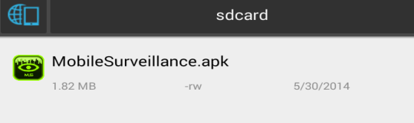

ステップ 2. MobileSurveillance.apkファイルを押す

ステップ 3「 Install」ボタンを押す

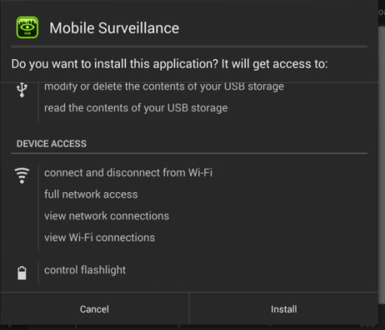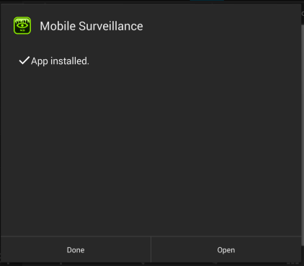

#### インストールウェブサーバ

**ステップ１**. MobileSurveillanceを[展開するためのアプリケーションを準備](http://www.google.com.vn/url?sa=t&rct=j&q=&esrc=s&source=web&cd=3&ved=0CDwQFjAC&url=http%3A%2F%2Ftechnet.microsoft.com%2Fja-jp%2Flibrary%2Fee956906%28v%3Dws.10%29.aspx&ei=26s3U-SlDsnNkgW37YGQDg&usg=AFQjCNEhUn8TGYB1gnNun6UqDCnmByl6BA&sig2=KB8H6zegfiCNc5mGaMQp5A&bvm=bv.63808443,d.dGI&cad=rja)する

サーバーのフォルダに展開パッケージを展開する。, たとえば： D:\capstone

**ステップ２**. データベースを作成する 。

Microsoft SQL ServerManagementStudio（MSSQL）で展開パッケージの「Databases」フォルダ内の「MobileSurveillance_DbScript」ファイルを開く。

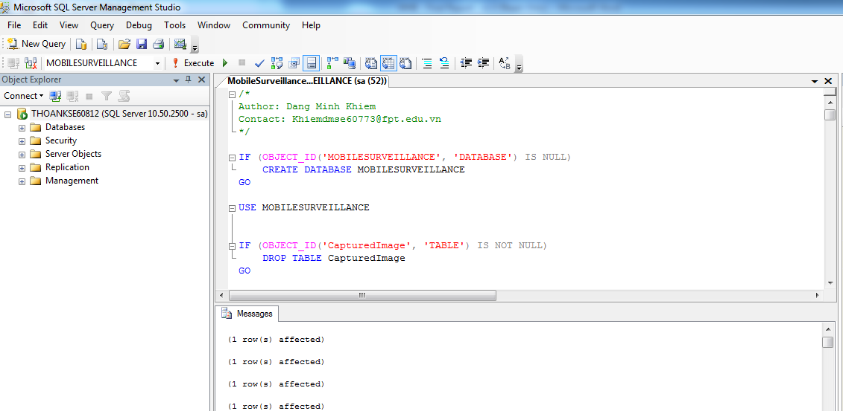

次は、データベーススクリプトを[展開するためのアプリケーションには](http://www.google.com.vn/url?sa=t&rct=j&q=&esrc=s&source=web&cd=3&ved=0CDwQFjAC&url=http%3A%2F%2Ftechnet.microsoft.com%2Fja-jp%2Flibrary%2Fee956906%28v%3Dws.10%29.aspx&ei=26s3U-SlDsnNkgW37YGQDg&usg=AFQjCNEhUn8TGYB1gnNun6UqDCnmByl6BA&sig2=KB8H6zegfiCNc5mGaMQp5A&bvm=bv.63808443,d.dGI&cad=rja)、F5を押す。データベースが正常に作成されている場合は、次の手順に進む。

**ステップ３：アプリケーションをインストールする。**

IISマネージャを開くために、Windows 7のスタートメニューまたはWindows8のチャームで「IISマネージャ」に入力する。

「サイト」フォルダを展開して、右で既定のWebサイトをクリックしてください。 「Add Application」を選択したら, [Add Application]ウィンドウが開く。 「Add Application」ウィンドウでは、ウェブサイトの名前の「Alias」フィールドを入力する。

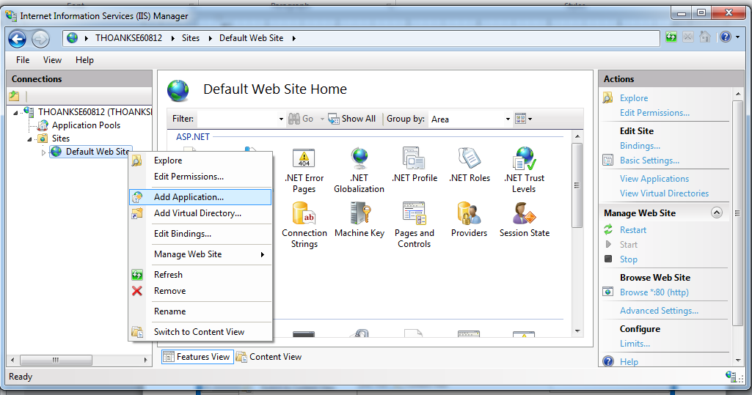

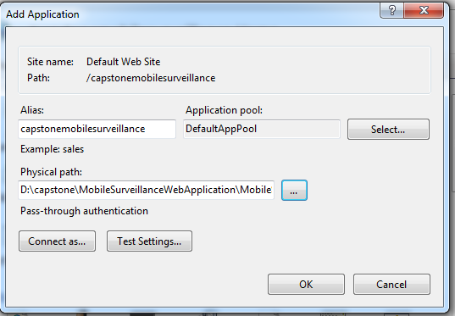

展開パッケージが含まれているフォルダを参照するために「...」ボタンをクリックしてください。 「アプリケーション」フォルダにある「MobileSurveillance」フォルダ内のWebサイト」フォルダを選択して、[OK]をクリックする。   
MobileSurveillanceウェブサイトを右クリックして、IIS ExpressはWebサイトの名前で「既定のWebサイト」、「Manage Application」を選択すると、「参照」に追加されてい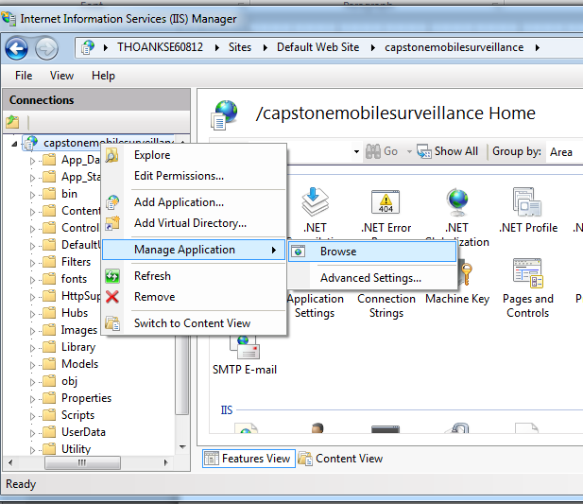ることを確認する。

データベース接続構成を変えなかったので、このステップでエラーがデータベースに接続することを見ているとに注意してください。

**[Optional] ステップ４：新しい自己署名証明書を作成する**

Facebook上にインストールされるとき、このステップではアプリケーションに閲覧するSSLを有効（enable）にしていることになっている。

左のツリーで表示される探検家で根本の機械ノードをクリックすることによって、証明書をIISで管理される。そして、右で特徴枠で「Server certificates」アイコンを選ぶ：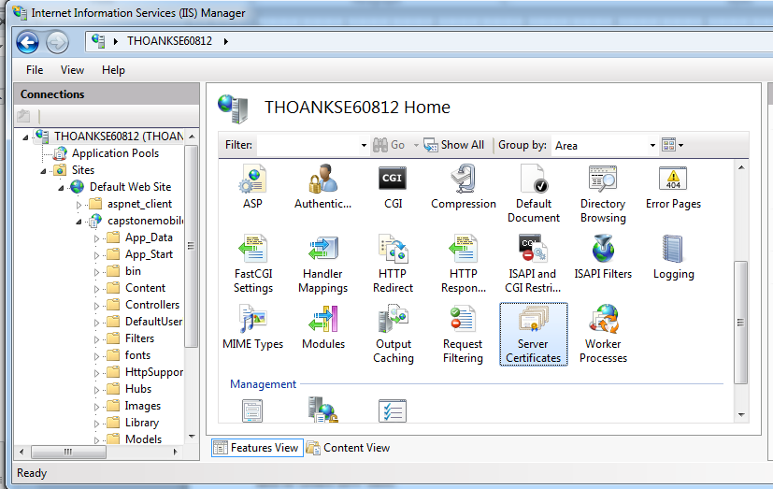

それから、ー機械でべての登録された証明書をリストして、任意に新しいものを輸入する、および／または、作ることができる。、任意のVerisignのような認証局へ行くことができて、この管理UIを使っている輸入に証明書を購入することができた。  
あるいは、私がサイトの開発することとテストすることの間に、使うことができるテスト証明書である「自己署名された証明書」を、作ることができる。  
このようにするために、右側の「Self-Signed証明書を作成してください」関連する管理ツールをクリックする：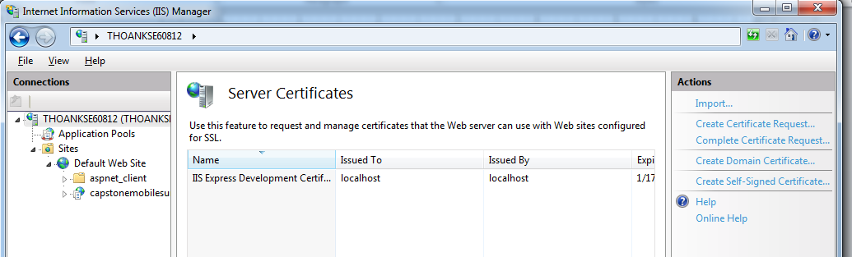

証明書を適用するため、名前を入力してください（たとえば：

「Test」）、そして、ヒットok。

それから、IISは自動的に新しい自己署名された秘密の証明書を作成して、機械でそれを登録する。

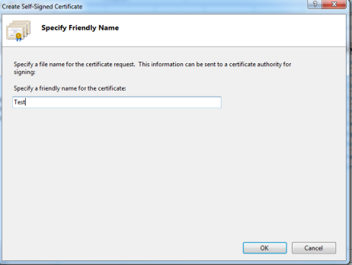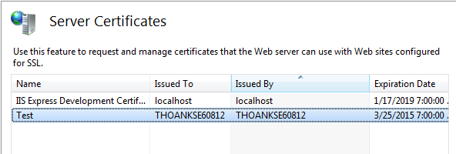

SSLに以前に作ったウェブサイトを可能にして、左のツリーで表示と「Bindings」がスクリーンの右側にその「行動」枠で結ぶクリックのウェブサイトノードを選ぶ：

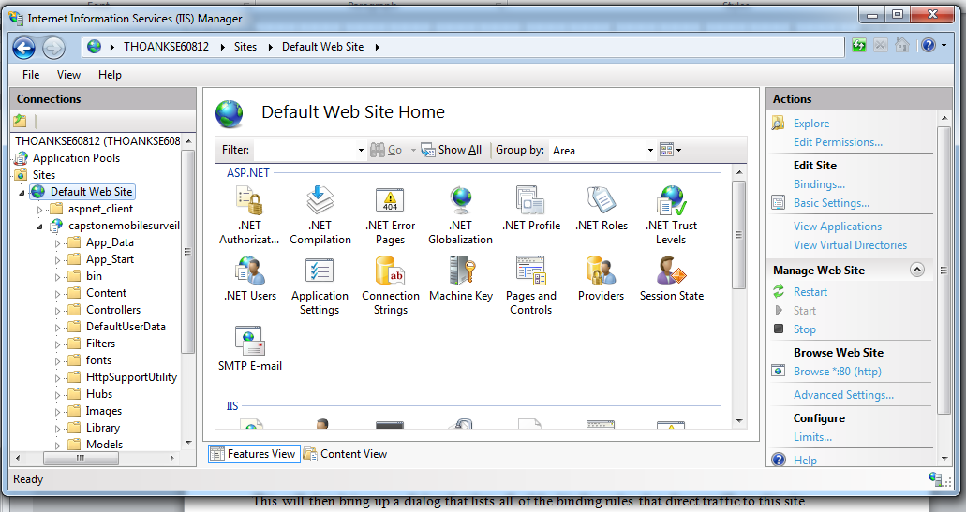

それから、、このサイトに（これはサイトのホスト-ヘッダ/IPアドレス/ポートの組合せを意味する）、交通を当てる拘束力のある全ての規則をリストする対話をあげる：

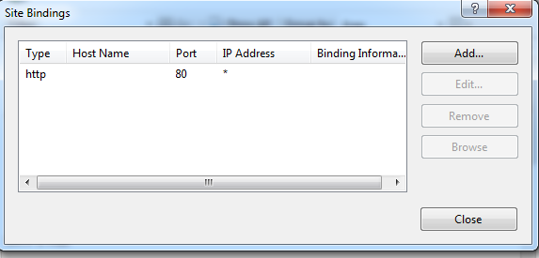

サイトにSSLを有効（enable）するために、我々は「追加」ボタンをクリックする。これは、我々が使うことができる対話を「結びつけている追加」をHTTPSプロトコルサポートを加えるように育てる。我々は、SSL証明書Dropdownlistから対話の初期に作成して、自己署名された証明書を選ぶことができて、SSLについて内容を暗号化するとき、その証明書を使いたいすると示すことができる：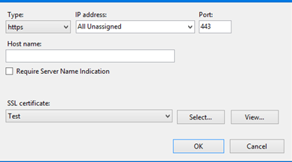

「OK」をクリックする。

ステップ5：データベース接続文字列を設定してください。

配備一括法案の「\capstone\MobileSurveillanceWebApplication\MobileSurveillanceWebApplication」フォルダにおいて、Notepadまたは他のテキストエディタを使用しても、ファイルWeb.configを見つけて、開けてください。

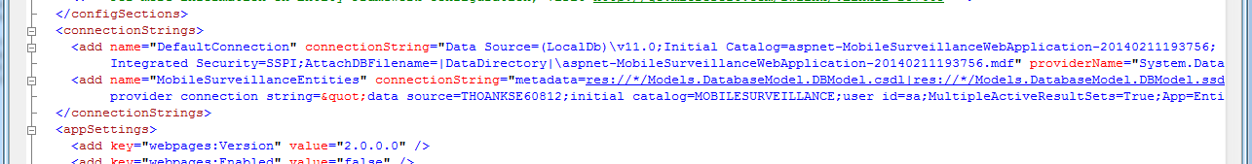



connectionStringsタグでは、接続紐のデータソースをあなたがデータベースを装置したSQLServer例に変えてください。

また、接続文字列でSQLServer例にアクセスするために、パスワードを更新してください。

mailSettingタグでは、ホストは変わって、港、ユーザー名、そして、賛成にパスワードはあなたメール価格を切断する。

## ユーザの手引書

### 携帯のアプリケーシオン

#### ログイン

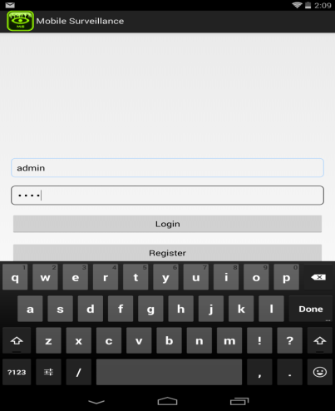

1

2

3

|  |  |
| --- | --- |
| ステップ | 命令 |
| 1. | 「Username」テキストボックスにユーザネームを入力する。 |
| 2. | 「Password」テキストボックスにユーザネームを入力する。 |
| 3. | 「Login」ボタンを押す。 |

#### TRAJECTORYの作成

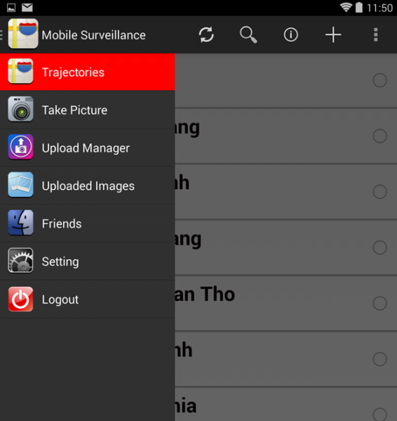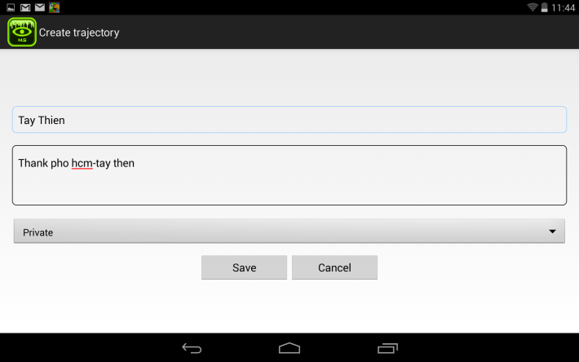

32

4

52

6

2

11

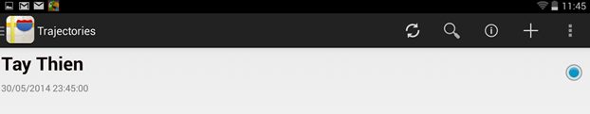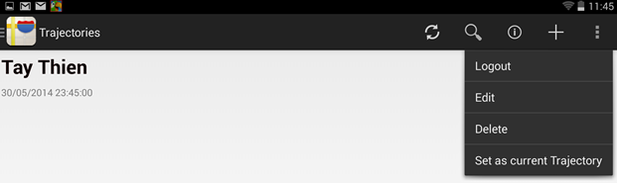

7

8

|  |  |
| --- | --- |
| ステップ | 命令 |
| 1. | slider barの「Trajectory」リンクを押す。 |
| 2. | menu barの「Create」アイコン. を押す。 |
| 3. | 「Trajectory name」テキストボックスにTRAJECTORYの名前を入力する。 |
| 4. | 「Description」テキストボックスにTRAJECTORYの記述を入力する。 |
| 5. | ドロップダウンリストからTRAJECTORYの状態選択する。 |
| 6. | 「Create」ボタンを押す。 |
| 7. | TRAJECTORYのラジオボタン‎をチェックする。 |
| 8. | 「Set as current Trajectory」を押す。 |

#### TRAJECTORYのビュー

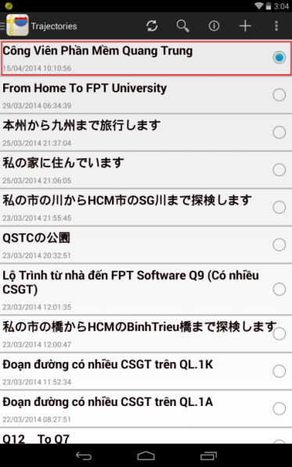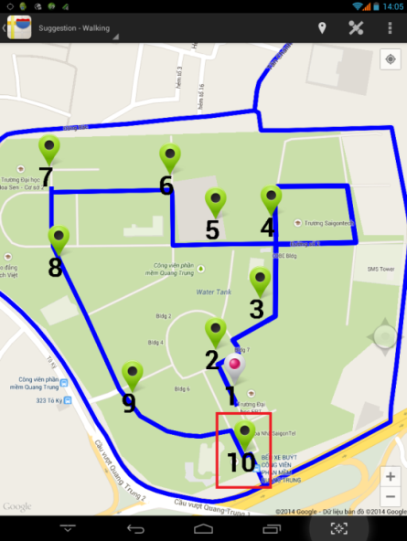

3

2

1

2

2

2

2

2

2

2

1

2

2

2

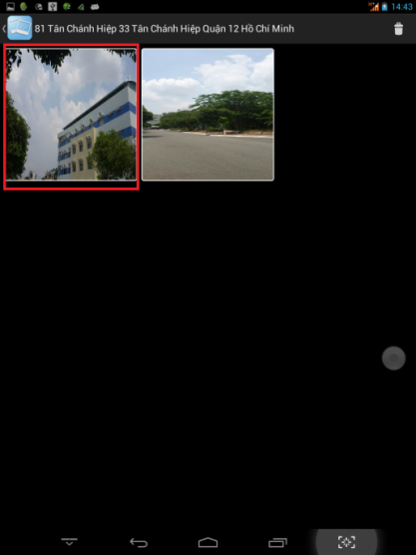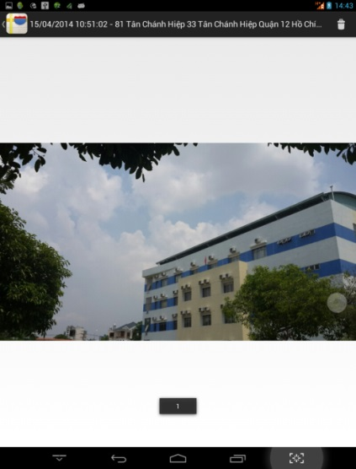

|  |  |
| --- | --- |
| ステップ | 命令 |
| 1. | 「Trajectory name」リンクを押す |
| 2. | Markerを押す |
| 3. | 写真を押す |

#### 手動で写真の撮る

|  |  |
| --- | --- |
| ステップ | 命令 |
| 1. | Slider bar の「Setting」リンクを押す。 |
| 2. | 「Auto Capture」の「OFF」ボタンを押す。 |
| 3. | 「Take picture」 のリンクを押す。 |
| 4. | 「Capture」ボタンを押す。 |

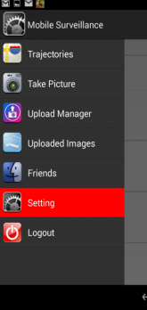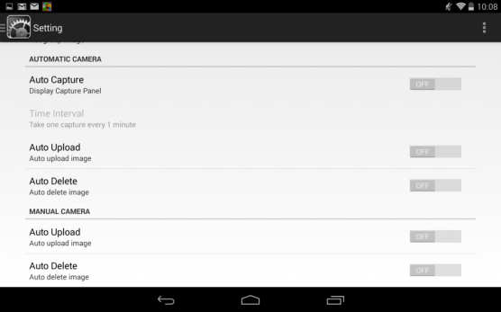

1

2

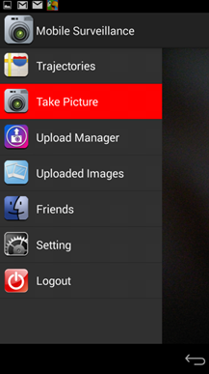

4

3

#### 自動で写真の撮る

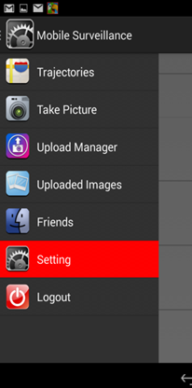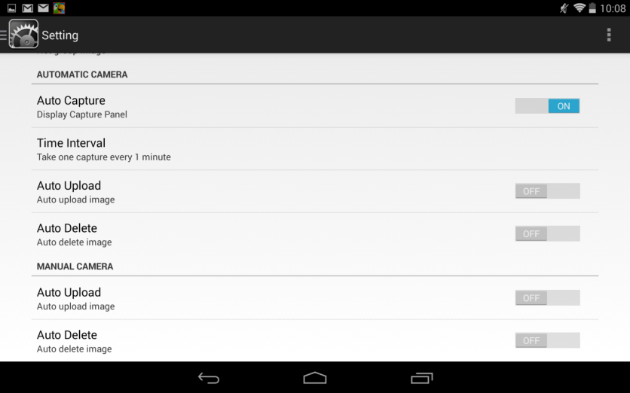

24

14

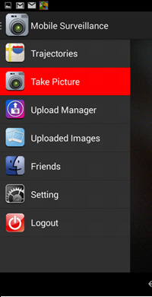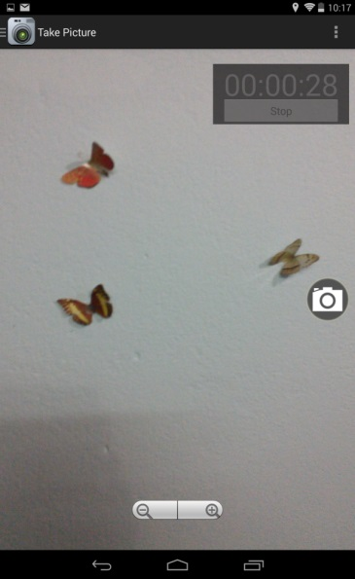

324

4

|  |  |
| --- | --- |
| ステップ | 命令 |
| 1. | Slider bar の「Setting」リンクを押す。 |
| 2. | 「Auto Capture」の「ON」ボタンを押す。 |
| 3. | 「Take picture」 のリンクを押す。 |
| 4. | 「Start」ボタンを押す。 |
| (5). | 「Stop」ボタンを押す。 |

#### 写真のアップロード

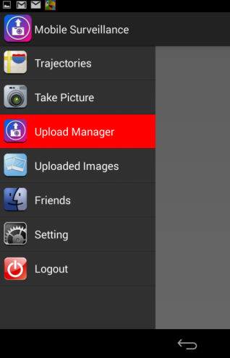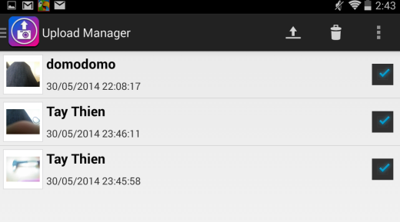

2

3

1

|  |  |
| --- | --- |
| ステップ | 命令 |
| 1. | Slider barの「Upload Manager」リンクを押す。 |
| 2. | 写真を選択する。 |
| 3. | 「Upload」アイコンを押す。 |

### ウェブアプリケーション

#### ログイン

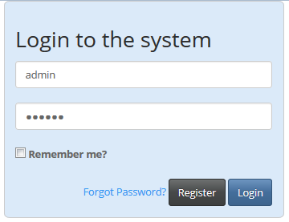

1

2

3

|  |  |
| --- | --- |
| ステップ | 命令 |
| 1. | 「Username」テキストボックスにユーザネームを入力する。 |
| 2. | 「password」テキストボックスにユーザネームを入力する。 |
| 3. | 「Login」ボタンを押す。 |

#### レジスター

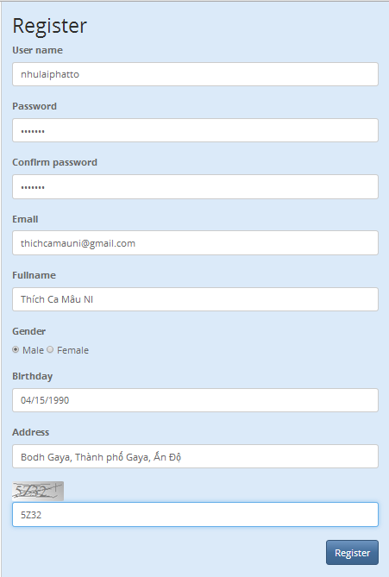

1

2

3

4

5

7

8

9

10

6

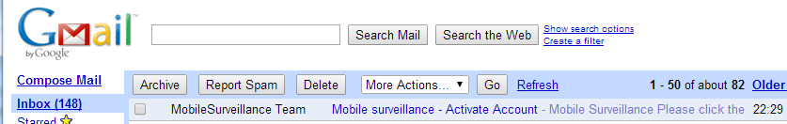

11

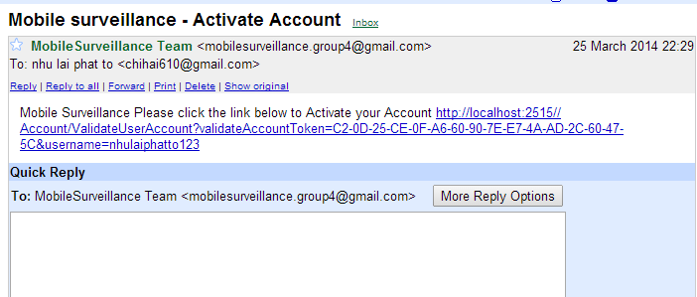

12

|  |  |
| --- | --- |
| ステップ | 命令 |
| 1. | 「Username」テキストボックスにユーザネームを入力する。 |
| 2. | 「Password」テキストボックスにユーザネームを入力する。 |
| 3. | 「Confirm password」テキストボックスにユーザネームを入力する。 |
| 4. | 「Email」テキストボックスにユーザネームを入力する。 |
| 5. | 「Fullname」テキストボックスにユーザネームを入力する。 |
| 6. | ドロップダウンリストからユーザ性を選択する。 |
| 7. | 「Birthday」テキストボックスにユーザネームを入力する。 |
| 8. | 「Address」テキストボックスにユーザネームを入力する。 |
| 9. | 「Security code」テキストボックスにユーザネームを入力する。 |
| 10. | 「Register」ボタンを押す。 |
| 11. | レジスターのメールの確認のタイトル |
| 12. | MobileSurveillance の送信したリンクをクリックする、レジスターの段階を済ませる。. |

#### パスワードを取得する



12

22

32

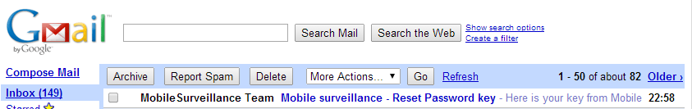

422

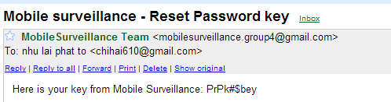



52

6

72

82

|  |  |
| --- | --- |
| ステップ | 命令 |
| 1. | 「Forgot password」リンクを押す。 |
| 2. | 「email」テキストボックスにユーザネームを入力する。 |
| 3. | 「Retrieve Password」ボタンを押す。 |
| 4. | Sign in your email. The mail we have given you content a key. |
| 5. | 「key」テキストボックスにユーザネームを入力する。 |
| 6. | 「New Password」テキストボックスにユーザを入力する。 |
| 7. | 「Username」テキストボックスにユーザネームを入力する。 |
| 8. | 「ResetPassword」ボタンを押す。 |

#### TRAJECTORY をビュー

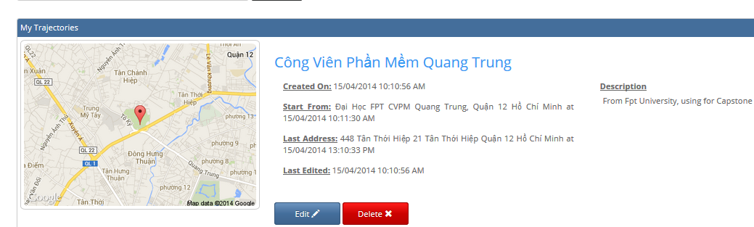

1

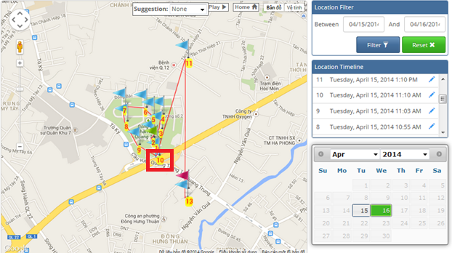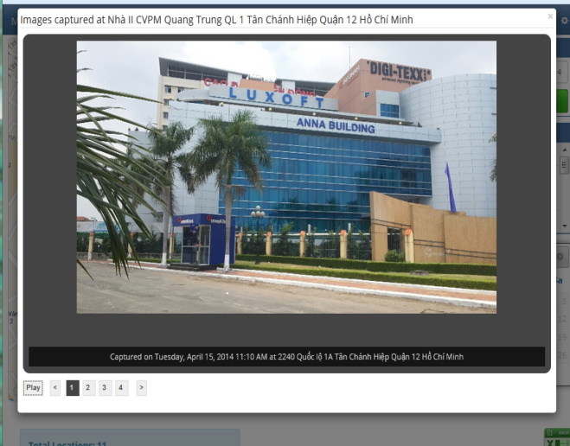

2

|  |  |
| --- | --- |
| ステップ | 命令 |
| 1. | 「Trajectory name」リンクをチェックする |
| 2. | Markerをクリックする |

#### ロケーションの管理

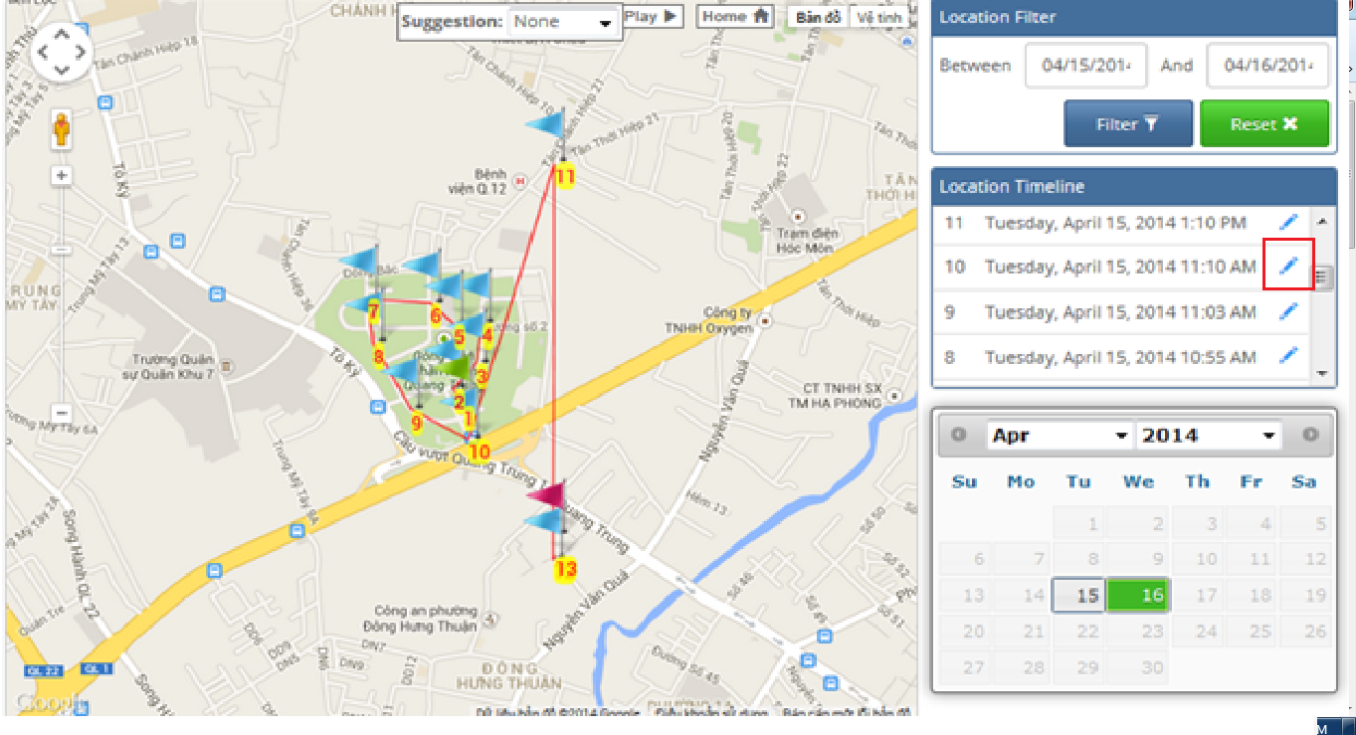

1

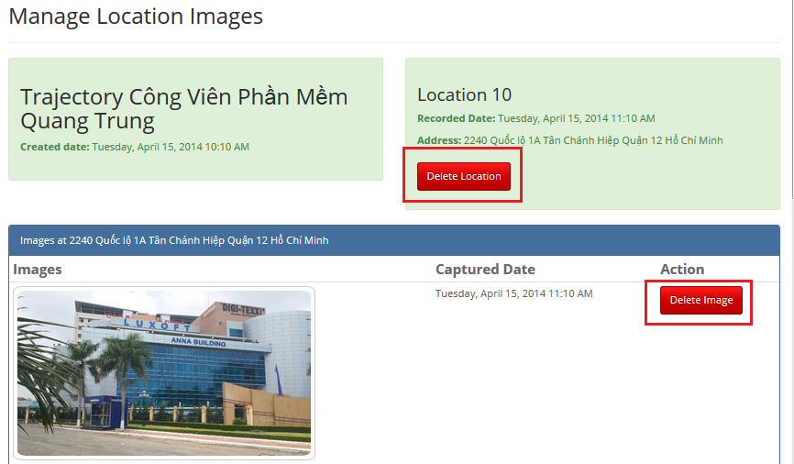

3

2

|  |  |
| --- | --- |
| ステップ | 命令 |
| 1. | 「Location time」のエディトボタンをクリックする |
| 2. | 「Delete Image」ボタンをクリックする |
| 3. | 「Delete Location」ボタンをクリックする |

#### FRIEND のビュー

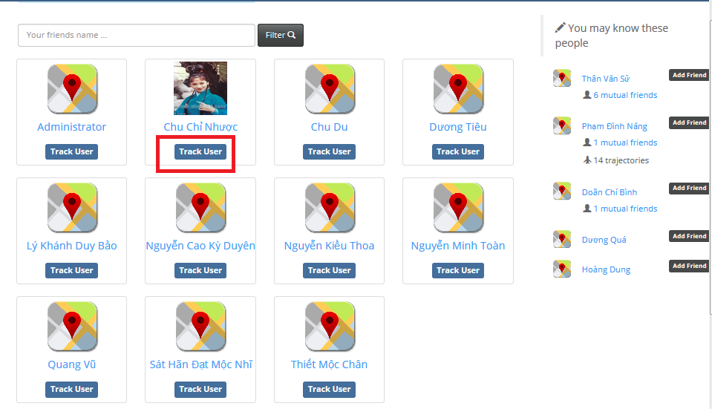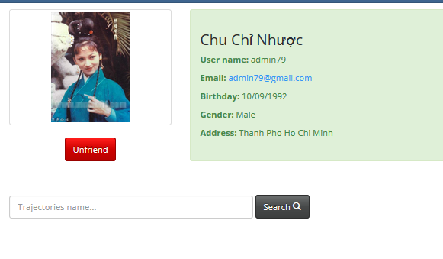

2

1

|  |  |
| --- | --- |
| ステップ | 命令 |
| 1. | FRIEND NOTIFICATION をクリックする |
| 2. | 「Track user 」ボタンをクリックする。 |

# 

# Appendix

## Reference

**Android Developer**

<http://developer.android.com/guide/index.html>

**UML Design**

<http://www.uml-diagrams.org/>

**Stack Overflow**

<http://stackoverflow.com/>

**Android Hive**

<http://www.androidhive.info/2013/09/android-working-with-camera-api/>

<http://www.androidhive.info/2013/08/android-working-with-google-maps-v2/>

<http://www.androidhive.info/2012/07/android-gps-location-manager-tutorial/>

<http://www.androidhive.info/category/sqlite/>

**AppHarbor Documentation**

https://appharbor.com/page/support

**Android Google Map API V2**

<https://developers.google.com/maps/documentation/android/>

**Google Map Javascript API V3**

<https://developers.google.com/maps/documentation/javascript/>

**IP Webcam**

<https://play.google.com/store/apps/details?id=com.pas.webcam&hl=en>

**Wi-Fi Home Surveillance IP Cam**

https://play.google.com/store/apps/details?id=com.webofcam&hl=